


L2 Operations Manual
  - Safaricom Ethiopia

Case Management
_________________________________________________________________________
Version 1.1

Copyright
© 2025 6d Technologies. All rights reserved.
The information contained in this document is subject to change without prior notice and pertains solely to the product outlined in the introduction. This document is intended exclusively for use by 6d’s customers, under the terms of the agreement through which it has been provided. No portion of this document may be reproduced, stored, or transmitted in any form or by any means without the prior written consent of 6d Technologies.
This document is intended for use by qualified and trained professionals. The customer bears full responsibility for its application. Both this document and the associated product are protected under applicable copyright laws.
Disclaimer
The information and statements provided in this document regarding the suitability, capacity, or performance of the hardware or software products mentioned are not to be considered binding. Such specifications shall be governed exclusively by the terms of the agreement between 6d Technologies and the customer.
While 6d Technologies has made every reasonable effort to ensure that the instructions in this document are accurate and complete, the company does not warrant the absence of material errors or omissions. If required, 6d will provide clarification or additional information on matters that may not be explicitly addressed in this document.
Feedback
6d Technologies welcomes customer feedback as an integral part of its ongoing efforts to enhance and improve the quality of its documentation.
Trademarks and Registered Trademarks
The products and product names referenced in this document may be trademarks or registered trademarks of their respective owners.

Revision History
Version | Issued Date | Author | Description
Draft | 10/04/2025 | Thanvir Jalal | Initial working draft compiled during L2 CM transition preparation
1.0 | 27/05/2025 | Thanvir Jalal | First official release shared with Safaricom as part of L2 operations handover
1.1 | 05/06/2025 | Thanvir Jalal | Added retention details, updated COM callback-related APIs and logs, updated integration points

Table of Contents
Table of Contents 4
1. Introduction 11
1.1 Purpose of the Document 11
1.2 Target Audience 11
1.3 Scope of the Application 11
1.4 Objectives of the Handover 12
2. System Overview 13
2.1 Architecture Overview 13
2.2 Key Functional Modules 14
2.2.1 cm-api-services 14
2.2.2 cm-audit-service 15
2.2.3 cm-tmf-api-service 15
2.2.4 filebeat-out 16
2.2.5 filebeat-cdr 16
2.2.6 filebeat-logs 16
2.2.7 cm-config-api-services 17
2.2.8 cm-user-management 17
2.2.9 cm-web-portal 18
2.2.10 filebeat-logs 18
2.2.11 cm-bulkticket-services 19
2.2.12 cm-notification 19
2.2.13 cm-processor 19
2.2.14 filebeat-logs 20
2.2.15 cm-scheduler 20
2.2.16 filebeat-logs 21
2.2.17 ProxySQL 22
2.3 Architecture Diagrams 23
2.4 Integration Points 24
3. Kubernetes Deployment Details 26
3.1 CM-POD-1 26
3.1.1 Overview 26
3.1.2 Summary 28
3.2 CM-POD-2 31
3.2.1 Overview 31
3.2.2 Summary 33
3.3 CM-POD-3 35
3.3.1 Overview 35
3.3.2 Summary 37
3.4 CM-POD-4 39
3.4.1 Overview 39
3.4.2 Summary 40
3.5 CM-PROXYSQL-POD 41
3.5.1 Overview 41
3.5.2 Summary 42
4. Microservices Overview & Configurations 44
4.1 CM-POD-1 44
4.1.1 cm-api-services 44
4.1.2 cm-audit-service 48
4.1.3 cm-tmf-api-Services 49
4.1.4 Filebeat 51
4.2 CM-POD-2 56
4.2.1 cm-config-api-services 56
4.2.2 cm-user-management 59
4.2.3 cm-web-portal 60
4.2.4 Filebeat 64
4.3 CM-POD-3 66
4.3.1 cm-bulkticket-services 66
4.3.2 cm-notifications 67
4.3.3 cm-processor 68
4.3.4 Filebeat 70
4.4 CM-POD-4 72
4.4.1 cm-schedular 72
4.4.2 Filebeat 74
4.5 CM-PROXYSQL-POD 76
5. Keycloak Integration 79
5.1 SSO Authentication Flow 79
5.2 Keycloak Client Configuration Highlights 80
5.3 Roles and Scopes Management 80
5.4 Fine-Grained Access Control Configuration 81
5.4.1 Key Concepts 81
5.4.2 Step-by-Step: Configuring Fine-Grained Access 81
5.4.3 Mapping Reference Sheet 83
6. Database & Persistence 85
6.1 Database Overview 85
6.2 Table Definitions 85
6.2.1 Product Type 85
6.2.2 Case category 86
6.2.3 Case type 86
6.2.4 SLA Master 87
6.2.5 SLA Mapping 89
6.2.6 Team Master 89
6.2.7 Team Mapping 90
6.2.8 Resolution 91
6.2.9 Source 92
6.2.10 Intent 92
6.2.11 Intent Mapping 92
6.2.12 Caused Code 93
6.2.13 Case nature 93
6.2.14 Case sub nature 94
6.2.15 Meta Data 95
6.2.16 Meta data mapping 96
6.2.17 Message Template 96
6.2.18 FAQ 97
6.2.19 Holidays 97
6.2.20 Ticket Master Table 98
6.2.21 Ticket Master History Table 105
6.2.22 Assignee change Audit Table 111
6.2.23 Status change Audit Table 112
6.2.24 Remarks Table 113
6.2.25 Meta Details Table 114
6.2.26 Customer Notes Table 114
6.2.27 Document Details Table 115
6.2.28 Audit Details Table 116
6.2.29 Email Notification Details Table 117
6.2.30 Profile Type Master 117
6.2.31 Document Type 118
6.2.32 Event Type 118
6.2.33 Priority 119
6.2.34 Status Details 119
6.2.35 Channels 120
6.2.36 Audience 120
6.2.37 Message Template Language 120
6.2.38 Report Parameters 120
6.2.39 Bulk Ticketing 121
6.2.40 FEATURE MASTER 121
6.2.41 MENU DETAILS 122
6.2.42 BL URL CONFIG 123
6.2.43 BS CATEGORY MASTER 124
6.2.44 LANGUAGE PROPS 124
6.2.45 SYSTEM PROPS 124
6.2.46 USER MASTER 136
6.3 DB Server Details 137
6.4 DB User Credentials 137
6.5 Safe Execution of Read-Only Queries 138
6.6 DB Backup & Archiving 140
6.6.1 MySQL Enterprise Backup (MEB) – Cluster-Level Snapshot 140
6.6.2 Daily Configuration Table Dump – Fine-Grained Recovery 141
7. CI/CD & Deployment 142
7.1 Overview 142
7.2 Deployment Workflow Overview 142
7.2.1 Git Extension Setup on Local Machine (L2) 142
7.2.2 L2 Image Retrieval and Internal Registry Push 145
7.2.3 Sync via ArgoCD 146
7.2.4 Validation After Deployment 147
7.2.5 Manual Git-Based Deployment (Fallback – Jump Server) 147
7.3 References and Access Details 148
8. Logging, Reporting, Monitoring, and CDR Management 150
8.1 Log Storage Overview 150
8.2 Accessing Logs from Jump Servers 150
8.3 Log Backup and Housekeeping Script 151
8.4 Current Log Retention Policy 151
8.5 CDR Storage 152
8.5.1 CDR Processing and Data Flow 152
8.6 Monitoring and Alerting 153
8.6.1 Prometheus Metrics Endpoints 153
8.6.2 Shell Script-Based Health Monitoring 153
8.7 Reporting 154
8.7.1 To analyse or validate the logic used in any report procedure 154
8.7.2 Procedure Update Process 155
9. Scheduled Operational Shell Scripts 156
9.1 Summary of Scheduled Scripts 156
9.2 Script Logic Summaries 156
9.2.1 HOURLY_CM_TOP_TICKETS_V2.sh – Hourly Ticket Summary Alert 156
9.2.2 Daily-CM-Ticketing-History-Loading.sh – Hard-Closed Ticket Archiver 157
9.2.3 CM_POD1-Refresh.sh – POD Health Monitor 157
10. Troubleshooting Guide 158
10.1 General Troubleshooting Approach 158
10.2 Log Access Paths 158
10.3 Log Analysis – Tracking Requests 159
10.3.1 Tracking GET Requests from UI to Backend 159
10.3.2 Tracking Post or Put Requests from UI to Backend 162
10.4 Common Kubernetes Troubleshooting Commands 164
10.5 CM Unresponsiveness Due to NFS Mount Slowness 165
10.6 CM UI Loads as a White Screen After Web Portal Restart 167
10.7 Steps to take Heap & Thread Dump 167
10.7.1 Heap Dump Collection 167
10.7.2 Thread Dump Collection 168
11. Operational Tasks 169
11.1 Monthly Ticket Movement to History Table 169
11.2 Scheduler Site Failover Handling 169
11.3 BS CATEGORY MASTER Manual Data Addition 170
11.4 SSL/TLS Certificate Update Procedure 170
12. L2-to-L3 Escalation Procedure and SLA Guidelines 173
12.1 Purpose 173
12.2 Escalation Workflow 173
12.2.1 L2 Diagnosis 173
12.2.2 Submit Escalation to 6d Support 173
12.2.3 L3 Assignment 174
12.2.4 Template Verification 174
12.3 Prerequisites Before Escalation 174
12.4 Incident Severity Classification (P1-P4) 175
12.5 Ticket Hold & Auto-Closure Policy 175
12.6 Post-Escalation Handling 175
13. Appendices 177
13.1 API Request Reference 177
13.1.1 View Tickets 177
13.1.2 View Remarks on a Ticket 177
13.1.3 Fetch Category by Product ID 178
13.1.4 Fetch Categories by Case Category ID 178
13.1.5 Update Ticket Status (Multiple Tickets) 179
13.1.6 Add Remarks to a Ticket 179
13.1.7 Update Ticket Status (Single Ticket) 180
13.1.8 Create Trouble Ticket (TMF Compliant) 181
13.2 API Response Reference 184
13.2.1 Response Format 184
13.2.2 Response Fields Explained 185
13.2.3 Response Codes and Descriptions 185
13.3 Postman collection of the APIs 185

Introduction

Purpose of the Document
This document serves as a comprehensive technical handover guide for the Case Management (CM) Application deployed in a Kubernetes-based production environment. It is intended to enable L2 support engineers to independently manage, monitor, and troubleshoot the application, ensuring continuity of operations with minimal dependency on the development team.
The document outlines all critical components, configurations, and operational procedures required to support the CM application. It also includes essential information about microservices, logging, authentication, database interactions, deployment pipelines, and integration points with other systems.

Target Audience
This documentation is specifically designed for:
- L2 Operations Engineers
- Monitoring Teams
The content assumes a working knowledge of Kubernetes, MySQL, microservices architecture, and basic Linux system administration & Shell Scripting.

Scope of the Application
The Case Management (CM) system is a telecom-grade application responsible for handling customer support tickets, automating workflows, and ensuring SLA-based resolution through various channels and microservices. The key responsibilities of the application include:
- Capturing and processing tickets from Internal & external systems (COM, CRM, Other third parties.)
- Managing ticket lifecycles, escalations, and closures
- Logging audit events and metadata for compliance
- Triggering workflows and notifications based on business rules
- Integrating with authentication services (Keycloak)
This document covers the entire ecosystem surrounding the CM application, including:
- Application architecture and components
- Kubernetes deployment model and scaling behaviour
- Configuration files
- Keycloak-based authentication and token management
- Database schema overview and data flow
- CI/CD deployment process
- Monitoring and logging via Filebeat, Kafka, Splunk & Shell scripts
- Known issues and troubleshooting guidelines

Objectives of the Handover
- Ensure operational readiness of the L2 support team
- Transfer complete knowledge of application deployment, configuration, and maintenance
- Establish self-sufficiency in handling incidents and performing standard operations
- Document all integration touchpoints and recovery mechanisms

System Overview
The Case Management (CM) application is an enterprise-grade platform designed to facilitate the creation, tracking, and resolution of customer-related cases across various operational and business domains. It enables automated ticket handling, escalation, SLA tracking, bulk ticket processing, audit logging, and real-time notifications through a modular and scalable microservices architecture.

Architecture Overview
The Case Management (CM) system is deployed on a Kubernetes (K8s) cluster using an active-active architecture across two geographically separated sites—ED2 and MDC1. This setup ensures high availability, disaster resilience, and load distribution across environments.
Deployment and configuration management follow a GitOps-based approach, leveraging Argo CD for the synchronization of infrastructure and application states directly from the repositories. This ensures consistency, auditability, and secure delivery of changes across both environments.
The application is logically structured into four primary Kubernetes pods, each responsible for a distinct set of functionalities:
- CM-POD-1: Hosts core APIs, TMF (TeleManagement Forum) integrations, and the audit logging service.
- CM-POD-2: Includes configuration management APIs, the main web-based user interface, and user/team synchronization services.
- CM-POD-3: Manages bulk ticket processing, notification handling, and the orchestration of message content.
- CM-POD-4: Executes scheduled background jobs such as SLA monitoring, escalation handling, and hard-closing of long-resolved tickets.
Each pod contains one or more microservices and is often paired with a Filebeat sidecar container. Filebeat is used for:
- Shipping structured and multiline logs to Kafka.
- Exporting CDRs to designated directories or Kafka topics for mediation and reporting.
This modular and containerized architecture allows for scalability, independent lifecycle management, and better resource isolation across CM components.

The Case Management system is modularized into four primary pods, each responsible for a distinct set of functionalities. The microservices are distributed across the pods as outlined below:
Pod Name | Microservices
cm-pod-1 | cm-api-services
 | cm-audit-service
 | cm-tmf-api-service
 | filebeat-logs
 | filebeat-cdrs
 | filebeat-out
cm-pod-2 | cm-config-api-services
 | cm-user-management
 | cm-web-portal
 | filebeat-logs
cm-pod-3 | cm-bulkticket-services
 | cm-notification
 | cm-processor
 | filebeat-logs
cm-pod-4 | cm-scheduler
 | filebeat-logs

Key Functional Modules

cm-api-services
The cm-api-services module serves as the core backend engine of the Case Management (CM) application. It is primarily responsible for executing the business logic and processing all ticket-related operations, such as creation, retrieval, updates, escalations, status transitions and generates CDRs for all these actions.
This microservice acts as the main interface between the UI (cm-web-portal) and the backend, handling most of the real-time user interactions. All ticket lifecycle actions initiated by users—whether manual or automated—are routed through cm-api-services.
As a foundational module, it integrates with several other CM components, including:
- Database layer (via configured JNDI datasource)
- User and configuration services for validation and metadata enrichment
- Notification and audit services to maintain end-to-end visibility and compliance
- External systems, such as CRM or 3rd party platforms, where applicable
The service is designed to be stateless and scalable, ensuring high performance and consistency across distributed deployments in the active-active architecture

cm-audit-service
The cm-audit-service is dedicated to recording and maintaining a complete audit trail of all critical operations performed through the Case Management (CM) user interface. Specifically, it captures every create, update, and delete action initiated by users.
Each audit record contains comprehensive metadata, including:
- The user ID and role of the person performing the action
- The operation type (e.g., create, update, delete)
- The entity affected (e.g., ticket, SLA configuration, team assignment)
- The timestamp of the operation
- The originating IP address or host
- Serialized snapshots of the request and response payloads
This service is essential for ensuring:
- Accountability – all actions are linked to authenticated users
- Traceability – changes can be traced across services and time
- Compliance – fulfils audit and governance requirements
- Operational Insight – supports debugging and analysis in the event of data discrepancies or user-reported issues
All audit data is stored persistently in dedicated audit tables and can be accessed through internal dashboards, API queries, or exported for regulatory reporting.

cm-tmf-api-service
The cm-tmf-api-service module is responsible for managing third-party integrations by exposing APIs that conform to the TM Forum Open API (TMF) standards. These standards are widely adopted in the telecom industry to ensure interoperability, consistency, and reusability across Business Support Systems (BSS), Operational Support Systems (OSS), and external partner platforms.
This service provides a standardized interface through which external systems—such as Customer Relationship Management (CRM), MPESA platforms and other downstream or upstream third-party applications—can:
- Create or update tickets
- Query ticket statuses
By adhering to TMF specifications, cm-tmf-api-service reduces integration effort, simplifies API governance, and promotes compatibility with systems outside the CM/BSS domain.

filebeat-out
The filebeat-out container is a specialized instance of Filebeat configured to handle the post-processing and transformation of CDRs generated by the CM application particularly from the cm-api-services module.
CDRs are initially produced in plain .txt format and written to a predefined application directory. The filebeat-out container is responsible for:
- Reading these raw .txt CDR files
- Converting them into structured NDJSON (Newline Delimited JSON) format
- Writing the transformed output to a target directory
This output directory acts as the source for mediation systems or reporting engines, which consume the structured CDRs for downstream processing, SLA reporting, or regulatory compliance.
The filebeat-out container is deployed as a sidecar within the same pod as the generating service. It is optimized for reliable file parsing, formatting consistency, and file rotation. This ensures that CDR delivery to downstream systems is decoupled from core application logic, maintaining modularity and operational efficiency.

filebeat-cdr
The filebeat-cdr container is responsible for collecting CDR logs generated within individual CM pods and forwarding them to a Kafka topic for real-time processing, monitoring, or downstream analytics.
This container is configured to:
- Read pod-specific .txt CDR files from directories using environment variables to dynamically locate files within each pod.
- Transform log entries into a stream of newline-delimited messages (NDJSON), ensuring compatibility with systems that expect structured, line-by-line event data.
- Send the data to Kafka over a secure channel using SASL authentication with SCRAM-SHA-512, ensuring that log transmission is both secure and reliable.
The filebeat-cdr container runs as a sidecar alongside the CM microservices that generate CDRs, ensuring that logs are captured and transmitted independently of the application lifecycle.

filebeat-logs
The filebeat-logs container is responsible for collecting and forwarding application logs from multiple Case Management (CM) microservices to a centralized Kafka topic. This enables real-time log aggregation, monitoring, and long-term retention through downstream logging platforms such as ELK or Splunk.
This container is deployed as a sidecar in several CM pods (e.g., cm-pod-1, cm-pod-2, cm-pod-3) and is configured to:
- Tail log files generated by various CM modules, including scheduler, processor, notification, audit, user management, config API, and UI services.
- Use a multiline pattern to correctly group multi-line log entries such as stack traces or structured logs.
- Tag logs dynamically with a Kafka topic field to enable accurate routing and classification.
- Stream logs to Kafka using secure SASL authentication, with support for compression and partitioning to ensure scalability and efficiency.
This setup ensures:
- Consistent and structured log formatting
- Seamless observability across services
- Centralized log availability for alerting, troubleshooting, and compliance auditing

cm-config-api-services
The cm-config-api-services module serves as the central configuration management microservice within the Case Management (CM) application. It is the backend component responsible for handling all operations related to the "Configuration" section of the CM user interface, enabling dynamic control over system behaviour without requiring code changes.
This microservice is invoked whenever the UI or the Business Logic (BL) layer requires access to or modification of key configuration data. These configurations include, but are not limited to:
- SLA policies and thresholds
- Case categories and ticket types
- Escalation rules

cm-user-management
The cm-user-management microservice is responsible for managing and synchronizing all user and team-related data within the Case Management (CM) application. It acts as the integration bridge between the CM system and the central User Management System (UMS) to ensure that user metadata and team structures are always up-to-date and consistent.
Whenever user-related operations such as user creation, updates, team assignments, or role changes are performed in UMS, the system triggers an event or sends a notification to the cm-user-management microservice. Upon receiving this input, the microservice processes the payload and updates the corresponding tables in the CM database.

cm-web-portal
The cm-web-portal is the user interface (UI) microservice of the Case Management (CM) application. It provides the primary front-end interface through which end users interact with the system to perform essential operations such as creating, updating, viewing, and managing tickets.
Designed for usability and responsiveness, the cm-web-portal abstracts the underlying business logic and offers a streamlined experience tailored to different user roles. It communicates with various backend services, including:
- cm-api-services for core ticket operations
- cm-config-api-services for fetching configuration data such as case types, SLA settings, and escalation rules
The portal also integrates tightly with Keycloak, the CM system’s identity and access management solution. It handles:
- Authentication via secure redirection to Keycloak login pages
- Token validation for securing access to APIs
- Role-based access control (RBAC) to ensure users can only access UI features and data permitted by their assigned roles
Through this microservice, users can efficiently interact with tickets, dashboards, configuration tools, and other modules of the CM system in a secure and intuitive environment.

filebeat-logs
The filebeat-logs container is responsible for collecting and forwarding application logs from multiple Case Management (CM) microservices to a centralized Kafka topic. This enables real-time log aggregation, monitoring, and long-term retention through downstream logging platforms such as ELK or Splunk.
This container is deployed as a sidecar in several CM pods (e.g., cm-pod-1, cm-pod-2, cm-pod-3) and is configured to:
- Tail log files generated by various CM modules, including scheduler, processor, notification, audit, user management, config API, and UI services.
- Use a multiline pattern to correctly group multi-line log entries such as stack traces or structured logs.
- Tag logs dynamically with a Kafka topic field to enable accurate routing and classification.
- Stream logs to Kafka using secure SASL authentication, with support for compression and partitioning to ensure scalability and efficiency.

This setup ensures:
- Consistent and structured log formatting
- Seamless observability across services
- Centralized log availability for alerting, troubleshooting, and compliance auditing

cm-bulkticket-services
The cm-bulkticket-services microservice is designed to enable the bulk creation of tickets within the Case Management (CM) application. It provides a powerful utility for operational teams who need to handle large volumes of similar or recurring ticket requests efficiently.
This functionality is accessible via the CM user interface, where authorized users can upload a structured CSV file, with each row representing a distinct ticket. Upon receiving the file, the cm-bulkticket-services microservice executes a series of operations to process and create tickets:
- Validates the file format, structure, and data integrity based on predefined rules
- Parses each row of the CSV into a structured ticket creation request
- Invokes backend APIs via the cm-api-services module to create each ticket in the system according to the business rules and configuration settings

cm-notification
The cm-notifications microservice is responsible for handling all outbound communications from the Case Management (CM) application. It enables the delivery of Email and SMS notifications triggered by specific events during the ticket lifecycle, such as ticket creation, status updates, SLA breaches, escalations, and closures.
This service acts as an intermediary between the CM platform and the Notification Gateway (NGW), which is the external system responsible for message transmission.

cm-processor
The cm-processor microservice is a key orchestration component within the Case Management (CM) application, responsible for managing notification workflows and trigger api-services for CDR generation based on predefined business events.
Functioning as an intermediary logic layer, this service reacts to events triggered by other system components particularly the cm-scheduler & cm-api-services and coordinates the required downstream actions. Its primary responsibilities include:
- Constructing notification message payloads (Email or SMS) by combining dynamic ticket data with predefined templates
- Routing notification requests to the cm-notifications service for dispatch through the appropriate communication channel
- Initiating CDR generation by invoking the relevant APIs in the cm-api-services, ensuring that key operational events such as SLA breaches and ticket escalations are recorded for compliance and reporting

filebeat-logs
The filebeat-logs container is responsible for collecting and forwarding application logs from multiple Case Management (CM) microservices to a centralized Kafka topic. This enables real-time log aggregation, monitoring, and long-term retention through downstream logging platforms such as ELK or Splunk.
This container is deployed as a sidecar in several CM pods (e.g., cm-pod-1, cm-pod-2, cm-pod-3) and is configured to:
- Tail log files generated by various CM modules, including scheduler, processor, notification, audit, user management, config API, and UI services.
- Use a multiline pattern to correctly group multi-line log entries such as stack traces or structured logs.
- Tag logs dynamically with a Kafka topic field to enable accurate routing and classification.
- Stream logs to Kafka using secure SASL authentication, with support for compression and partitioning to ensure scalability and efficiency.
This setup ensures:
- Consistent and structured log formatting
- Seamless observability across services
- Centralized log availability for alerting, troubleshooting, and compliance auditing

cm-scheduler
The cm-scheduler microservice is responsible for executing automated, scheduled background tasks within the Case Management (CM) application. It plays a vital role in enforcing SLA policies, initiating escalations, and maintaining data lifecycle compliance without requiring manual intervention.
This service performs two key functions:
- Hard Closure of Aged Tickets
At scheduled intervals, the cm-scheduler scans the database to identify tickets that have been in a 'Closed' state for more than 90 days. These tickets are then automatically transitioned to a 'Hard Closed' status.
This action:
- Prevents further modifications to finalized cases
- Reduces clutter in operational views
- Enhances system performance
- Supports compliance with audit and data retention policies

- SLA Breach and Escalation Detection
The service continuously monitors all open tickets to detect:
- SLA breaches
- Pending escalations based on threshold rules
The cm-scheduler operates on configurable time intervals, typically defined using scheduled thread execution, and is driven by values defined in its configuration files.
This microservice ensures that:
- SLA policies are proactively enforced
- Escalations are automated and consistent
- Ticket lifecycle cleanup is systematically applied
Important:
- L2 must ensure that schedulers in MDC1 and DC2 never perform the same function simultaneously.
- Only one site should process SLA Breaches, and only one should handle Hard Close logic at any given time.
- Additionally, cm-pod-4 must always run with replica: 1 to prevent:
- Multiple schedulers running in parallel
- Duplicate processing on the same tickets
- Database locking and data consistency issues

Note: Always verify scheduler behaviour and replica settings before enabling any function during failover or post-recovery.

filebeat-logs
The filebeat-logs container is responsible for collecting and forwarding application logs from multiple Case Management (CM) microservices to a centralized Kafka topic. This enables real-time log aggregation, monitoring, and long-term retention through downstream logging platforms such as ELK or Splunk.
This container is deployed as a sidecar in several CM pods (e.g., cm-pod-1, cm-pod-2, cm-pod-3) and is configured to:
- Tail log files generated by various CM modules, including scheduler, processor, notification, audit, user management, config API, and UI services.
- Use a multiline pattern to correctly group multi-line log entries such as stack traces or structured logs.
- Tag logs dynamically with a Kafka topic field to enable accurate routing and classification.
- Stream logs to Kafka using secure SASL authentication, with support for compression and partitioning to ensure scalability and efficiency.
This setup ensures:
- Consistent and structured log formatting
- Seamless observability across services
- Centralized log availability for alerting, troubleshooting, and compliance auditing

ProxySQL
ProxySQL is a high-performance, feature-rich MySQL proxy server that sits between the application and the backend MySQL servers. It handles query routing, connection pooling, failover management, query caching, and load balancing all dynamically and with minimal configuration changes on the application side.
It operates as a middle layer and can route queries to appropriate backend MySQL nodes based on defined rules, user authentication, or query characteristics.
Key Benefits of ProxySQL
Feature | Description
Query-level Load Balancing | Routes different query types (e.g., SELECT vs DML) to appropriate MySQL nodes.
Connection Multiplexing | Reduces the number of concurrent backend MySQL connections.
Failover Handling | Automatically detects and reroutes queries if a backend node fails.
Runtime Configuration | No restart required for most configuration changes.
Read/Write Split | Routes writes to master and reads to replicas automatically.
Fine-grained Query Rules | Define complex matching rules (e.g., regex-based) for precise query routing.
Integrated Health Checks | Probes backends continuously for ONLINE status via runtime_mysql_servers.

Architecture Diagrams
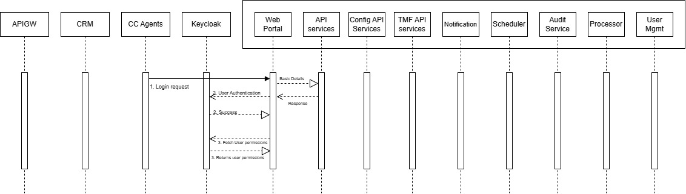
This section provides visual representations of the Case Management (CM) system to help illustrate the deployment topology, service interactions, and data flows across components and external systems.
Figure 2.1: User Login Flow
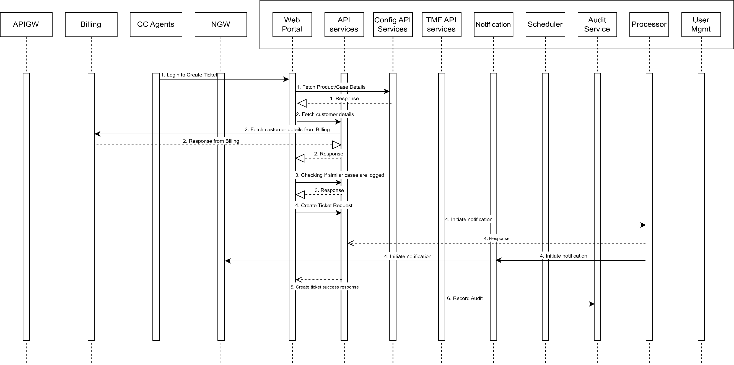
Figure 2.2: Case Creation Lifecycle Flow

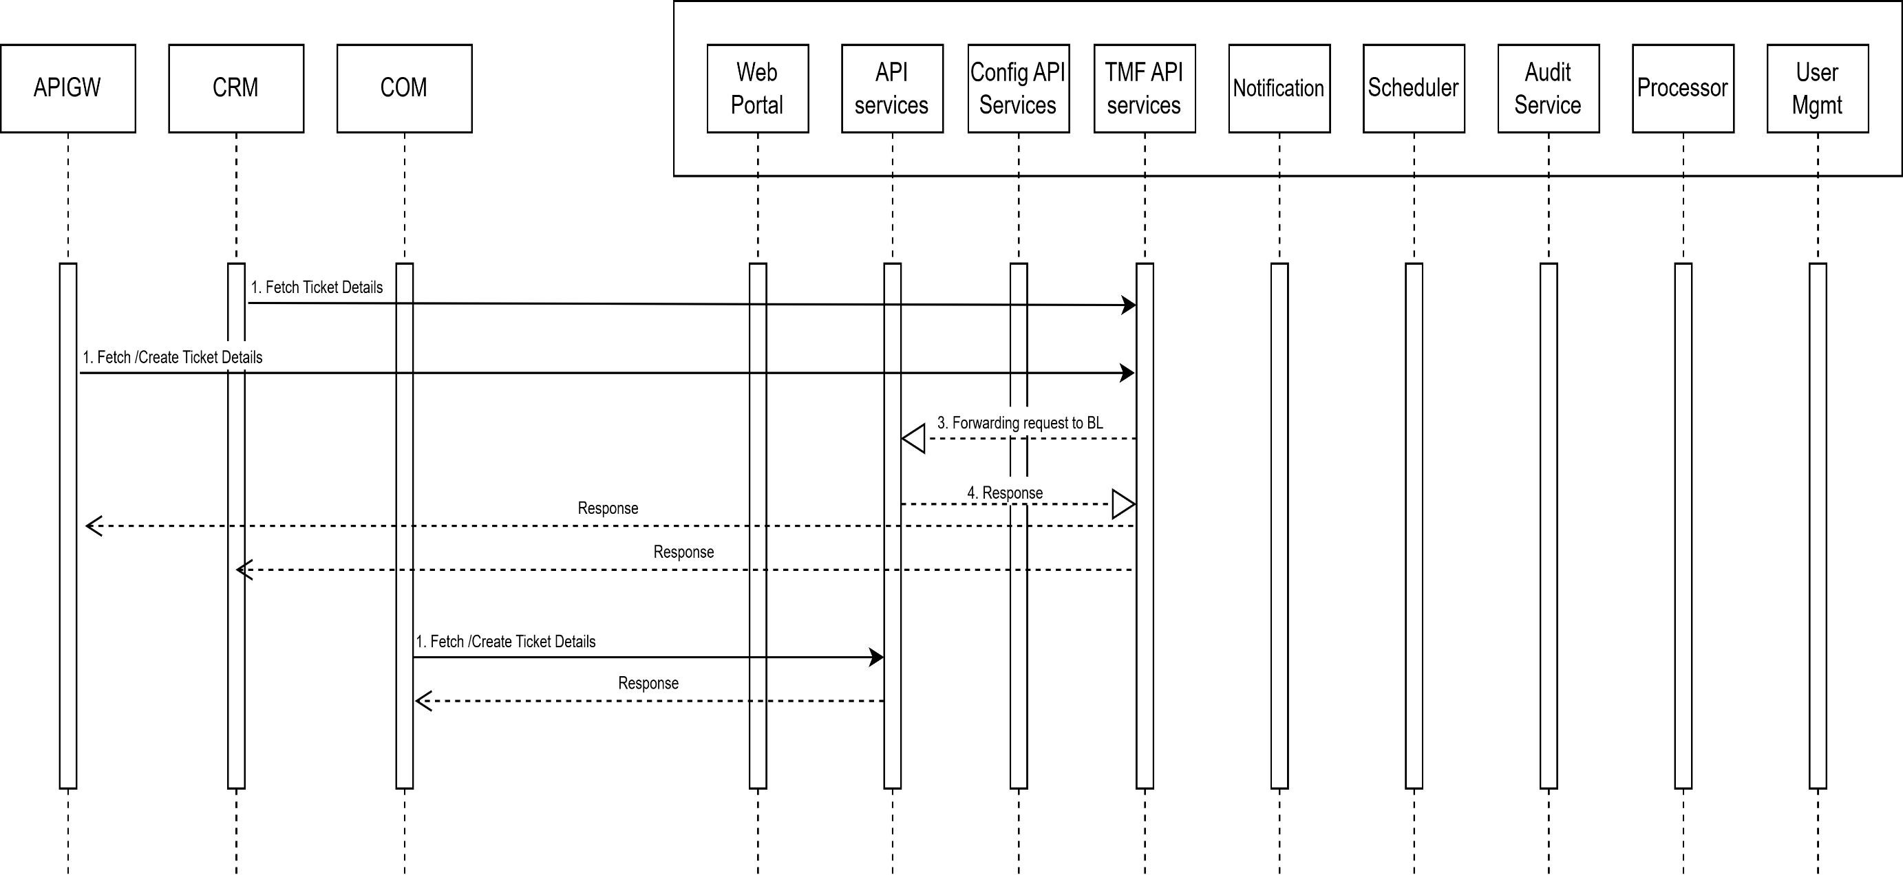
Figure 2.3: Third Party Flow
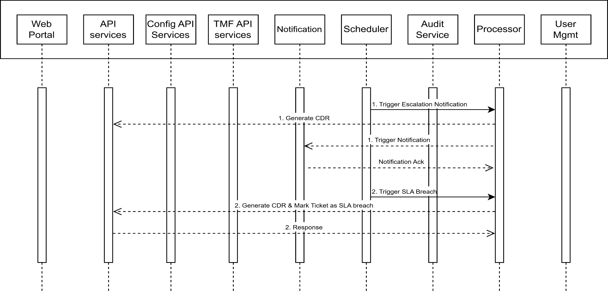
Figure 2.4: SLA/Escalation Flow

Integration Points
The Case Management (CM) application integrates with multiple external systems and infrastructure components to provide a seamless, scalable, and secure enterprise-grade solution. Below is a summary of the key integration points and their roles within the CM ecosystem:
- Keycloak
Provides centralized authentication and token-based access control across the CM application. All UI interactions are secured using tokens issued by Keycloak, ensuring secure and role-based user access.
- UMS (User Management System)
Acts as the master source for user and team data. Whenever user-related operations (e.g., user creation, updates, role assignments) occur in UMS, they are synchronized with the CM system via the cm-user-management microservice to ensure consistency and accuracy.
- NGW (Notification Gateway)
Handles Email and SMS delivery. The cm-notifications service communicates with NGW to send real-time alerts and updates based on ticket lifecycle events such as creation, escalation, and closure.
- Kafka
Serves as the central log streaming and CDR distribution backbone. Filebeat containers push structured logs and CDRs into Kafka topics, which are then consumed by external platforms for monitoring, mediation, reporting, and compliance.
- MySQL InnoDB Cluster via ProxySQL
Acts as the primary data persistence layer for all CM modules. The use of ProxySQL provides connection pooling and high availability across the five-node InnoDB cluster, supporting both transactional integrity and performance.
- NFS (Network File System)
Used for shared storage of logs, file uploads, CDR exports, and configuration assets. It enables persistent, centralized access to file-based data by various CM services and downstream systems (e.g., mediation).
- APIGW (API Gateway)
Third-party systems connect to CM via the API Gateway, which acts as a secure entry point to expose TMF-compliant APIs. The cm-tmf-api-service/cm-api-services handles request processing from external applications routed through APIGW.
- CRM (Customer Relationship Management)
CM is deeply integrated with CRM systems, enabling agents to view customer case information and directly launch the CM interface to create or manage tickets on behalf of users, ensuring a unified support workflow.
- COM (Customer Order Management)
COM is an internal BSS module that is integrated with CM. COM is responsible for creating tickets and uploading the corresponding documents during key business processes such as customer onboarding, service addition, upgrade/downgrade, and technology changes (including AirFiber, APN, and related services). This integration ensures that all relevant service events are captured and tracked in CM with the necessary documentation.
- Billing
CM integrates with the Billing system to fetch and display customer details using identifiers such as MSISDN, Profile ID, or Account ID. This allows case handlers to quickly retrieve accurate and up-to-date billing information while creating each case, ensuring efficient case creation and validation of customer status.
- Reporting
For reporting requirements, CM interacts with the Reporting module, utilizing Pentaho for report generation. When a report is requested, CM calls the reporting module, which executes the relevant PRPT files and database procedures to generate the report. The resulting Pentaho reports are displayed within the CM application interface, allowing users to access operational and analytical data seamlessly.

Kubernetes Deployment Details
The Case Management (CM) application is deployed on a Kubernetes cluster using a modular, microservice-based architecture. The application components are logically grouped into four primary pods (cm-pod-1 to cm-pod-4), each hosting one or more containers based on their functional roles.
Deployments are managed using a GitOps approach via Argo CD, with all resource definitions maintained in YAML files. Configurations are structured using Kustomize overlays to enable environment-specific customization.
Each pod is deployed as a Kubernetes Deployment object and is backed by a set of associated resources, including:
- ConfigMaps for application-level configuration files
- Persistent Volumes (NFS-based) for shared storage
- Secrets for managing sensitive information such as credentials
- Filebeat sidecar containers for log and CDR collection
- Horizontal Pod Autoscalers (HPA) for dynamic scaling based on CPU and memory usage

CM-POD-1
cm-pod-1 hosts the core backend services of the CM application and is a critical component in managing API traffic, third-party integrations, and audit operations.

Overview
Ingress Controller
↓
Service: cm-pod-1 (ClusterIP)
├ Port 4444 (cm-api-services)
├ Port 8888 (cm-tmf-api-services)
└- Port 8090 (cm-audit-service)
↓
Deployment: cm-pod-1
→ cm-api-services Container
- Image: et02-harbor.safaricomet.net/bss/cm/cm-api-services:v1.6.1-prod-40
- Port: 4444
- Resources: CPU: 10000m, Memory: 6000Mi
- External Mounts:
  - /opt/jboss/CDR → /bss-nfs-cdr/CM/CM-CDR
  - /opt/jboss/wildfly/Files → /bss-nfs-doc/CM/CM-FILES
  - /opt/jboss/wildfly/CommonFiles → /bss-nfs-doc/CRM/crm-documents
  - /opt/jboss/wildfly/standalone/log → /bss-nfs-log/CM/cm-api-services/logs
→ cm-tmf-api-services Container
- Image: et02-harbor.safaricomet.net/bss/cm/cm-tmf-api-services:v1.6.1-prod-1
- Port: 8888
- Resources: CPU: 2000m, Memory: 800Mi
- External Mounts:
  - /tmf-services_log → /bss-nfs-log/CM/cm-tmf-api-services/logs
→ cm-audit-service Container
- Image: et02-harbor.safaricomet.net/bss/cm/cm-audit-service:latest-main
- Port: 8090
- Resources: CPU: 2000m, Memory: 500Mi
- External Mounts:
  - /audit_log → /bss-nfs-log/CM/cm-audit-service/logs
→ filebeat-cdrs Container
- Image: et02-harbor.safaricomet.net/bss/filebeat:8.1.1
- Resources: CPU: 204m, Memory: 256Mi
- External Mount:
  - /var/log/cdrs → /bss-nfs-cdr/CM/CM-CDR

→ filebeat-logs Container
- Image: et02-harbor.safaricomet.net/bss/filebeat:8.1.1
- Resources: CPU: 100m, Memory: 256Mi
- External Mounts:
  - /LOGS/ → /bss-nfs-log/CM/cm-api-services/logs
  - /tmf-services_log → /bss-nfs-log/CM/cm-tmf-api-services/logs
  - /audit_log → /bss-nfs-log/CM/cm-audit-service/logs
→ filebeat-out Container
- Image: et02-harbor.safaricomet.net/bss/filebeat:8.1.1
- Resources: CPU: 200m, Memory: 256Mi
- External Mounts:
  - /var/log/cdrs/ → /bss-nfs-log/CDR/CM/CM-CDR
  - /var/log/cdr-out/ → /bss-nfs-cdr/CM/cm-edr-output
→ Monitoring Integration
- cm-api-services-metrics (port 4319), cm-tmf-api-services-metrics (port 8007), cm-audit-service-metrics (port 8006) all annotated for Prometheus scraping.

Summary

Resources

Microservices | Type | Value | Defined File Name
cm-api-services | CPU Limit | 10000m | cm-pod-1-resource-patch.yaml
 | CPU Request | 2000m | cm-pod-1-resource-patch.yaml
 | MEM Limit | 6000Mi | cm-pod-1-resource-patch.yaml
 | MEM Request | 3000Mi | cm-pod-1-resource-patch.yaml
cm-tmf-api-services | CPU Limit | 2000m | cm-pod-1-resource-patch.yaml
 | CPU Request | 500m | cm-pod-1-resource-patch.yaml
 | MEM Limit | 800Mi | cm-pod-1-resource-patch.yaml
 | MEM Request | 500Mi | cm-pod-1-resource-patch.yaml
cm-audit-service | CPU Limit | 2000m | cm-pod-1-resource-patch.yaml
 | CPU Request | 500m | cm-pod-1-resource-patch.yaml
 | MEM Limit | 500Mi | cm-pod-1-resource-patch.yaml
 | MEM Request | 200Mi | cm-pod-1-resource-patch.yaml
filebeat-cdrs | CPU Limit | 204m | cm-pod-1-resource-patch.yaml
 | CPU Request | 100m | cm-pod-1-resource-patch.yaml
 | MEM Limit | 256Mi | cm-pod-1-resource-patch.yaml
 | MEM Request | 94Mi | cm-pod-1-resource-patch.yaml
filebeat-logs | CPU Limit | 100m | cm-pod-1-resource-patch.yaml
 | CPU Request | 90m | cm-pod-1-resource-patch.yaml
 | MEM Limit | 256Mi | cm-pod-1-resource-patch.yaml
 | MEM Request | 204Mi | cm-pod-1-resource-patch.yaml

Mounts

ConfigMap Name | Mounted In | Mount Path / SubPath | Defined In | External Path | DC2 NFS | MDC1 NFS
cm-api-services-standalone | cm-api-services | /opt/jboss/wildfly/standalone/configuration/standalone.xml | kustomization.yaml, deployment.yaml | cm-pod-1-configs/cm-api-services/standalone.xml | NA | NA
cm-api-log4j-config | cm-api-services | /opt/jboss/wildfly/standalone/configuration/log4j2.xml | kustomization.yaml, deployment.yaml | cm-pod-1-configs/cm-api-services/log4j2.xml | NA | NA
cm-standalone-conf-config | cm-api-services | /opt/jboss/wildfly/bin/standalone.conf | kustomization.yaml, deployment.yaml | cm-pod-1-configs/cm-api-services/standalone.conf | NA | NA
cm-tmf-api-services-config | cm-tmf-api-services | /config/application.yaml | kustomization.yaml, deployment.yaml | cm-pod-1-configs/cm-tmf-api-services/application.yaml | NA | NA
cm-audit-service-config | cm-audit-service | /config/application.yaml | kustomization.yaml, deployment.yaml | cm-pod-1-configs/cm-audit-service/application.yaml | NA | NA
cm-api-cdr | cm-api-services, filebeat-out | /opt/jboss/CDR, /var/log/cdrs/ | deployment.yaml,volume-patch.yaml | /bss-nfs-cdr/CM/CM-CDR | mdc2-psc-nfs.safaricomet.net | mdc1-psc-nfs.safaricomet.net
cm-files | cm-api-services | /opt/jboss/wildfly/Files | deployment.yaml,volume-patch.yaml | /bss-nfs-doc/CM/CM-FILES | mdc2-psc-nfs.safaricomet.net | mdc1-psc-nfs.safaricomet.net
cm-common-files | cm-api-services | /opt/jboss/wildfly/CommonFiles | deployment.yaml,volume-patch.yaml | /bss-nfs-doc/CRM/crm-documents | mdc2-psc-nfs.safaricomet.net | mdc1-psc-nfs.safaricomet.net
cm-api-services-log | cm-api-services, filebeat-logs | /opt/jboss/wildfly/standalone/log, /LOGS/ | deployment.yaml (volumeMounts + volumes) | /bss-nfs-log/CM/cm-api-services/logs | mdc2-psc-nfs.safaricomet.net | mdc1-psc-nfs.safaricomet.net
cm-tmf-api-services-log | cm-tmf-api-services, filebeat-logs | /tmf-services_log | deployment.yaml (volumeMounts + volumes) | /bss-nfs-log/CM/cm-tmf-api-services/logs | mdc2-psc-nfs.safaricomet.net | mdc1-psc-nfs.safaricomet.net
cm-audit-service-log | cm-audit-service, filebeat-logs | /audit_log | deployment.yaml (volumeMounts + volumes) | /bss-nfs-log/CM/cm-audit-service/logs | mdc2-psc-nfs.safaricomet.net | mdc1-psc-nfs.safaricomet.net
cm-cdr-out | filebeat-out | /var/log/cdr-out/ | deployment.yaml (volumeMounts + volumes) | /bss-nfs-cdr/CM/cm-edr-output | mdc2-psc-nfs.safaricomet.net | mdc1-psc-nfs.safaricomet.net
cm-filebeat-out-config | filebeat-out | /etc/filebeat-out.yml | deployment.yaml (volumeMounts + volumes) | cm-pod-1-configs/cm-filebeat-out/filebeat-out.yml | NA | NA

Images

Microservice | DC2 Harbor URL | DC2 Tag | MDC1 Harbor URL | MDC1 Tag | Defined in
cm-api-services | et02-harbor.safaricomet.net/bss/cm/cm-api-services | v1.6.1-prod-40 | mdc1-sfcr.safaricomet.net/bss/cm-api-services | v1.6.1-prod-40 | kustomization.yaml
cm-tmf-api-services | et02-harbor.safaricomet.net/bss/cm/cm-tmf-api-services | v1.6.1-prod-1 | mdc1-sfcr.safaricomet.net/bss/cm-tmf-api-services | v1.6.1-prod-1 | kustomization.yaml
cm-audit-service | et02-harbor.safaricomet.net/bss/cm/cm-audit-service | latest-main | mdc1-sfcr.safaricomet.net/bss/cm-audit-service | latest-main | kustomization.yaml
filebeat-cdrs | et02-harbor.safaricomet.net/bss/filebeat | 8.1.1 | mdc1-sfcr.safaricomet.net/bss/filebeat | 8.1.1 | kustomization.yaml
filebeat-logs | et02-harbor.safaricomet.net/bss/filebeat | 8.1.1 | mdc1-sfcr.safaricomet.net/bss/filebeat | 8.1.1 | kustomization.yaml
filebeat-out | et02-harbor.safaricomet.net/bss/filebeat | 8.1.1 | mdc1-sfcr.safaricomet.net/bss/filebeat | 8.1.1 | kustomization.yaml

CM-POD-2
cm-pod-2 is responsible for handling configuration, user management, and serving the user interface (UI) for the CM application. It plays a key role in administrative functions and front-end interaction.

Overview
Ingress Controller
↓
Service: cm-pod-2 (ClusterIP)
├ Port 4444 (cm-web-portal)
├ Port 4464 (cm-config-api-services)
├ Port 6666 (cm-user-management)
↓
Deployment: cm-pod-2
→ cm-web-portal Container
- Image: cm-web-portal:v1.6.1-prod-43
- Port: 4444
- Resources: CPU: 6000m, Memory: 4096Mi
- Volumes:
  - cm-web-portal-standalone (ConfigMap)
    - Mounted at: /opt/jboss/wildfly/standalone/configuration/standalone.xml
  - cm-web-portal-log (NFS)
    - Path: /bss-nfs-log/CM/cm-web-portal/logs
    - Mounted at: /opt/jboss/wildfly/standalone/log
  - cm-files (NFS)
    - Path: /bss-nfs-doc/CM/CM-FILES
    - Mounted at: /opt/jboss/wildfly/Files
  - cm-common-files (NFS)
    - Path: /bss-nfs-doc/CRM/crm-documents
    - Mounted at: /opt/jboss/wildfly/CommonFiles
  - tz-config (hostPath)
    - Path: /usr/share/zoneinfo/Africa/Addis_Ababa
    - Mounted at: /etc/localtime
→ cm-config-api-services Container
- Image: cm-config-api-services:v1.6.1-prod-5
- Port: 4464
- Resources: CPU: 1000m, Memory: 1024Mi
- Volumes:
  - cm-config-api-services-standalone (ConfigMap)
    - Mounted at: /opt/jboss/wildfly/standalone/configuration/standalone.xml
  - cm-config-api-log (NFS)
    - Path: /bss-nfs-log/CM/cm-config-api-services/logs
    - Mounted at: /opt/jboss/wildfly/standalone/log
  - tz-config (hostPath)
    - Path: /usr/share/zoneinfo/Africa/Addis_Ababa
    - Mounted at: /etc/localtime
→ cm-user-management Container
- Image: cm-user-management:v1.6.1-prod-1
- Port: 6666
- Resources: CPU: 300m, Memory: 500Mi
- Volumes:
  - cm-user-management-config (ConfigMap)
    - Mounted at: /config/application.yaml
  - cm-user-management-log (NFS)
    - Path: /bss-nfs-log/CM/cm-user-management/logs
    - Mounted at: /user-management_log
  - tz-config (hostPath)
    - Path: /usr/share/zoneinfo/Africa/Addis_Ababa
    - Mounted at: /etc/localtime
→ filebeat-logs Container
- Image: filebeat-logs:8.1.1
- Resources: CPU: 200m, Memory: 256Mi
- Volumes:
  - cm-filebeat-config (ConfigMap)
    - Mounted at: /etc/filebeat.yml
  - cm-web-portal-log (NFS, read-only)
    - Path: /bss-nfs-log/CM/cm-web-portal/logs
    - Mounted at: /var/LOGS/
  - cm-config-api-log (NFS, read-only)
    - Path: /bss-nfs-log/CM/cm-config-api-services/logs
    - Mounted at: /opt/jboss/wildfly/standalone/log
  - cm-user-management-log (NFS, read-only)
    - Path: /bss-nfs-log/CM/cm-user-management/logs
    - Mounted at: /user-management_log
  - tz-config (hostPath)
    - Path: /usr/share/zoneinfo/Africa/Addis_Ababa
    - Mounted at: /etc/localtime
→ Monitoring Integration
- Prometheus Metrics Service: cm-user-management-metrics
- Port: 8001
- Path: /actuator/Prometheus
- Annotations: Enable scraping via Prometheus for cm-user-management in cm-pod-2
- Prometheus Metrics Service: cm-web-portal-metrics
- Port: 4319
- Path: /metrics
- Annotations: Enable scraping via Prometheus for cm-web-portal in cm-pod-2

- Prometheus Metrics Service: cm-config-api-services-metrics
- Port: 4339
- Path: /metrics
- Annotations: Enable scraping via Prometheus for cm-config-api-services in cm-pod-2

Summary

Resources

Microservices | Type | Value | Defined File Name
cm-web-portal | CPU Limit | 6000m | cm-pod-2-resource-patch.yaml
 | CPU Request | 1000m | cm-pod-2-resource-patch.yaml
 | MEM Limit | 4096Mi | cm-pod-2-resource-patch.yaml
 | MEM Request | 1700Mi | cm-pod-2-resource-patch.yaml
cm-config-api-services | CPU Limit | 1000m | cm-pod-2-resource-patch.yaml
 | CPU Request | 800m | cm-pod-2-resource-patch.yaml
 | MEM Limit | 1024Mi | cm-pod-2-resource-patch.yaml
 | MEM Request | 820Mi | cm-pod-2-resource-patch.yaml
cm-user-management | CPU Limit | 300m | cm-pod-2-resource-patch.yaml
 | CPU Request | 240m | cm-pod-2-resource-patch.yaml
 | MEM Limit | 500Mi | cm-pod-2-resource-patch.yaml
 | MEM Request | 200Mi | cm-pod-2-resource-patch.yaml
filebeat-logs | CPU Limit | 200m | cm-pod-2-resource-patch.yaml
 | CPU Request | 160m | cm-pod-2-resource-patch.yaml
 | MEM Limit | 256Mi | cm-pod-2-resource-patch.yaml
 | MEM Request | 204Mi | cm-pod-2-resource-patch.yaml

Mounts

ConfigMap Name | Mounted In | Mount Path / SubPath | Defined In | External Path | DC2 NFS | MDC1 NFS
cm-web-portal-config | cm-web-portal | /config/application.yaml | kustomization.yaml, deployment.yaml | cm-pod-2-configs/cm-web-portal/application.yaml | NA | NA
cm-config-api-services-config | cm-config-api-services | /config/application.yaml | kustomization.yaml, deployment.yaml | cm-pod-2-configs/cm-config-api-services/application.yaml | NA | NA
cm-user-management-config | cm-user-management | /config/application.yaml | kustomization.yaml, deployment.yaml | cm-pod-2-configs/cm-user-management/application.yaml | NA | NA
cm-web-portal-log | cm-web-portal, filebeat-logs | /var/LOGS | deployment.yaml (volumeMounts + volumes) | /bss-nfs-log/CM/cm-web-portal/logs | mdc2-psc-nfs.safaricomet.net | mdc1-psc-nfs.safaricomet.net
cm-config-api-log | cm-config-api-services, filebeat-logs | /opt/jboss/wildfly/standalone/log | deployment.yaml (volumeMounts + volumes) | /bss-nfs-log/CM/cm-config-api-services/logs | mdc2-psc-nfs.safaricomet.net | mdc1-psc-nfs.safaricomet.net
cm-user-management-log | cm-user-management, filebeat-logs | /user-management_log | deployment.yaml (volumeMounts + volumes) | /bss-nfs-log/CM/cm-user-management/logs | mdc2-psc-nfs.safaricomet.net | mdc1-psc-nfs.safaricomet.net
cm-files | cm-web-portal | /opt/jboss/wildfly/Files | deployment.yaml (volumeMounts + volumes) | /bss-nfs-doc/CM/CM-FILES | mdc2-psc-nfs.safaricomet.net | mdc1-psc-nfs.safaricomet.net
cm-common-files | cm-web-portal | /opt/jboss/wildfly/CommonFiles | deployment.yaml (volumeMounts + volumes) | /bss-nfs-doc/CRM/crm-documents | mdc2-psc-nfs.safaricomet.net | mdc1-psc-nfs.safaricomet.net

Images

Microservice | DC2 Harbor URL | DC2 Tag | MDC1 Harbor URL | MDC1 Tag | Defined In
cm-web-portal | et02-harbor.safaricomet.net/bss/cm/cm-web-portal | v1.6.1-prod-43 | mdc1-sfcr.safaricomet.net/bss/cm-web-portal | v1.6.1-prod-43 | kustomization.yaml
cm-config-api-services | et02-harbor.safaricomet.net/bss/cm/cm-config-api-services | v1.6.1-prod-5 | mdc1-sfcr.safaricomet.net/bss/cm-config-api-services | v1.6.1-prod-5 | kustomization.yaml
cm-user-management | et02-harbor.safaricomet.net/bss/cm/cm-user-management | v1.6.1-prod-1 | mdc1-sfcr.safaricomet.net/bss/cm-user-management | v1.6.1-prod-1 | kustomization.yaml
filebeat-logs | et02-harbor.safaricomet.net/bss/filebeat | 8.1.1 | mdc1-sfcr.safaricomet.net/bss/filebeat | 8.1.1 | kustomization.yaml

CM-POD-3
cm-pod-3 is focused on bulk ticket creation, notification dispatch, and orchestrating event-based logic.

Overview
Ingress Controller
↓
Service: cm-pod-3 (ClusterIP)
├ Port 8826 (cm-processor)
├ Port 8830 (cm-notification)
├ Port 8497 (cm-bulkticket-services)
↓
Deployment: cm-pod-3
→ cm-processor Container
- Image: et02-harbor.safaricomet.net/bss/cm/cm-processor:v1.6.1-prod-3
- Port: 8826
- Resources: CPU: 300m, Memory: 800Mi
- Volumes:
  - cm-processor-config (ConfigMap)
    - Mounted at: /config/application.yaml
  - cm-processor-log (NFS)
    - Path: /bss-nfs-log/CM/cm-processor/logs
    - Mounted at: /processor_log
  - tz-config (hostPath)
    - Path: /usr/share/zoneinfo/Africa/Addis_Ababa
    - Mounted at: /etc/localtime
→ cm-notification Container
- Image: et02-harbor.safaricomet.net/bss/cm/cm-notification:v1.6.1-prod-2
- Port: 8830
- Resources: CPU: 300m, Memory: 800Mi
- Volumes:
  - cm-notification-config (ConfigMap)
    - Mounted at: /config/application.yaml
  - cm-notification-log (NFS)
    - Path: /bss-nfs-log/CM/cm-notification/logs
    - Mounted at: /notification_log
  - tz-config (hostPath)
    - Path: /usr/share/zoneinfo/Africa/Addis_Ababa
    - Mounted at: /etc/localtime
→ cm-bulkticket-services Container
- Image: et02-harbor.safaricomet.net/bss/cm/cm-bulkticket-services:latest-main
- Port: 8497
- Resources: CPU: 200m, Memory: 500Mi
- Volumes:
  - cm-bulkticket-services-config (ConfigMap)
    - Mounted at: /config/application.properties
  - cm-files (NFS)
    - Path: /bss-nfs-doc/CM/CM-FILES
    - Mounted at: /opt/jboss/wildfly/Files
  - cm-common-files (NFS)
    - Path: /bss-nfs-doc/CRM/crm-documents
    - Mounted at: /opt/jboss/wildfly/CommonFiles
  - cm-bulkticket-services-log (NFS)
    - Path: /bss-nfs-log/CM/cm-batch-processor/logs
    - Mounted at: /BulkTicket_log
  - tz-config (hostPath)
    - Path: /usr/share/zoneinfo/Africa/Addis_Ababa
    - Mounted at: /etc/localtime
→ filebeat-logs Container
- Image: et02-harbor.safaricomet.net/bss/filebeat:8.1.1
- Resources: CPU: 200m, Memory: 256Mi
- Volumes:
  - cm-filebeat-config (ConfigMap)
    - Mounted at: /etc/filebeat.yml
  - cm-processor-log (NFS, read-only)
    - Path: /bss-nfs-log/CM/cm-processor/logs
    - Mounted at: /processor_log
  - cm-notification-log (NFS, read-only)
    - Path: /bss-nfs-log/CM/cm-notification/logs
    - Mounted at: /notification_log
  - cm-bulkticket-services-log (NFS, read-only)
    - Path: /bss-nfs-log/CM/cm-batch-processor/logs
    - Mounted at: /BulkTicket_log
  - tz-config (hostPath)
    - Path: /usr/share/zoneinfo/Africa/Addis_Ababa
    - Mounted at: /etc/localtime
→ Monitoring Integration
- Prometheus Metrics Service: cm-processor-metrics
- Port: 8004
- Path: /actuator/prometheus
- Annotations: Enable scraping via Prometheus for cm-processor in cm-pod-3

- Prometheus Metrics Service: cm-notification-metrics
- Port: 8003
- Path: /actuator/prometheus
- Annotations: Enable scraping via Prometheus for cm-notification in cm-pod-3

- Prometheus Metrics Service: cm-bulkticket-services-metrics
- Port: 8005
- Path: /actuator/prometheus
- Annotations: Enable scraping via Prometheus for cm-bulkticket-services in cm-pod-3

Summary

Resources

Microservices | Type | Value | Defined File Name
cm-processor | CPU Limit | 300m | cm-pod-3-resource-patch.yaml
 | CPU Request | 240m | cm-pod-3-resource-patch.yaml
 | MEM Limit | 800Mi | cm-pod-3-resource-patch.yaml
 | MEM Request | 600Mi | cm-pod-3-resource-patch.yaml
cm-notification | CPU Limit | 300m | cm-pod-3-resource-patch.yaml
 | CPU Request | 240m | cm-pod-3-resource-patch.yaml
 | MEM Limit | 800Mi | cm-pod-3-resource-patch.yaml
 | MEM Request | 640Mi | cm-pod-3-resource-patch.yaml
cm-bulkticket-services | CPU Limit | 200m | cm-pod-3-resource-patch.yaml
 | CPU Request | 160m | cm-pod-3-resource-patch.yaml
 | MEM Limit | 500Mi | cm-pod-3-resource-patch.yaml
 | MEM Request | 200Mi | cm-pod-3-resource-patch.yaml
filebeat-logs | CPU Limit | 200m | cm-pod-3-resource-patch.yaml
 | CPU Request | 160m | cm-pod-3-resource-patch.yaml
 | MEM Limit | 256Mi | cm-pod-3-resource-patch.yaml
 | MEM Request | 204Mi | cm-pod-3-resource-patch.yaml

Mounts

ConfigMap Name | Mounted In | Mount Path / SubPath | Defined In | External Path | DC2 NFS | MDC1 NFS
cm-processor-config | cm-processor | /config/application.yaml | kustomization.yaml, deployment.yaml | cm-pod-3-configs/cm-processor/application.yaml | NA | NA
cm-notification-config | cm-notification | /config/application.yaml | kustomization.yaml, deployment.yaml | cm-pod-3-configs/cm-notification/application.yaml | NA | NA
cm-bulkticket-services-config | cm-bulkticket-services | /config/application.yaml | kustomization.yaml, deployment.yaml | cm-pod-3-configs/cm-bulkticket-services/application.yaml | NA | NA
cm-processor-log | cm-processor, filebeat-logs | /processor_log | deployment.yaml (volumeMounts + volumes) | /bss-nfs-log/CM/cm-processor/logs | mdc2-psc-nfs.safaricomet.net | mdc1-psc-nfs.safaricomet.net
cm-notification-log | cm-notification, filebeat-logs | /notification_log | deployment.yaml (volumeMounts + volumes) | /bss-nfs-log/CM/cm-notification/logs | mdc2-psc-nfs.safaricomet.net | mdc1-psc-nfs.safaricomet.net
cm-bulkticket-services-log | cm-bulkticket-services, filebeat-logs | /BulkTicket_log | deployment.yaml (volumeMounts + volumes) | /bss-nfs-log/CM/cm-batch-processor/logs | mdc2-psc-nfs.safaricomet.net | mdc1-psc-nfs.safaricomet.net
cm-files | cm-processor | /opt/jboss/wildfly/Files | deployment.yaml (volumeMounts + volumes) | /bss-nfs-doc/CM/CM-FILES | mdc2-psc-nfs.safaricomet.net | mdc1-psc-nfs.safaricomet.net
cm-common-files | cm-processor | /opt/jboss/wildfly/CommonFiles | deployment.yaml (volumeMounts + volumes) | /bss-nfs-doc/CRM/crm-documents | mdc2-psc-nfs.safaricomet.net | mdc1-psc-nfs.safaricomet.net

Images

Microservice | DC2 Harbor URL | DC2 Tag | MDC1 Harbor URL | MDC1 Tag | Defined in
cm-processor | et02-harbor.safaricomet.net/bss/cm/cm-processor | v1.6.1-prod-3 | mdc1-sfcr.safaricomet.net/bss/cm-processor | v1.6.1-prod-3 | kustomization.yaml
cm-notification | et02-harbor.safaricomet.net/bss/cm/cm-notification | v1.6.1-prod-2 | mdc1-sfcr.safaricomet.net/bss/cm-notification | v1.6.1-prod-2 | kustomization.yaml
cm-bulkticket-services | et02-harbor.safaricomet.net/bss/cm/cm-bulkticket-services | latest-main | mdc1-sfcr.safaricomet.net/bss/cm-bulkticket-services | latest-main | kustomization.yaml

CM-POD-4
cm-pod-4 runs the scheduler service, which manages all time-based operations such as SLA breach detection and ticket hard closure.

Overview
Ingress Controller
↓
Service: cm-pod-4 (ClusterIP)
└── Port 8846 (cm-scheduler)
↓
Deployment: cm-pod-4
→ cm-scheduler Container
- Image: et02-harbor.safaricomet.net/bss/cm/cm-scheduler:v1.6.1-prod-6
- Port: 8846
- Resources: CPU: 300m, Memory: 800Mi
- Volumes:
  - cm-scheduler-config (ConfigMap)
    - Mounted at: /config/application.yaml
  - cm-scheduler-log (NFS)
    - Path: /bss-nfs-log/CM/cm-scheduler/logs
    - Mounted at: /scheduler_log
  - tz-config (hostPath)
    - Path: /usr/share/zoneinfo/Africa/Addis_Ababa
    - Mounted at: /etc/localtime
→ filebeat-logs Container
- Image: et02-harbor.safaricomet.net/bss/filebeat:8.1.1
- Resources: CPU: 200m, Memory: 256Mi
- Volumes:
  - cm-filebeat-config (ConfigMap)
    - Mounted at: /etc/filebeat.yml
  - cm-scheduler-log (NFS, read-only)
    - Path: /bss-nfs-log/CM/cm-scheduler/logs
    - Mounted at: /scheduler_log
  - tz-config (hostPath)
    - Path: /usr/share/zoneinfo/Africa/Addis_Ababa
    - Mounted at: /etc/localtime
→ Monitoring Integration
- Prometheus Metrics Service: cm-scheduler-metrics
  - Port: 8002
  - Path: /actuator/prometheus
  - Annotations enable scraping via Prometheus for cm-pod-4

Summary

Resources

Microservices | Type | Value | Defined File Name
cm-scheduler | CPU Limit | 300m | cm-pod-4-resource-patch.yaml
 | CPU Request | 240m | cm-pod-4-resource-patch.yaml
 | MEM Limit | 800Mi | cm-pod-4-resource-patch.yaml
 | MEM Request | 640Mi | cm-pod-4-resource-patch.yaml
filebeat-logs | CPU Limit | 200m | cm-pod-4-resource-patch.yaml
 | CPU Request | 160m | cm-pod-4-resource-patch.yaml
 | MEM Limit | 256Mi | cm-pod-4-resource-patch.yaml
 | MEM Request | 204Mi | cm-pod-4-resource-patch.yaml

Mounts

ConfigMap Name | Mounted In | Mount Path / SubPath | Defined In | External Path | DC2 NFS | MDC1 NFS
cm-scheduler-config | cm-scheduler | /config/application.yaml | kustomization.yaml, deployment.yaml | cm-pod-4-configs/cm-scheduler/application.yaml | NA | NA
cm-scheduler-log | cm-scheduler, filebeat-logs | /scheduler_log | deployment.yaml (volumeMounts + volumes) | /bss-nfs-log/CM/cm-scheduler/logs | mdc2-psc-nfs.safaricomet.net | mdc1-psc-nfs.safaricomet.net

Images

Microservice | DC2 Harbor URL | DC2 Tag | MDC1 Harbor URL | MDC1 Tag | Defined in
cm-scheduler | et02-harbor.safaricomet.net/bss/cm/cm-scheduler | v1.6.1-prod-6 | mdc1-sfcr.safaricomet.net/bss/cm-scheduler | v1.6.1-prod-6 | kustomization.yaml
filebeat-logs | et02-harbor.safaricomet.net/bss/filebeat | 8.1.1 | mdc1-sfcr.safaricomet.net/bss/filebeat | 8.1.1 | kustomization.yaml

CM-PROXYSQL-POD

Overview
Service: cm-proxysql (ClusterIP)
└── Port 6033 (MySQL Access for Services)
↓
Deployment: cm-proxysql-pod
→ proxysql Container
- Image: et02-harbor.safaricomet.net/bss/proxysql/proxysql:2.4.4
- Ports:
- 6033 → MySQL interface
- 6032 → Admin interface
- Environment Variables:
- TZ sourced from cm-pod-tz ConfigMap (Africa/Addis_Ababa)
- Resources:
- Requests: CPU: 800m, Memory: 512Mi
- Limits: CPU: 1000m, Memory: 1000Mi
- Probes:
- StartupProbe: Checks ProxySQL runtime servers for ONLINE status
- ReadinessProbe: Ensures hostgroup 2 servers are online before marking pod as ready
- LivenessProbe: Verifies ProxySQL is running with a valid MySQL connection
- External Mounts:
- /etc/proxysql.cnf → from ConfigMap cm-proxysql (subPath: proxysql.cnf)
- DNS Config:
- single-request-reopen enabled for DNS stability in multi-A records environments
→ Horizontal Pod Autoscaler
- Min Replicas: 1
- Max Replicas: 2
- Triggers:
- CPU usage ≥ 90%
- Memory usage ≥ 90%
- Scale Down Behavior:
- Stabilization window: 300 seconds
- Policy: Scale down 100% in 15 seconds
→ Pod Disruption Budget
- MinAvailable: 1 pod always available
- Selector: app-group: cm
→ Service Exposure
- Service Name: cm-proxysql
- Type: ClusterIP
- Port: 6033 (MySQL access for internal CM services)

Summary

Resources

Microservices | Type | Value | Defined File Name
proxysql | CPU Limit | 1000m | cm-proxy-pod-resource-patch.yaml
 | CPU Request | 800m | cm-proxy-pod-resource-patch.yaml
 | MEM Limit | 1000Mi | cm-proxy-pod-resource-patch.yaml
 | MEM Request | 512Mi | cm-proxy-pod-resource-patch.yaml

Mounts

ConfigMap Name | Mounted In | Mount Path / SubPath | Defined In | External Path | DC2 NFS | MDC1 NFS
cm-proxysql | proxysql | /etc/proxysql.cnf | kustomization.yaml, deployment.yaml | cm-proxy-pod-configs/proxysql.cnf | NA | NA

Images

Microservice | DC2 Harbor URL | DC2 Tag | MDC1 Harbor URL | MDC1 Tag | Defined in
proxysql | et02-harbor.safaricomet.net/bss/proxysql/proxysql | 2.4.4 | mdc1-sfcr.safaricomet.net/bss/proxysql | 2.4.4 | kustomization.yaml

Microservices Overview & Configurations
The Case Management (CM) application relies on a set of key configuration files that govern its runtime behaviour across different environments. These configurations include data source definitions, logging settings, system properties, and service-specific parameters. All configuration files are maintained in a centralized Git repository and are organized using environment-specific overlay directories. This structure allows for consistent configuration management across UAT, production, and other environments.
When changes are required, users can clone the Git repository to their local machine, update the relevant configuration files under the appropriate overlay directory, and commit the changes. Once changes are pushed to the remote repository, they can be applied to the target environment via Argo CD, which handles synchronization and deployment. This GitOps-based approach ensures that configuration changes are traceable, auditable, and aligned with best practices for continuous delivery.

CM-POD-1

cm-api-services
The API Services module serves as the core backend component of the Case Management (CM) application. It is responsible for handling the primary business logic and processing all incoming requests related to ticket operations. The UI service interacts extensively with this module to perform actions such as creating, viewing, updating, and managing tickets throughout their lifecycle. As a critical component of the system, the API Services module is tightly integrated with various internal services and external systems.

standalone.cnf

The standalone.cnf file (sometimes also referred to as standalone.conf in WildFly/JBoss deployments) is used to configure JVM-level and environment-specific settings for a JBoss/WildFly application server running in standalone mode.
Path: cm/cm-pod-1/standalone.cnf
JAVA_OPTS="-Xms2048m -Xmx3200m -XX:MetaspaceSize=512M -XX:MaxMetaspaceSize=700m -Djava.net.preferIPv4Stack=true"

Option | Purpose
-Xms2048m | Sets the initial heap size to 2 GB
-Xmx3200m | Sets the maximum heap size to 3.2 GB
-XX:MetaspaceSize=512M | Initial size for Metaspace (class metadata memory)
-XX:MaxMetaspaceSize=700M | Maximum size Metaspace can grow to
-Djava.net.preferIPv4Stack | Ensures IPv4 is used if both IPv4 and IPv6 are available

standalone.xml
Defines the JBoss/WildFly server configuration, including the datasource, logging, and subsystem settings.
Path: cm/cm-pod-1/cm-api-services/standalone.xml
- Datasource Configuration
<datasource jndi-name="java:jboss/datasources/MySqlDS" pool-name="MySqlDS" enabled="true" use-java-context="true">
<connection-url>jdbc:mysql://cm-proxysql:6033/WKN_CM?autoReconnect=true&amp;useSSL=true&amp;serverTimezone=EAT&amp;useUnicode=true&amp;characterEncoding=utf8</connection-url>
<driver>mysql</driver>
<pool>
<min-pool-size>10</min-pool-size>
<max-pool-size>30</max-pool-size>
<prefill>true</prefill>
</pool>
<security>
<user-name>cmpod1user</user-name>
<password>xxxxx</password>
</security>
</datasource>
- JNDI Name (`java:jboss/datasources/MySqlDS`): Used by apps to access database.
- Connection URL includes parameters like autoReconnect, SSL, timezone, and encoding.
- Min-pool-size and Max-pool-size set limits on DB connections for efficiency.

- Logging Configuration
<periodic-rotating-file-handler name="FILE" autoflush="false">
<formatter>
<named-formatter name="PATTERN"/>
</formatter>
<file relative-to="jboss.server.log.dir" path="${jboss.node.name}-cm-api-services.log"/>
<suffix value=".yyyy-MM-dd"/>
<append value="true"/>
</periodic-rotating-file-handler>
- Enables daily rotation of logs.
- Archives logs with date suffix for easy troubleshooting.
- Stored in WildFly’s log directory.
- Enable different log levels (e.g., INFO, DEBUG, ERROR) based on the environment

- Detailed Logging Handlers & Formatters
<console-handler name="CONSOLE">
<level name="INFO"/>
<formatter>
<named-formatter name="COLOR-PATTERN"/>
</formatter>
</console-handler>
<periodic-rotating-file-handler name="FILE" autoflush="false">
<formatter>
<named-formatter name="PATTERN"/>
</formatter>
<file relative-to="jboss.server.log.dir" path="${jboss.node.name}-cm-api-services.log"/>
<suffix value=".yyyy-MM-dd"/>
<append value="true"/>
</periodic-rotating-file-handler>
<logger category="com.arjuna">
<level name="ERROR"/>
</logger>
<logger category="io.jaegertracing.Configuration">
<level name="ERROR"/>
</logger>
<logger category="org.jboss.as.config">
<level name="ERROR"/>
</logger>
<logger category="sun.rmi">
<level name="ERROR"/>
</logger>
<logger category="com.sixdee.imp">
<level name="INFO"/>
</logger>
<root-logger>
<level name="INFO"/>
<handlers>
<handler name="CONSOLE"/>
<handler name="FILE"/>
</handlers>
</root-logger>
<formatter name="PATTERN">
<pattern-formatter pattern="[CM]::[API-SERVICES]::[${jboss.node.name}]::[%d]::[%t]::[%X{traceId}]::[%X{transactionId}]::[%-4p]::[%X{LOG_TAG}]::[%m]%n"/>
</formatter>
<formatter name="COLOR-PATTERN">
<pattern-formatter pattern="[CM]::[API-SERVICES]::[${jboss.node.name}]::[%d]::[%t]::[%X{traceId}]::[%X{transactionId}]::[%-4p]::[%X{LOG_TAG}]::[%m]%n"/>
</formatter>
- Console-handler outputs log messages to the console with INFO level, useful for real-time debugging.
- Periodic-rotating-file-handler writes logs to files daily, creating archives with a date suffix.
- Specific loggers (like com.arjuna, io.jaegertracing) are set to ERROR to limit detailed logging.
- Root-logger captures general logs at INFO level, sending them to both file and console.
- Custom pattern formatter includes detailed contextual information like timestamp, thread ID, trace IDs, log level, and custom tags.
- Enable different log levels (e.g., INFO, DEBUG, ERROR) based on the environment

- Network & Socket Bindings
<socket-binding-group name="standard-sockets" default-interface="public">
<socket-binding name="http" port="4444"/>
<socket-binding name="https" port="4123"/>
<socket-binding name="management-http" interface="management" port="4319"/>
</socket-binding-group>

- HTTP port (4444) for regular web traffic.

log4j.xml

The following configuration defines a RollingRandomAccessFile Appender for logging Call Detail Records (CDRs) in the Case Management (CM) application.
Path: cm/cm-pod-1/cm-api-services/log4j.xml
- RollingRandomAccessFile Appender
<RollingRandomAccessFile append="true"
name="TICKETING_CDR_QUEUE_NAME"
fileName="/opt/jboss/CDR/${env:MY_POD_NAME}_ticket-cdr.txt"
filePattern="/opt/jboss/CDR/${env:MY_POD_NAME}_ticket-cdr_%d{yyyyMMddHHmmss}_%i.txt">
<PatternLayout>
<Pattern>%m%n</Pattern>
</PatternLayout>
<Policies>
<TimeBasedTriggeringPolicy interval="600" modulate="true"/>
</Policies>
</RollingRandomAccessFile>

Element | Description
RollingRandomAccessFile | Defines a rolling file appender optimized for performance and frequent writes.
append="true" | Ensures logs are appended to the existing file instead of overwriting it.
name="TICKETING_CDR_QUEUE_NAME" | Unique name identifier for this appender, usually mapped in logger categories.
fileName | Sets the current active log file path. ${env:MY_POD_NAME} dynamically inserts the pod name (used in Kubernetes) to separate logs per pod instance.
filePattern | Defines the naming pattern for archived log files, with timestamp (yyyyMMddHHmmss) and rollover index (%i).
PatternLayout | Specifies the format of each log entry. Here, only the message (%m) followed by a newline (%n) is written—ideal for clean, structured CDR logs.
TimeBasedTriggeringPolicy | Triggers log file rollover every 600 seconds (10 minutes). modulate="true" aligns rollover to wall-clock time for consistency.

cm-audit-service
The cm-audit-service is responsible for auditing all create, update, and delete operations initiated through the Case Management (CM) user interface. It captures detailed metadata for each action, including the user who performed the operation, the nature of the change, the affected entity, timestamps, and originating IP address. This service ensures accountability, traceability, and compliance by maintaining a persistent audit trail that can be queried for investigations, compliance reporting, or debugging.

application.yaml
Contains Spring Boot-related configurations such as thread pools, URLs for dependent services, feature flags, and timeout values.
Path: cm/cm-pod-1/cm-audit-service/application.yaml
datasource:
url: jdbc:mysql://cm-proxysql:6033/WKN_CM
username: cmpod1user
password: xxxxxx
hikari.minimum-pool-size: 10
hikari.maximum-pool-size: 15

- URL: Database connection details (host: cm-proxysql, port: 6033, database: WKN_CM).
- Username/Password: Database credentials.
- Hikari Pool Settings:
- Manages database connection pool efficiently.
- Minimum pool size: 10
- Maximum pool size: 15
logging:
file:
path: ./audit_log/
pattern:
console: "[CM]::[AUDIT-SERVICES]::[cm-pod-1]::[%d]::[%t]::[%X{traceId}]::[%X{transactionId}]::[%level]::[%X{LOG_TAG}]::[%msg]%n"
file: "[CM]::[AUDIT-SERVICES]::[cm-pod-1]::[%d]::[%t]::[%X{traceId}]::[%X{transactionId}]::[%level]::[%X{LOG_TAG}]::[%msg]%n"
- File Path: ./audit_log/

- Directory where logs are stored.

- Log Patterns:

Customized log format for easy identification, tracing, and debugging:

  - [CM]: Identifies logs from Case Management application.
  - [AUDIT-SERVICES]: Indicates the specific service/component logging the message.
  - [cm-pod-1]: Indicates specific instance or pod.
  - %d: Timestamp.
  - %t: Thread name.
  - %X{traceId} & %X{transactionId}: Correlation IDs for distributed tracing.
  - %level: Log level (INFO, DEBUG, ERROR, etc.).
  - %X{LOG_TAG}: Additional custom tag.
  - %msg: Actual log message.
server:
port: 8090
servlet:
contextPath: /CM-AUDIT-SERVICE
- Port: 8090

  - Defines port for application HTTP endpoint.

- Context Path: /CM-AUDIT-SERVICE

- Application root context URL path.

cm-tmf-api-Services
The tmf-api-services module is designed to handle incoming requests from third-party systems and adheres to the TM Forum Open API (TMF) standards. This ensures seamless and standardized integration with external platforms such as CRM & other third-party (outside BSS).

application.yaml

Contains Spring Boot-related configurations such as thread pools, URLs for dependent services, feature flags, and timeout values.
Path: cm/cm-pod-1/ cm-tmf-api-services/ application.yaml
server:
port: 8888
servlet:
contextPath: /TMF
TTM_BASE_URL: TTM_ROOT_URL
CM_CONFIG_ROOT_URL: CM_CONFIG_ROOT_URL
TMF_API_URL : TMF_API_URL
TTM_CASE_VIEW_URL: /viewTickets
TTM_CASE_CREATE_URL: /createTicket
TTM_NOTE_CREATE_URL: /addTicketNote
- server.port: 8888
The application runs on port 8888. This is the main HTTP port exposed for TMF API Services.

- server.servlet.contextPath: /TMF
All endpoints in this application will be prefixed with /TMF, e.g., /TMF/viewTickets.

- Service URLs and Endpoints:
These are configuration keys (likely overridden via environment variables or Kubernetes config maps) used to communicate with other services:

  - TTM_BASE_URL points to the root URL for Ticketing APIs.
  - CM_CONFIG_ROOT_URL is for configuration services in the CM suite.
  - TMF_API_URL is the base for TM Forum-compliant APIs.
  - The /viewTickets, /createTicket, and /addTicketNote paths define specific resource endpoints.
logging:
file:
path: ./tmf-services_log/
pattern:
console: "[CM]::[TMF-API-SERVICES]::[cm-pod-1]::[%d]::[%t]::[%X{traceId}]::[%X{transactionId}]::[%level]::[%X{LOG_TAG}]::[%msg]%n"
file: "[CM]::[TMF-API-SERVICES]::[cm-pod-1]::[%d]::[%t]::[%X{traceId}]::[%X{transactionId}]::[%level]::[%X{LOG_TAG}]::[%msg]%n"
level:
com:
sixdee:
imp:
cm: DEBUG
- Logging Configuration:
Logs are written to the ./tmf-services_log/ directory.

  - The console and file logs share the same pattern, which includes:

    - Timestamps, thread ID, trace ID, transaction ID, log level, and a custom tag (LOG_TAG).
    - Helps in distributed tracing and debugging.

datasource:
url: jdbc:mysql://cm-proxysql:6033/WKN_CM
username: cmpod1user
password: xxxxxx
hikari.minimum-pool-size: 10
hikari.maximum-pool-size: 15
- Datasource:

- Connects to MySQL DB at cm-proxysql on port 6033 and database WKN_CM.
- Uses cmpod1user credentials.
- HikariCP is configured with a minimum of 10 and maximum of 15 connections.

Filebeat
The filebeat service is used to efficiently manage and forward logs generated by various components of the Case Management (CM) application. It performs two critical functions:
- Log Forwarding to Kafka: Filebeat collects logs from application containers—such as cm-api-services, cm-scheduler, cm-processor, and others—and pushes them to a configured Kafka topic. These logs are then consumed by downstream systems for real-time monitoring, centralized logging, or alert generation.
- CDR Export for Mediation and Reporting: In addition to log forwarding, a dedicated Filebeat instance collects CDRs from specified directories (e.g., /opt/jboss/CDR/) and routes them either to Kafka or writes them to a designated NFS-mounted directory. These CDR files are used by external systems for mediation and SLA reporting.

CDR filebeat-out.yml

The filebeat-out.yml configuration is specifically designed to handle the post-processing of CDRs generated by the CM application (cm-api-services). These CDRs, initially written in .txt format within the application directory, need to be transformed and moved to a designated output directory from which downstream reporting or mediation modules can pick them up.
This Filebeat configuration performs the following key functions:
- Reads raw CDR .txt files from the application's internal path, typically mounted as a volume (e.g., /var/log/cdrs/).
- Processes and reformats the content into Newline Delimited JSON (NDJSON) format, which is a structured format preferred for machine-readable ingestion.
- Writes the transformed data to an output directory (e.g., /var/log/cdr-out/), where the mediation layer or external reporting service fetches the files for further processing and billing purposes.
The transformation from .txt to .ndjson ensures compatibility with downstream systems that rely on structured data formats for parsing, filtering, and aggregation.
Path: cm/cm-pod-1/cm-filebeat-out/ filebeat-out.yml
filebeat.inputs:
- type: log
tail_files: true
paths:
- /var/log/cdrs/${MY_POD_NAME}*.txt
document_type: cm-ticket-edr-mdc1
output.file:
path: "/var/log/cdr-out/"
filename: cm-ticket-edr-mdc1
rotate_every_kb: 1000
number_of_files: 100
permissions: 0666
rotate_on_startup: true
codec.format:
string: '%{[message]}'
- Input Section
- type: log
Specifies that Filebeat should monitor plain text log files.
- tail_files: true
Instructs Filebeat to read only new logs (tailing) instead of reading files from the beginning. This is useful in containers or when logs are rotated frequently.
- paths: /var/log/cdrs/${MY_POD_NAME}*.txt
This path includes a variable ${MY_POD_NAME} (injected at runtime via environment variable). It targets log files with names starting with the pod name (e.g., cm-pod-1_ticket-cdr.txt) inside the /var/log/cdrs/ directory.
- document_type: cm-ticket-edr-mdc1
This field is used to tag the events for further identification. It helps to differentiate logs when shipping to log processors.
- Output Section
- path: "/var/log/cdr-out/"
Filebeat writes the parsed output to this directory.
- filename: cm-ticket-edr-mdc1
Output log files will be named cm-ticket-edr-mdc1, appended with rotation indices.
- rotate_every_kb: 1000
Each output file will be rotated when it reaches 1000 KB (1 MB) in size.
- number_of_files: 100
Retains a maximum of 100 rotated files before overwriting the oldest.
- permissions: 0666
File permissions are set to rw-rw-rw-, allowing read/write access to all users. This can be useful when multiple containers or services need access to the logs.
- rotate_on_startup: true
Forces file rotation each time Filebeat starts, ensuring clean new logs start from a fresh file.
- codec.format.string: '%{[message]}'
Custom output format — only the raw message field from each log event is written to the output file (without additional Filebeat metadata).

CDR filebeat.yml

To collect pod-specific CDR .txt files, convert them into a stream of newline-delimited messages, and push them to a Kafka topic (6d-case-management-edr) using secure, authenticated transport.
Path: base/apps/cm/ cm-pod-1/deployment.yaml

filebeat.inputs:
filebeat.inputs:
- type: log
paths:
- /var/log/cdrs/*${MY_POD_NAME}*.txt
topics: ["6d-case-management-edr"]
kafka.topic:
- 6d-case-management-edr
document_type: filebeat
fields:
kafka_topic: 6d-case-management-edr

- paths: Collects log files from /var/log/cdrs/ specific to the current pod (${MY_POD_NAME}), ensuring unique and segregated collection across instances.
- fields.kafka_topic: Assigns a field used dynamically to direct logs to the corresponding Kafka topic.
- topics and kafka.topic: Ensure logs are tagged and routed accurately in Kafka.

output.kafka:
codec.format:
string: '%{[message]}'
hosts: ["10.4.142.61:9094"]
topic: '%{[fields.kafka_topic]}'
partition.hash.kafka_topic:
reachable_only: false
required_acks: 1
compression: gzip
max_message_bytes: 1000000
security.protocol: SASL_PLAINTEXT
sasl.mechanism: SCRAM-SHA-512
username: 6d
password: hUXVkilLpgN2
topics:
- topic: "6d-case-management-edr"
has_fields: ['kafka_topic']

- hosts: Specifies the Kafka broker address.
- topic: Dynamically derived from the kafka_topic field, ensuring flexibility across services or tenants.
- codec.format: Sends only the raw message content (%{[message]}), without additional metadata.
- partition.hash.kafka_topic: Ensures proper distribution of messages across partitions.
- required_acks: 1: Ensures that Kafka acknowledges each message for basic delivery assurance.
- compression: GZIP compression reduces payload size and network usage.
- SASL_PLAINTEXT & SCRAM-SHA-512: Provides secure authentication to the Kafka cluster.
- topics block: Explicitly declares that logs with the kafka_topic field should be routed to the specified Kafka topic.

Log filebeat.yml

This Filebeat configuration is used to collect logs from multiple Case Management (CM) microservices and forward them to a centralized Kafka topic (6d-cm-log) for real-time processing, monitoring, and long-term retention.
The setup ensures consistent log formatting and aggregation from various services deployed across different pods and containers.
Path: /cm/cm-pod-4-configs/cm-filebeat/ filebeat.yml
filebeat.inputs:
- type: log
tail_files: true
multiline:
type: pattern
pattern: '^\[CM]'
negate: true
match: after
max_lines: 5000
paths:
- /scheduler_log/*.log
document_type: 6d-cm-log
fields:
kafka_topic: 6d-cm-log

- type: log: Filebeat is reading plain log files.
- tail_files: true: Begins reading from the end of the file (useful for live pods).
- multiline pattern:

- ^\[CM]: Log entries start with [CM], which is used as the anchor line.
- Combines stack traces or error blocks into a single event until the next [CM]-tagged line is found.
- Prevents partial stack traces from being treated as individual logs.

- paths: Absolute paths to each service’s log file location.
- fields.kafka_topic: Adds a field to dynamically route logs to the correct Kafka topic.
Note: This structure is repeated for every component (scheduler, processor, notification, etc.), all pointing to kafka_topic: 6d-cm-log.

output.kafka:
codec.format:
string: '%{[message]}'
hosts: ["10.4.142.61:9094"]
topic: "6d-cm-log"
partition.round_robin:
reachable_only: false
required_acks: 1
compression: gzip
max_message_bytes: 1000000
sasl.mechanism: SCRAM-SHA-512
security.protocol: SASL_PLAINTEXT
username: 6d
password: hUXVkilLpgN2
topics:
- topic: '%{[fields.kafka_topic]}'
has_fields: ['kafka_topic']

- topic: Uses the value of fields.kafka_topic to route logs.
- compression: Reduces size using gzip.
- SCRAM-SHA-512: Ensures secure Kafka authentication.
- max_message_bytes: Ensures large log lines (e.g., stack traces) are supported.

CM-POD-2

cm-config-api-services
The cm-config-api-services module functions as the configuration management microservice within the Case Management (CM) application. It acts as the backend component responsible for serving and managing all functionalities related to the "Configuration" section of the CM user interface.
This microservice is invoked whenever the UI or Business Logic (BL) layer requires access to configuration data such as SLA settings, ticket categories, case types, escalation parameters, and other dynamic properties that influence ticket behavior and routing logic.

standalone.xml
Core configuration file for the WildFly/JBoss server in standalone mode. Controls all subsystems like datasources, logging, security, deployment, EJBs, and more.
Path: cm/cm-pod-2/cm-config-api-services/standalone.xml
- Logging Configuration:
<subsystem xmlns="urn:jboss:domain:logging:8.0">
<console-handler name="CONSOLE">
<level name="INFO"/>
<formatter>
<named-formatter name="COLOR-PATTERN"/>
</formatter>
</console-handler>
<periodic-rotating-file-handler name="FILE" autoflush="false">
<formatter>
<named-formatter name="PATTERN"/>
</formatter>
<file relative-to="jboss.server.log.dir" path="${jboss.node.name}-cm-config-services.log"/>
<suffix value=".yyyy-MM-dd"/>
<append value="true"/>
</periodic-rotating-file-handler>
<logger category="com.arjuna">
<level name="ERROR"/>
</logger>
<logger category="io.jaegertracing.Configuration">
<level name="ERROR"/>
</logger>
<logger category="org.jboss.as.config">
<level name="ERROR"/>
</logger>
<logger category="sun.rmi">
<level name="ERROR"/>
</logger>
<logger category="com.sixdee.imp">
<level name="INFO"/>
</logger>
<root-logger>
<level name="INFO"/>
<handlers>
<handler name="CONSOLE"/>
<handler name="FILE"/>
</handlers>
</root-logger>
<formatter name="PATTERN">
<pattern-formatter pattern="[CM]::[CONFIG-API-SERVICES]::[${jboss.node.name}]::[%d]::[%t]::[%X{traceId}]::[%X{transactionId}]::[%-4p]::[%X{LOG_TAG}]::[%m]%n"/>
</formatter>
<formatter name="COLOR-PATTERN">
<pattern-formatter pattern="[CM]::[CONFIG-API-SERVICES]::[${jboss.node.name}]::[%d]::[%t]::[%X{traceId}]::[%X{transactionId}]::[%-4p]::[%X{LOG_TAG}]::[%m]%n"/>
</formatter>
</subsystem>

- Enables daily rotation of logs.
- Archives logs with date suffix for easy troubleshooting.
- Stored in WildFly’s log directory.

- JNDI Datasource for MySQL
<datasources>
<datasource jndi-name="java:jboss/datasources/MySqlDS" pool-name="MySqlDS" enabled="true" use-java-context="true" statistics-enabled="${wildfly.datasources.statistics-enabled:${wildfly.statistics-enabled:false}}">
<connection-url>jdbc:mysql://cm-proxysql:6033/WKN_CM?autoReconnect=true&amp;useSSL=true&amp;serverTimezone=EAT&amp;useUnicode=true&amp;characterEncoding=utf8</connection-url>
<driver>mysql</driver>
<pool>
<min-pool-size>10</min-pool-size>
<max-pool-size>30</max-pool-size>
<prefill>true</prefill>
</pool>
<security>
<user-name>cmpod2user</user-name>
<password>xxxxxx</password>
</security>
</datasource>
<drivers>
<driver name="mysql" module="com.mysql">
<driver-class>com.mysql.cj.jdbc.Driver</driver-class>
<xa-datasource-class>com.mysql.cj.jdbc.MysqlXADataSource</xa-datasource-class>
</driver>
</drivers>
</datasources>

Defines database connection used by the app.
- URL: Connects to MySQL at cm-proxysql:6033/WKN_CM.
- Authentication: cmpod2user / xxxxxx
- Connection Pool:
  - Minimum connections: 10
  - Maximum connections: 30
  - prefill=true → pre-establishes connections on startup.

- Port Configuration
<socket-binding-group name="standard-sockets" default-interface="public" port-offset="${jboss.socket.binding.port-offset:20}">
<socket-binding name="ajp" port="${jboss.ajp.port:4119}"/>
<socket-binding name="http" port="${jboss.http.port:4444}"/>
<socket-binding name="https" port="${jboss.https.port:4123}"/>
<socket-binding name="management-http" interface="management" port="${jboss.management.http.port:4319}"/>
<socket-binding name="management-https" interface="management" port="${jboss.management.https.port:4139}"/>
<socket-binding name="txn-recovery-environment" port="4917"/>
<socket-binding name="txn-status-manager" port="4349"/>
<outbound-socket-binding name="mail-smtp">
<remote-destination host="localhost" port="25"/>
</outbound-socket-binding>
</socket-binding-group>

- Default HTTP port: 4444

cm-user-management
The cm-user-management microservice is responsible for managing and synchronizing user and team-related data within the Case Management (CM) application. It acts as the integration point between the CM system and the central User Management System (UMS).
Whenever a user or team operation—such as creation, update, or role assignment—is performed in UMS, a triggered event or notification is sent to the cm-user-management service. Upon receiving this event, the microservice processes the payload and updates the relevant user and team mapping tables within the CM database to ensure that the most recent and accurate user data is available.

standalone.xml
Defines the JBoss/WildFly server configuration, including the datasource, logging, and subsystem settings
Path: cm/cm-pod-2/cm-user-management/standalone.xml
- Server Configuration
server:
port: 6666
servlet:
contextPath: /CM-USER-MANAGMENT
- Application runs on port 6666.
- Base URL will be: http://<host>:6666/CM-USER-MANAGMENT

- Logging configuration
logging:
file:
path: ./user-management_log/
pattern:
console: "[CM]::[USER-MANAGEMENT]::[cm-pod-2]::[%d]::[%t]::[%X{traceId}]::[%X{transactionId}]::[%level]::[%X{LOG_TAG}]::[%msg]%n"
file: "[CM]::[USER-MANAGEMENT]::[cm-pod-2]::[%d]::[%t]::[%X{traceId}]::[%X{transactionId}]::[%level]::[%X{LOG_TAG}]::[%msg]%n"
level:
com:
sixdee:
imp:
cm: DEBUG
- Log file path: ./user-management_log/
- Pattern includes:
- Timestamp (%d)
- Thread (%t)
- Trace/Txn IDs (%X{traceId}, %X{transactionId})
- Log level (%level)
- Tag and message

- Database Connection
datasource:
url: jdbc:mysql://${CM_DB_HOST:cm-proxysql}:${CIM_DB_PORT:6033}/${CM_DB_NAME:WKN_CM}
username: ${CM_DB_USER:cmpod2user}
password: ${CM_DB_PASSWORD:xxxx }
hikari.minimum-pool-size: 10
hikari.maximum-pool-size: 15
- Connects to WKN_CM via cm-proxysql:6033.
- Uses cmpod2user / xxxx.
- Uses Hikari connection pool:
- Min: 10, Max: 15 connections

cm-web-portal
The cm-web-portal is the user interface (UI) microservice of the Case Management (CM) application. It provides the front-end interface through which end users interact with the system to create, update, and view tickets.
This service is built to offer a user-friendly experience while abstracting the complexity of the backend logic. It communicates with the backend Business Logic (BL) services, such as cm-api-services and cm-config-api-services, to fetch, display, and submit data as requested by the user.
In addition to backend communication, the cm-web-portal integrates with Keycloak for handling authentication and session management. It redirects users to Keycloak for login, validates tokens upon login, and controls access to different features based on user roles and permissions.

standalone.cnf

The standalone.cnf file (sometimes also referred to as standalone.conf in WildFly/JBoss deployments) is used to configure JVM-level and environment-specific settings for a JBoss/WildFly application server running in standalone mode.
Path:cm/cm-pod-2/cm-web-portal/standalone.conf
JAVA_OPTS="-Xms1024m -Xmx2798m -XX:MetaspaceSize=288M -XX:MaxMetaspaceSize=512m -Djava.net.preferIPv4Stack=true"

Option | Purpose
-Xms1024m | Sets the initial heap size to 1 GB
-Xmx2798m | Sets the maximum heap size to 2.5 GB
-XX:MetaspaceSize=288M | Initial size for Metaspace (class metadata memory)
-XX:MaxMetaspaceSize=512M | Maximum size Metaspace can grow to
-Djava.net.preferIPv4Stack | Ensures IPv4 is used if both IPv4 and IPv6 are available

standalone.xml
Core configuration file for the WildFly/JBoss server in standalone mode. Controls all subsystems like datasources, logging, security, deployment, EJBs, and more.
Path: cm/cm-pod-2/cm-web-portal/standalone.xml
- System Properties – Keycloak & URLs
<system-properties>
<property name="BILL.realm" value="6D_IN"/>
<property name="BILL.auth-server-url" value="http://10.0.14.70:9292/auth/"/>
<property name="BILL.resource" value="BlueSky_BILL_GUI"/>
<property name="BILL.credentials.secret" value="a044d437-9e95-4616-98e1-7cd8bc72af1b"/>
<property name="CM.realm" value="safaricom"/>
<property name="CM.auth-server-url" value="https://keycloak.bss3.safaricomet.net/auth/"/>
<property name="CM.ssl-required" value="none"/>
<property name="CM.resource" value="Wakanda_CM"/>
<property name="CM.verify-token-audience" value="true"/>
<property name="CM.credentials.secret" value="c35191b9-84df-458c-8873-3be69e4c3882"/>
<property name="CM.use-resource-role-mappings" value="true"/>
<property name="CM.confidential-port" value="443"/>
<property name="CM.policy-enforcer" value="{}"/>
<property name="CM.DISABLE_TRUST_MANAGER" value="true"/>
<property name="jboss.as.management.blocking.timeout" value="600"/>
<property name="BL_PRIMARY_URL_TICKETING" value="https://cm.bss3.safaricomet.net/TTM/"/>
<property name="BL_SECONDARY_URL_TICKETING" value="https://cm.bss3.safaricomet.net/TTM/"/>
<property name="REDIRECT_URL" value="https://cm.bss3.safaricomet.net/CM/index.jsp"/>
</system-properties>
- CM.auth-server-url: URL of Keycloak server for authentication.
- CM.resource: Resource (client ID) registered in Keycloak (Wakanda_CM).
- CM.credentials.secret: Secret to authenticate this UI with Keycloak.
- CM.ssl-required: none: SSL is not enforced between app and Keycloak (for internal traffic).
- CM.policy-enforcer: Enables default policy enforcement.
- BL_PRIMARY_URL_TICKETING & REDIRECT_URL: Used for backend integration and post-login redirection.

- Logging Configuration:
<subsystem xmlns="urn:jboss:domain:logging:8.0">
<console-handler name="CONSOLE">
<level name="INFO"/>
<formatter>
<named-formatter name="COLOR-PATTERN"/>
</formatter>
</console-handler>
<periodic-rotating-file-handler name="FILE" autoflush="false">
<formatter>
<named-formatter name="PATTERN"/>
</formatter>
<file relative-to="jboss.server.log.dir" path="${jboss.node.name}-cm-web-portal.log"/>
<suffix value=".yyyy-MM-dd"/>
<append value="true"/>
</periodic-rotating-file-handler>
<logger category="com.arjuna">
<level name="ERROR"/>
</logger>
<logger category="io.jaegertracing.Configuration">
<level name="ERROR"/>
</logger>
<logger category="org.jboss.as.config">
<level name="ERROR"/>
</logger>
<logger category="sun.rmi">
<level name="ERROR"/>
</logger>
<logger category="com.sixdee.imp">
<level name="INFO"/>
</logger>
<root-logger>
<level name="INFO"/>
<handlers>
<handler name="CONSOLE"/>
<handler name="FILE"/>
</handlers>
</root-logger>
<formatter name="PATTERN">
<pattern-formatter pattern="[CM]::[CM-UI]::[${jboss.node.name}]::[%d]::[%t]::[%X{traceId}]::[%X{transactionId}]::[%-4p]::[%X{LOG_TAG}]::[%m]%n"/>
</formatter>
<formatter name="COLOR-PATTERN">
<pattern-formatter pattern="[CM]::[CM-UI]::[${jboss.node.name}]::[%d]::[%t]::[%X{traceId}]::[%X{transactionId}]::[%-4p]::[%X{LOG_TAG}]::[%m]%n"/>
</formatter>
</subsystem>
- Console-handler outputs log messages to the console with INFO level, useful for real-time debugging.
- Periodic-rotating-file-handler writes logs to files daily, creating archives with a date suffix.
- Specific loggers (like com.arjuna, io.jaegertracing) are set to ERROR to limit detailed logging.
- Root-logger captures general logs at INFO level, sending them to both file and console.
- Custom pattern formatter includes detailed contextual information like timestamp, thread ID, trace IDs, log level, and custom tags.

- Database Connection
<datasources>
<datasource jndi-name="java:jboss/datasources/MySqlDS" pool-name="MySqlDS" enabled="true" use-java-context="true" statistics-enabled="${wildfly.datasources.statistics-enabled:${wildfly.statistics-enabled:false}}">
<connection-url>jdbc:mysql://cm-proxysql:6033/WKN_CM?autoReconnect=true&amp;useSSL=true&amp;serverTimezone=EAT&amp;useUnicode=true&amp;characterEncoding=utf8</connection-url>
<driver>mysql</driver>
<pool>
<min-pool-size>10</min-pool-size>
<max-pool-size>30</max-pool-size>
<prefill>true</prefill>
</pool>
<security>
<user-name>cmpod2user</user-name>
<password>xxx</password>
</security>
</datasource>
- Connects to the WKN_CM database via Proxysql.
- Auth: cmpod2user / xxx
- Connection Pool: Min 10 / Max 30 / Prefilled on startup

- Port Configuration
<socket-binding-group name="standard-sockets" default-interface="public" port-offset="${jboss.socket.binding.port-offset:0}">
<socket-binding name="ajp" port="${jboss.ajp.port:4119}"/>
<socket-binding name="http" port="${jboss.http.port:4444}"/>
<socket-binding name="https" port="${jboss.https.port:4123}"/>
<socket-binding name="management-http" interface="management" port="${jboss.management.http.port:4319}"/>
<socket-binding name="management-https" interface="management" port="${jboss.management.https.port:4139}"/>
<socket-binding name="txn-recovery-environment" port="4917"/>
<socket-binding name="txn-status-manager" port="4349"/>
<outbound-socket-binding name="mail-smtp">
<remote-destination host="localhost" port="25"/>
</outbound-socket-binding>
</socket-binding-group>

- HTTP port: 4444

Filebeat
The filebeat service is used to efficiently manage and forward logs generated by various components of the Case Management (CM) application.
- Log Forwarding to Kafka: Filebeat collects logs from application containers—such as cm-api-services, cm-scheduler, cm-processor, and others—and pushes them to a configured Kafka topic. These logs are then consumed by downstream systems for real-time monitoring, centralized logging, or alert generation.

Log filebeat.yml

This Filebeat configuration is used to collect logs from multiple Case Management (CM) microservices and forward them to a centralized Kafka topic (6d-cm-log) for real-time processing, monitoring, and long-term retention.
The setup ensures consistent log formatting and aggregation from various services deployed across different pods and containers.
Path: /cm/cm-pod-4-configs/cm-filebeat/ filebeat.yml
filebeat.inputs:
- type: log
tail_files: true
multiline:
type: pattern
pattern: '^\[CM]'
negate: true
match: after
max_lines: 5000
paths:
- /scheduler_log/*.log
document_type: 6d-cm-log
fields:
kafka_topic: 6d-cm-log

- type: log: Filebeat is reading plain log files.
- tail_files: true: Begins reading from the end of the file (useful for live pods).
- multiline pattern:

- ^\[CM]: Log entries start with [CM], which is used as the anchor line.
- Combines stack traces or error blocks into a single event until the next [CM]-tagged line is found.
- Prevents partial stack traces from being treated as individual logs.

- paths: Absolute paths to each service’s log file location.
- fields.kafka_topic: Adds a field to dynamically route logs to the correct Kafka topic.
Note: This structure is repeated for every component (scheduler, processor, notification, etc.), all pointing to kafka_topic: 6d-cm-log.
output.kafka:
codec.format:
string: '%{[message]}'
hosts: ["10.4.142.61:9094"]
topic: "6d-cm-log"
partition.round_robin:
reachable_only: false
required_acks: 1
compression: gzip
max_message_bytes: 1000000
sasl.mechanism: SCRAM-SHA-512
security.protocol: SASL_PLAINTEXT
username: 6d
password: hUXVkilLpgN2
topics:
- topic: '%{[fields.kafka_topic]}'
has_fields: ['kafka_topic']

- topic: Uses the value of fields.kafka_topic to route logs.
- compression: Reduces size using gzip.
- SCRAM-SHA-512: Ensures secure Kafka authentication.
- max_message_bytes: Ensures large log lines (e.g., stack traces) are supported.

CM-POD-3

cm-bulkticket-services
The cm-bulkticket-services microservice is designed to facilitate the creation of multiple tickets in bulk through the Case Management (CM) user interface. This service is particularly useful for operational teams handling large volumes of similar or recurring requests.
Users can upload a structured CSV file through the UI, where each row corresponds to an individual ticket to be created. Upon receiving the uploaded file, the cm-bulkticket-services microservice performs the following operations:
- Validates the structure and content of the file
- Parses each row into a ticket request
- Interfaces with the core business logic (BL) services to create each ticket in the system

application.properties

The application.properties file serves as the central configuration file for the Spring Boot application. It defines the runtime behaviour of the service, its integrations, and resource limits.
Path: cm/cm-pod-3/cm-bulkticket-services/application.properties
- Database Connection
spring.datasource.url=jdbc:mysql://cm-proxysql:6033/WKN_CM
spring.datasource.username=cmpod3user
spring.datasource.password=xxxx
spring.datasource.hikari.minimum-pool-size=10
spring.datasource.hikari.maximum-pool-size=15

Defines database connection used by the app.
- URL: Connects to MySQL at cm-proxysql:6033/WKN_CM.
- Authentication: cmpod3user / xxxxxx
- Connection Pool:
  - Minimum connections: 10
  - Maximum connections: 15

- Server Settings
server.port= 8497
server.servlet.contextPath= /bulkTicket

- Application runs on port 8497.
- Base URL will be: http://<host>:8497/bulkTicket

- Logging Configuration
logging.file.path=./BulkTicket_log/
logging.pattern.console= [CM]::[BULKTICKET-SERVICES]::[cm-pod-3]::[%d]::[%t]::[%X{traceId}]::[%X{transactionId}]::[%level]::[%X{LOG_TAG}]::[%msg]%n
logging.pattern.file= [CM]::[BULKTICKET-SERVICES]::[cm-pod-3]::[%d]::[%t]::[%X{traceId}]::[%X{transactionId}]::[%level]::[%X{LOG_TAG}]::[%msg]%n
- Log file path: ./BulkTicket_log/
- Pattern includes:
  - Timestamp (%d)
  - Thread (%t)
  - Trace/Txn IDs (%X{traceId}, %X{transactionId})
  - Log level (%level)
  - Tag and message

cm-notifications
The cm-notifications microservice is responsible for managing outbound communication from the Case Management (CM) system. It facilitates the delivery of Email and SMS notifications triggered by specific events throughout the lifecycle of a ticket.
This service acts as an intermediary between the CM platform and the NGW (Notification Gateway), which handles the actual message delivery. The cm-notifications microservice ensures that the right message, format, and delivery channel (Email or SMS) are selected based on the event type and user preferences.

application.yaml
The application.properties file serves as the central configuration file for the Spring Boot application. It defines the runtime behaviour of the service, its integrations, and resource limits.
Path: cm/cm-pod-3/cm-notifications/application.yaml

- Server Configuration
server:
port: 8830
servlet:
context-path: /CM-Notifications

- The service runs on port 8830
- Base URL is /CM-Notifications

- Database Configuration
datasource:
url: jdbc:mysql://${CIM_DB_HOST:cm-proxysql}:${CIM_DB_PORT:6033}/${CIM_DB_NAME:WKN_CM}
username: ${CIM_DB_USER:cmpod3user}
password: ${CIM_DB_PASSWORD:xxxx }
hikari.minimum-pool-size: 10
hikari.maximum-pool-size: 15
- Connects to WKN_CM DB on Proxysql (6033)
- Credentials: cmpod3user / xxx

- Logging Configuration
logging:
file:
path: ./notification_log/
pattern:
console: "[CM]::[NOTIFICATION-SERVICES]::[cm-pod-3]::[%d]::[%t]::[%X{traceId}]::[%X{transactionId}]::[%level]::[%X{LOG_TAG}]::[%msg]%n"
file: "[CM]::[NOTIFICATION-SERVICES]::[cm-pod-3]::[%d]::[%t]::[%X{traceId}]::[%X{transactionId}]::[%level]::[%X{LOG_TAG}]::[%msg]%n"
level:
com:
sixdee:
imp:
cm: DEBUG

- Log file path: ./notification_log/
- Pattern includes:
- Timestamp (%d)
- Thread (%t)
- Trace/Txn IDs (%X{traceId}, %X{transactionId})
- Log level (%level)
- Tag and message

cm-processor
The cm-processor microservice plays a key role in the orchestration of notification workflows and CDR generation within the Case Management (CM) application. It acts as the intermediary logic layer that responds to system events—particularly those triggered by the cm-scheduler—and initiates the appropriate downstream actions.
One of its core responsibilities is to construct the notification message content based on predefined templates and dynamic ticket data. When an event such as SLA breach, ticket update, or status transition occurs, the cm-scheduler microservice notifies the cm-processor, which in turn:
- Generates the message payload (Email or SMS)
- Sends the notification request to the cm-notifications service for delivery
- Triggers the appropriate CDR generation API in the cm-api-services to record the even

application.yaml
The application.yaml file serves as the central configuration file for the Spring Boot application. It defines the runtime behaviour of the service, its integrations, and resource limits.
Path: cm/cm-pod-3/cm-processor/application.yaml
- Server Configuration
server:
port: 8826
servlet:
contextPath: /CM-PROCESSOR

- Application is accessible at port 8826
- Base path: /CM-PROCESSOR

- Integration URLs
ttmRootUrl: http://cm-pod-1:4444/TTM
readTimeout: 3000
connectionTimeout: 3000
cmNotificationApiUrl: http://cm-pod-3:8830/CM-Notifications/notificationListener

- ttmRootUrl: Used to connect with the Ticketing module running on cm-pod-1
- cmNotificationApiUrl: Connects to the Notification Service (on cm-pod-3, port 8830)
- Timeout settings are set to 3000ms (3 seconds)

- Database Configuration
datasource:
url: jdbc:mysql://${CIM_DB_HOST:cm-proxysql}:${CIM_DB_PORT:6033}/${CIM_DB_NAME:WKN_CM}
username: ${CIM_DB_USER:cmpod3user}
password: ${CIM_DB_PASSWORD:xxxx}
hikari.minimum-pool-size: 10
hikari.maximum-pool-size: 15
- Connects to MySQL database WKN_CM via Proxysql.
- Default user: cmpod3user
- Pool configuration:
- Min: 10
- Max: 15

- Logging Configuration
logging:
file:
path: ./processor_log/
pattern:
console: "[CM]::[CM-PROCESSOR]::[cm-pod-3]::[%d]::[%t]::[%X{traceId}]::[%X{transactionId}]::[%level]::[%X{LOG_TAG}]::[%msg]%n"
file: "[CM]::[CM-PROCESSOR]::[cm-pod-3]::[%d]::[%t]::[%X{traceId}]::[%X{transactionId}]::[%level]::[%X{LOG_TAG}]::[%msg]%n"
level:
com:
sixdee:
imp:
cm: DEBUG

- Log file path: ./processor_log/
- Pattern includes:
  - Timestamp (%d)
  - Thread (%t)
  - Trace/Txn IDs (%X{traceId}, %X{transactionId})
  - Log level (%level)
  - Tag and message

Filebeat
The filebeat service is used to efficiently manage and forward logs generated by various components of the Case Management (CM) application.
- Log Forwarding to Kafka: Filebeat collects logs from application containers—such as cm-api-services, cm-scheduler, cm-processor, and others—and pushes them to a configured Kafka topic. These logs are then consumed by downstream systems for real-time monitoring, centralized logging, or alert generation.

Log filebeat.yml

This Filebeat configuration is used to collect logs from multiple Case Management (CM) microservices and forward them to a centralized Kafka topic (6d-cm-log) for real-time processing, monitoring, and long-term retention.
The setup ensures consistent log formatting and aggregation from various services deployed across different pods and containers.
Path: /cm/cm-pod-4-configs/cm-filebeat/ filebeat.yml
filebeat.inputs:
- type: log
tail_files: true
multiline:
type: pattern
pattern: '^\[CM]'
negate: true
match: after
max_lines: 5000
paths:
- /scheduler_log/*.log
document_type: 6d-cm-log
fields:
kafka_topic: 6d-cm-log

- type: log: Filebeat is reading plain log files.
- tail_files: true: Begins reading from the end of the file (useful for live pods).
- multiline pattern:

- ^\[CM]: Log entries start with [CM], which is used as the anchor line.
- Combines stack traces or error blocks into a single event until the next [CM]-tagged line is found.
- Prevents partial stack traces from being treated as individual logs.

- paths: Absolute paths to each service’s log file location.
- fields.kafka_topic: Adds a field to dynamically route logs to the correct Kafka topic.
Note: This structure is repeated for every component (scheduler, processor, notification, etc.), all pointing to kafka_topic: 6d-cm-log.
output.kafka:
codec.format:
string: '%{[message]}'
hosts: ["10.4.142.61:9094"]
topic: "6d-cm-log"
partition.round_robin:
reachable_only: false
required_acks: 1
compression: gzip
max_message_bytes: 1000000
sasl.mechanism: SCRAM-SHA-512
security.protocol: SASL_PLAINTEXT
username: 6d
password: hUXVkilLpgN2
topics:
- topic: '%{[fields.kafka_topic]}'
has_fields: ['kafka_topic']

- topic: Uses the value of fields.kafka_topic to route logs.
- compression: Reduces size using gzip.
- SCRAM-SHA-512: Ensures secure Kafka authentication.
- max_message_bytes: Ensures large log lines (e.g., stack traces) are supported.

CM-POD-4

cm-schedular
The cm-scheduler microservice is responsible for executing scheduled background tasks within the Case Management (CM) application. It plays a crucial role in maintaining data lifecycle compliance and proactively managing tickets based on defined SLA and escalation policies.
This service performs two primary functions:
- Hard Closure of Old Tickets:
It periodically scans the database to identify tickets that have been in a 'Closed' state for more than 90 days. These tickets are then transitioned to a 'Hard Closed' status, marking them as finalized and preventing further modifications. This helps in improving system performance and complying with data retention and audit policies.
- SLA Breach and Escalation Detection:
The scheduler continuously monitors open tickets to determine if any SLA timers have been breached or if a ticket requires escalation based on predefined thresholds. When such conditions are met, it triggers the cm-processor microservice, which then:
- Sends notification messages via the cm-notifications service
- Initiates CDR (Call Detail Record) generation through cm-api-services
The cm-scheduler is time-driven and configurable, with intervals typically defined using cron-like scheduling or thread-based execution in its application properties. This automation ensures that operational SLA enforcement and data cleanup are consistently applied without manual intervention.

application.yaml
The application.yaml file serves as the central configuration file for the Spring Boot application. It defines the runtime behaviour of the service, its integrations, and resource limits.
Path: cm/cm-pod-4/cm-schedular/application.yaml
- Server Configuration
server:
port: 8846

- The service runs on port 8846
- External Integration URLs
cmProcessorUrl: http://cm-pod-3:8826/CM-PROCESSOR/
readTimeout: 3000
connectionTimeout: 3000

- Calls CM-PROCESSOR service hosted on port 8826 (on cm-pod-3).
- Timeouts for HTTP requests: 3000 ms (3 sec).
- Scheduler specific logic
ticketClosedStatus: 1
defaultMailTag: 0
ticketCustomerActionReqStatus: 2
ticketHardCloseThread: true
ticketHardClosedStatus: 30
slaBreachedThread: true
- These application-level properties control ticket status handling and scheduler behavior:
- ticketClosedStatus: 1 → Status of closed tickets.
- ticketHardClosedStatus: 30 → Status of hardclosed tickets.
- ticketCustomerActionReqStatus: 2 → Status of customer action required tickets
- ticketHardCloseThread, slaBreachedThread: true → Threads for these tasks are enabled.

- Database Configuration
datasource:
url: jdbc:mysql://${CIM_DB_HOST:cm-proxysql}:${CIM_DB_PORT:6033}/${CIM_DB_NAME:WKN_CM}
username: ${CIM_DB_USER:cmpod4user}
password: ${CIM_DB_PASSWORD:xxxx}
hikari.minimum-pool-size: 10
hikari.maximum-pool-size: 50
- Connects to MySQL database WKN_CM via cm-proxysql.
- Auth: cmpod4user / xxxx
- Connection pool:
- Min: 10
- Max: 50
- Logging Configuration
logging:
file:
path: ./scheduler_log/
pattern:
console: "[CM]::[SCHEDULER]::[cm-pod-4]::[%d]::[%t]::[%X{traceId}]::[%X{transactionId}]::[%level]::[%X{LOG_TAG}]::[%msg]%n"
file: "[CM]::[SCHEDULER]::[cm-pod-4]::[%d]::[%t]::[%X{traceId}]::[%X{transactionId}]::[%level]::[%X{LOG_TAG}]::[%msg]%n"
level:
com:
sixdee:
imp:
cm: DEBUG

- Log file path: ./scheduler_log/
- Pattern includes:
- Timestamp (%d)
- Thread (%t)
- Trace/Txn IDs (%X{traceId}, %X{transactionId})
- Log level (%level)
- Tag and message

Filebeat
The filebeat service is used to efficiently manage and forward logs generated by various components of the Case Management (CM) application.
- Log Forwarding to Kafka: Filebeat collects logs from application containers—such as cm-api-services, cm-scheduler, cm-processor, and others—and pushes them to a configured Kafka topic. These logs are then consumed by downstream systems for real-time monitoring, centralized logging, or alert generation.

Log filebeat.yml

This Filebeat configuration is used to collect logs from multiple Case Management (CM) microservices and forward them to a centralized Kafka topic (6d-cm-log) for real-time processing, monitoring, and long-term retention.
The setup ensures consistent log formatting and aggregation from various services deployed across different pods and containers.
Path: /cm/cm-pod-4-configs/cm-filebeat/filebeat.yml
filebeat.inputs:
- type: log
tail_files: true
multiline:
type: pattern
pattern: '^\[CM]'
negate: true
match: after
max_lines: 5000
paths:
- /scheduler_log/*.log
document_type: 6d-cm-log
fields:
kafka_topic: 6d-cm-log

- type: log: Filebeat is reading plain log files.
- tail_files: true: Begins reading from the end of the file (useful for live pods).
- multiline pattern:

- ^\[CM]: Log entries start with [CM], which is used as the anchor line.
- Combines stack traces or error blocks into a single event until the next [CM]-tagged line is found.
- Prevents partial stack traces from being treated as individual logs.

- paths: Absolute paths to each service’s log file location.
- fields.kafka_topic: Adds a field to dynamically route logs to the correct Kafka topic.
Note: This structure is repeated for every component (scheduler, processor, notification, etc.), all pointing to kafka_topic: 6d-cm-log.
output.kafka:
codec.format:
string: '%{[message]}'
hosts: ["10.4.142.61:9094"]
topic: "6d-cm-log"
partition.round_robin:
reachable_only: false
required_acks: 1
compression: gzip
max_message_bytes: 1000000
sasl.mechanism: SCRAM-SHA-512
security.protocol: SASL_PLAINTEXT
username: 6d
password: hUXVkilLpgN2
topics:
- topic: '%{[fields.kafka_topic]}'
has_fields: ['kafka_topic']

- topic: Uses the value of fields.kafka_topic to route logs.
- compression: Reduces size using gzip.
- SCRAM-SHA-512: Ensures secure Kafka authentication.
- max_message_bytes: Ensures large log lines (e.g., stack traces) are supported.

CM-PROXYSQL-POD
The cm-proxysql-pod is a backend infrastructure component used to route, balance, and manage MySQL connections for the Case Management system. It ensures improved query performance, high availability, and centralized failover for database operations across the CM microservices.

proxysql.cnf
Path: /cm-proxysql-pod/cm-proxy-pod-configs/proxysql.cnf
- MySQL Backend Servers
These entries define the MySQL nodes ProxySQL connects to for routing queries.
mysql_servers =
(
{ address="10.4.74.132" , port=3306 , hostgroup=1, max_connections=520 , max_replication_lag=1000},
{ address="10.4.74.133" , port=3306 , hostgroup=1, max_connections=520 , max_replication_lag=1000},
{ address="10.4.74.134" , port=3306 , hostgroup=1, max_connections=520 , max_replication_lag=1000},
{ address="10.3.174.24" , port=3306 , hostgroup=1, max_connections=520 , max_replication_lag=1000},
{ address="10.3.174.25" , port=3306 , hostgroup=1, max_connections=520 , max_replication_lag=1000},

)

Host | Port | Hostgroup | Max Connections
10.4.74.132–134 | 3306 | 1 | 520
10.3.174.24–25 | 3306 | 1 | 520

- MySQL Users
These entries define application-level users allowed to connect via ProxySQL.

mysql_users =
(
{ username = "cmpod1user" ,
password = "xxxx" ,
default_hostgroup = 2 ,
active = 1
} ,

{ username = "cmpod2user" ,
password = "xxxx" ,
default_hostgroup = 2 ,
active = 1
},

{ username = "cmpod3user" ,
password = "xxxx" ,
default_hostgroup = 2 ,
active = 1
},

{ username = "cmpod4user" ,
password = "xxxx" ,
default_hostgroup = 2 ,
active = 1
}
)

Username | Hostgroup | Password | Purpose
cmpod1user | 2 | xxxx | Used by cm-pod-1
cmpod2user | 2 | xxxx | Used by cm-pod-2
cmpod3user | 2 | xxxx | Used by cm-pod-3
cmpod4user | 2 | xxxx | Used by cm-pod-4

- Query Routing Rules
Rule ID | Match Pattern | Target Hostgroup | Purpose
10 | ^SELECT.*FOR UPDATE | 2 | Enforces consistency on FOR UPDATE queries
25–95 | Patterns targeting specific CM-related tables | 2 | Ensures routing of special case-related queries
195 | ^SELECT.* (catch-all) | 3 | Default route for SELECTs not matched above

- Group Replication Configuration
This enables ProxySQL to intelligently route traffic based on GR (Group Replication) roles.
Parameter | Value | Purpose
writer_hostgroup | 2 | All writes are routed here
reader_hostgroup | 3 | Default group for all read operations
backup_writer_hostgroup | 4 | Fallback for writes in case of writer failure
offline_hostgroup | 1 | Used to quarantine unreachable or failed nodes
writer_is_also_reader | 1 | Allows writes to also serve reads
max_writers | 1 | Ensures single primary in write group

Keycloak Integration
The Case Management (CM) application uses Keycloak as its identity provider to implement Single Sign-On (SSO) and fine-grained access control. Authentication, role resolution, and UI access permissions are managed through a combination of client settings, access tokens, and role scopes issued by Keycloak.

SSO Authentication Flow
The CM application is registered as a confidential client in Keycloak under the name Wakanda_CM. The following describes the authentication flow:
- SSO Login Page
Users are presented with a common login screen listing all available clients.

- Client Redirect to Base URL
When users click the CM client (Wakanda_CM), they are redirected to the Base URL defined in the client configuration:
https://cm.bss2.safaricomet.net/CM/index.jsp

https://cm.bss3.safaricomet.net/CM/index.jsp

- Keycloak Redirection
CM forwards the user to Keycloak for authentication using the OpenID Connect (OIDC) protocol.

- Code Grant and Token Generation
After successful login, Keycloak returns a code to the CM application via the Valid Redirect URI. CM then uses this code to request an access token.

- User Role Fetch and UI Rendering
Using this access token, CM queries Keycloak for user permissions (scopes). Based on the roles/scopes returned, CM conditionally displays the appropriate screens and features.

Keycloak Client Configuration Highlights

Field | Value
Client ID | Wakanda_CM
Protocol | openid-connect
Access Type | confidential
Standard Flow | Enabled
Direct Access Grants | Enabled
Base URL | https://cm.bss2.safaricomet.net/CM/index.jsp
Valid Redirect URIs | https://cm.bss2.safaricomet.net/*, https://cm.bss3.safaricomet.net/*
Login Theme | safaricom_et_bss_int-sebi-keycloak-theme

Roles and Scopes Management
Keycloak roles are used to control access to specific parts of the CM UI. Roles are mapped to scopes and permissions within the client.
- Roles represent job functions or operational responsibilities (e.g., Admin_Role, CM_CASE_CREATE, CSR_CC_Supervisor).
- Scopes define the type of access (e.g., view, edit, create, delete) that a role has on a given resource.
- These mappings determine:
- Which screens are visible to the user
- Which buttons (like “Create”, “Delete”) are enabled
To better understand user roles and their corresponding permissions, please refer to the attached role matrix document:

Note: The role matrix must now be maintained by the L2 team, and updated whenever a new menu is added, a new role is introduced, or an existing role is modified in CM. Maintaining this matrix ensures that permissions stay aligned with business requirements and security policies.

Fine-Grained Access Control Configuration
Keycloak allows fine-grained access control by combining resources, scopes, permissions, and policies. This enables CM to securely control access to specific features, buttons, or API endpoints based on the user's role.

Key Concepts

Component | Description
Resource | Represents a protected entity (e.g., a screen or button in CM)
Scope | Defines the type of access permitted on a resource (e.g., view, create, edit)
Policy | Defines rules to evaluate if access should be granted (typically role-based)
Permission | Connects resource + scope + policy (it's the access rule engine)

Step-by-Step: Configuring Fine-Grained Access
- Define a Resource

- Navigate to Clients → Wakanda_CM → Authorization → Resources.
- Click “Create”.
- Fill in:
- Name: CM_CASE_SCREEN
- Display Name: Case Screen Access
- URI (optional): Not required
- Type: Not required
- Save the resource.
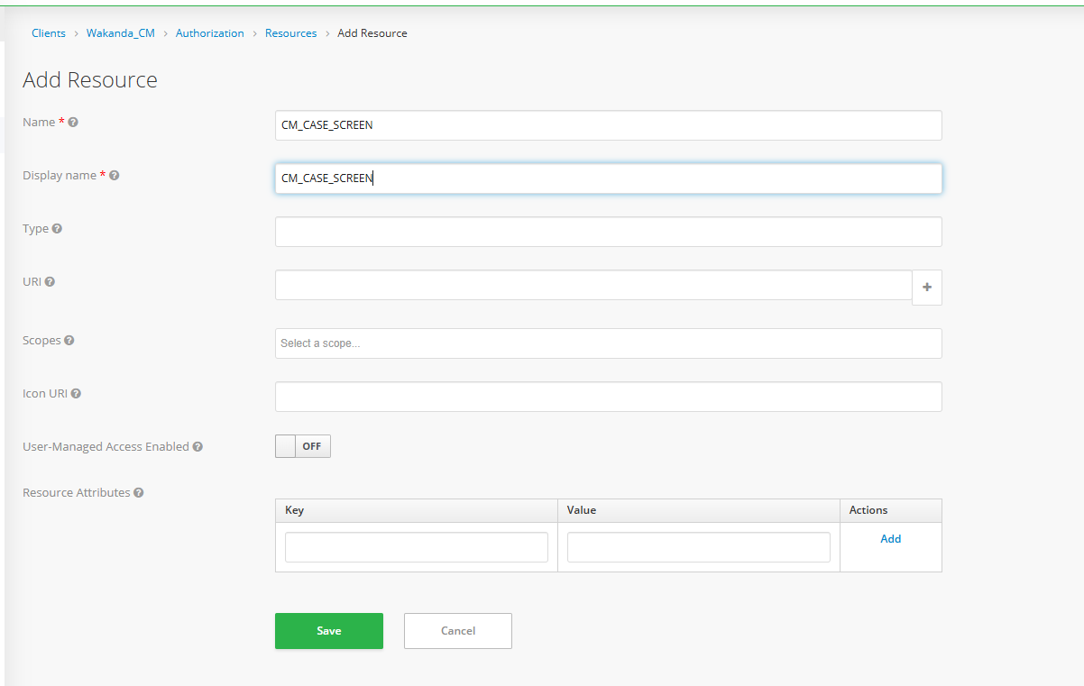
- Define Scopes

- Go to Clients → Wakanda_CM → Authorization → Scopes.
- Click “Create”.
- Add scopes like:
- view
- create
- edit
- delete
- Save each scope.
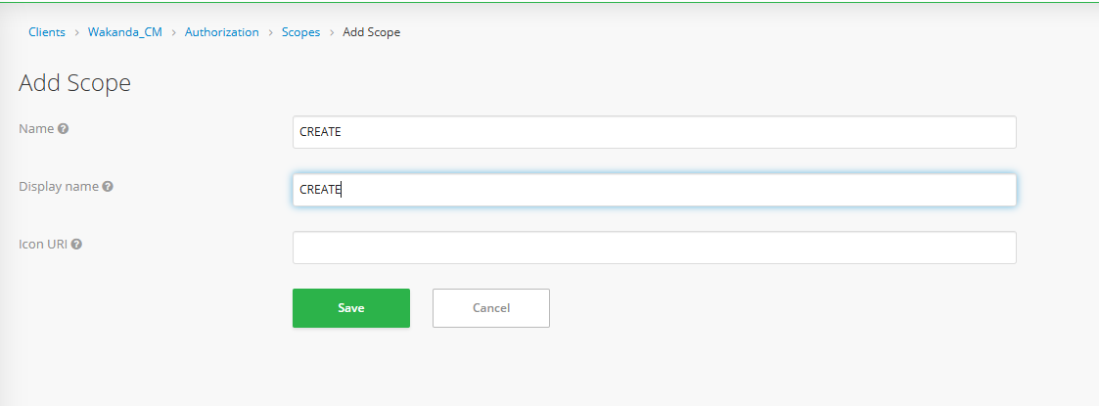
- Create a Role-Based Policy
- Go to Clients → Wakanda_CM → Authorization → Policies.
- Click “Create” → Type: Role-based.
- Fill in:
  - Name: CM_CASE_CREATE_POLICY
  - Logic: Positive
  - Apply to Role(s): CM_CASE_CREATE (or relevant role)
  - Realm Roles: Not required
  - Clients: Wakanda_CM
  - Client Roles: Select all the roles which need access to this policy
- Save the policy.
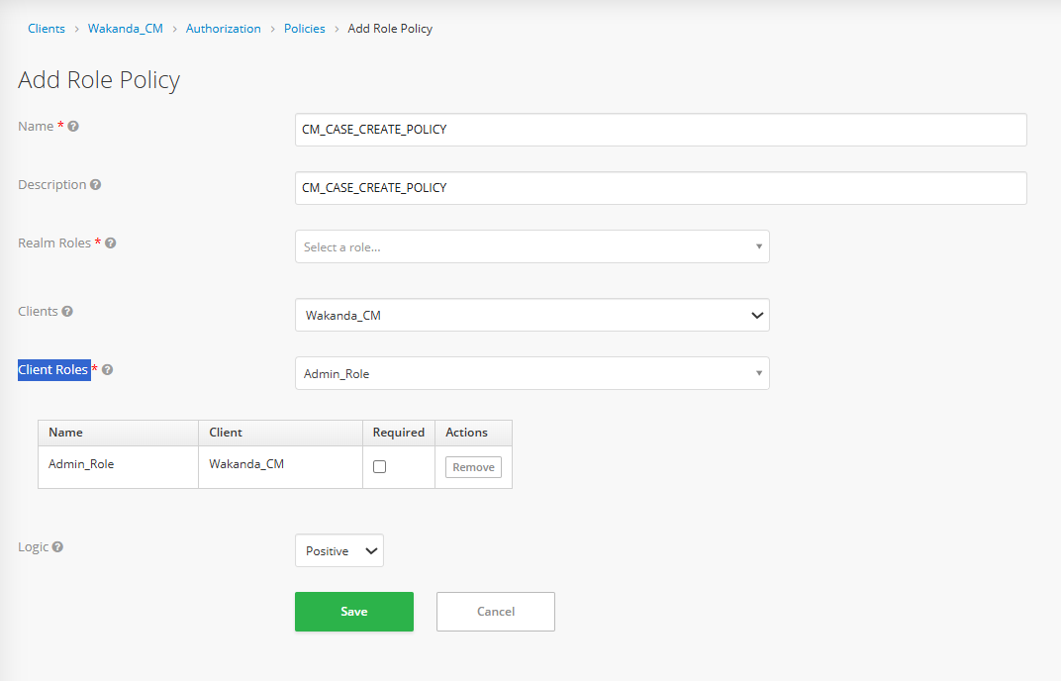
4. Create a Permission
- Navigate to Clients → Wakanda_CM → Authorization → Permissions.
- Click “Create” → Type: Scope-Based.
- Fill in:
- Name: CM_CASE_CREATE_PERMISSION
- Resource: CM_CASE_SCREEN (optional)
- Scopes: create
- Policies: CM_CASE_CREATE_POLICY
- Save the permission.
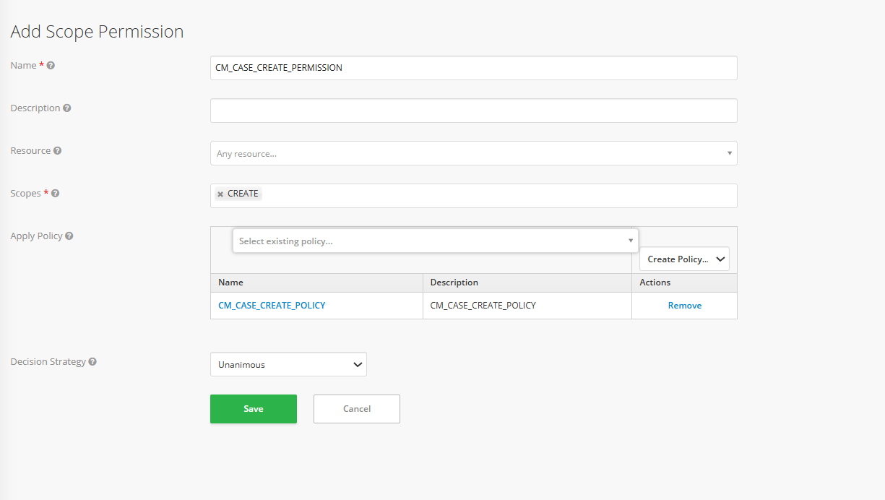

Mapping Reference Sheet
For a full mapping of UI menus to:
- Resources
- Associated Scopes
- Required Permissions
- Purpose of the scopes
Attached Reference:

Important: This file must now be owned and maintained by the L2 team. Any time a new screen, feature, resource, or scope is introduced in CM. It must be added to this mapping file. All changes should be tracked and reviewed regularly in this sheet and as well as in the role matrix

Database & Persistence

Database Overview
The Case Management (CM) application utilizes a MySQL InnoDB Cluster deployed across five virtual machines to ensure high availability and data consistency. A dedicated ProxySQL pod is used to provide connection pooling and to route database traffic from the application to the appropriate MySQL nodes. All microservices connect to the database through this ProxySQL layer using JNDI-configured datasources DB Engine: MySQL 8.x
- Connection Proxy: ProxySQL (port 6033)
- Primary Database Name: WKN_CM

Table Definitions

Product Type
Product Type is the top-level in the hierarchy of grouping. Below is the master table details in which stores the product type, with the major columns and its description with example.
Table name: TTM_PRODUCT_MASTER
Column Name | Data Type | Description | Notes / Special Instruction | Example
product_id | INT | Unique ID for each product type | Auto Increment, Primary Key | 227
product_name | VARCHAR(80) | Name of the product type | Unique | Welcome offer package
product_description | VARCHAR(100) | Description of the product |  | Welcome offer package
status | VARCHAR(20) | Status of the record | 0:Active, 1:Disabled, 2:Deleted | 0
create_user | VARCHAR(20) | Creator of the record | Nullable | 771
create_date | TIMESTAMP | Creation timestamp | Default Current Timestamp | 2022-08-05 17:55:14
modify_user | VARCHAR(20) | Last user who modified the record | Nullable | 771
modify_date | TIMESTAMP | Last modification timestamp | Auto Update Current Timestamp | 2023-03-08 10:44:00
comments | VARCHAR(100) | Comments related to product | Nullable | Welcome offer package
state | TINYINT(1) | Active state of the record | Default 1 | 1

Case category
Case Category is a middle in the hierarchy of grouping. Below is the master table details in which stores the case category created from UI, with the major columns and its description with example.
Table name: TTM_CASE_CATEGORY_MASTER
Column Name | Data Type | Description | Notes / Special Instruction | Example
CASE_CATEGORY_ID | INT | Unique ID for each case category | Auto Increment, Primary Key | 1201
CASE_CATEGORY_NAME | VARCHAR(80) | Name of the case category | Unique | Customers information Request by Legal Authorities
STATUS | VARCHAR(20) | Status of the record | Currently not considering in production | 0
CREATE_USER | VARCHAR(20) | Creator of the record | Nullable | 771
CREATE_DATE | TIMESTAMP | Creation timestamp | Default Current Timestamp | 2025-04-14 10:53:11
MODIFY_USER | VARCHAR(20) | Last user who modified the record | Nullable | 771
MODIFY_DATE | TIMESTAMP | Last modification timestamp | Auto Update Current Timestamp | 2025-04-14 10:53:11
comments | VARCHAR(150) | Comments related to category |  | Customers information Request by Legal Authorities
state | TINYINT(1) | Active state of the record | Default 1  1: Active  2: Non-active | 1

Case type
Case Type is the most specific level in the hierarchy of grouping. Below is the master table details in which stores the case type details along with mapping details with product type and case category, with the major columns and its description.
Table name: TTM_PRODUCT_CASE_TYPE_DETAILS
Column Name | Data Type | Description | Notes / Special Instruction | Example
seq_id | INT | Unique ID for case type | Auto Increment, Primary Key | 4082
product_id | INT | Product type mapped from product_id of TTM_PRODUCT_MASTER | Mandatory field | 295
case_category_id | VARCHAR(50) | Case category mapped from CASE_CATEGORY_ID of TTM_CASE_CATEGORY_MASTER | Mandatory field | 1189
case_type_name | VARCHAR(100) | Name of the case type | Mandatory field | Failed Deposit transaction from Dabak/Habtam Bet
case_type_description | VARCHAR(100) | Description of the case type | Nullable | Failed Deposit transaction from Dabak/Habtam Bet
status | INT | Status of the case type | Currently not used in production | 0
default_priority | INT | Priority mapped from priority_id of TTM_PRIORITY | Mandatory field | 3
create_date | TIMESTAMP | Created date | Default Current Timestamp | 2025-04-25 16:04:07
create_user | VARCHAR(20) | Created user |  | admin
update_user | VARCHAR(20) | Modified user | Nullable | \N
update_date | TIMESTAMP | Record last updated date | Auto Update Current Timestamp | 2025-04-25 16:04:07
comment | VARCHAR(150) | Additional comments | Nullable | \N
state | TINYINT(1) | Active state of the record | Default 1 | 1

SLA Master
SLA Master defines the SLA duration for different priorities and severities. Below is the master table details in which stores the SLA master details, with the major columns and its description.
Table name: TTM_SLA_DETAILS
Column Name | Data Type | Description | Notes / Special Instruction | Example
seq_id | INT | Unique ID for each SLA entry | Auto Increment, Primary Key | 439
mpt | VARCHAR(20) | Maximum Processing Time in minutes | Mandatory Field | 120
mpt_escalation_limit | VARCHAR(20) | Maximum processing time for escalation | Mandatory Field | 96
mpt_expired_escalation | VARCHAR(20) | Toggle for mail escalation on expiry (0=No, 1=Yes) | Default 0 | 1
default_escalation_mail_id | VARCHAR(200) | Default escalation email ID | Nullable | befikadu.belete@safaricom.et
create_date | TIMESTAMP | Created date | Default Current Timestamp | 2022-08-17 16:19:49
modify_date | TIMESTAMP | Modified date | Auto Update Current Timestamp | 2022-08-17 16:19:49
create_user | VARCHAR(11) | Created user | Nullable | 771
modify_user | VARCHAR(11) | Record modified by | Nullable | 771
sla_description | VARCHAR(100) | SLA description | Unique | SLA 5 Working Days
sla_travel_time | VARCHAR(20) | SLA travel time | Nullable | \N
sla_working_start_hour | VARCHAR(20) | Working start hour |  | 00:01
sla_working_end_hour | VARCHAR(20) | Working end hour |  | 23:59
sla_weekly_off_days | VARCHAR(20) | Weekly off days | Nullable  0 – Sunday  1 – Monday  2 – Tuesday  3 - Wednesday  4 – Thursday  5 - Friday  6 – Saturday | 0,6
comment | VARCHAR(150) | Additional comment | Nullable | Response Time
status | VARCHAR(20) | Status of SLA  (Currently not using in production) | 0:Active, 1:Disabled, 2:Deleted | 0
escalation_phone_number | VARCHAR(15) | Escalation contact number | Mandatory Field | 251287934353
sla_lunch_start_hour | VARCHAR(20) | Lunch break start time | Nullable | 07:59
sla_lunch_end_hour | VARCHAR(20) | Lunch break end time | Nullable | 08:00
sla_escalation_required | VARCHAR(20) | Escalation required flag | 0: Not required  1: Required | 1

SLA Mapping
SLA Mapping ties SLA master values to combinations of Product Types and Case Types. Below are the mapping table details in which stores the SLA details along with mapping details with product type and case type that has been created from SLA Mapping menu from UI, with the major columns and its description.
Table name: TTM_PRODUCT_PRIORITY_SLA_MAPPING
Note: As per the initial system design, SLA mapping was based on the combination of product type and case category. However, this was later updated to use the product type and case type combination, in alignment with revised business requirements. Although the column name remains as case category, it now holds the value of case type, and the SLA mappings are created accordingly based on product type and case type combination.
Column Name | Data Type | Description | Notes / Special Instruction | Example
seq_id | INT | Unique ID for SLA mapping | Auto Increment, Primary Key | 694
product_id | INT | Product type mapped from product_id of TTM_PRODUCT_MASTER | Mandatory Field | 225
case_category | INT | Case type mapped from SEQ_ID of TTM_PRODUCT_CASE_TYPE_DETAILS | Mandatory Field | 842
priority_id | INT | Priority mapped from PRIORITY_ID of TTM_PRIORITY | Mandatory Field | 2
sla_id | INT | SLA Master mapped from sla_id of TTM_PRIORITY | Mandatory Field | 433
create_date | TIMESTAMP | Creation date | Default Current Timestamp | 2022-08-05 19:26:00
modify_date | TIMESTAMP | Modification date | Auto Update Current Timestamp | 2022-08-05 19:26:00
create_user | VARCHAR(20) | Record created user | Nullable | admin
modify_user | VARCHAR(20) | Record modified user | Nullable | admin
status | VARCHAR(20) | Status  (Currently not used in Production) | 0:Active, 1:Disabled, 2:Deleted | 0
comment | VARCHAR(150) | Additional comment | Nullable | First Call Activation_SLA24

Team Master
The team mapping will automatically assign the team based on the product type and case type combination. Below are the master table details in which store the Team details.
Table name: TEAM_MASTER
Column Name | Data Type | Description | Notes / Special Instruction | Example
SEQ_ID | INT | Unique Team ID | Auto Increment, Primary Key | 453
TEAM_NAME | VARCHAR(200) | Name of the team | Unique | TES team
KEYCLOAK_TEAM_ID | VARCHAR(100) | Keycloak team Mapped from teamId of USER_ATTRIBUTE table of Keycloak | Mandatory Field | 166
DESCRIPTION | VARCHAR(200) | Description of the team | Nullable
EMAIL_ID | VARCHAR(50) | Email ID of the team leader Mapped from email_id of USER_MASTER table | Nullable | dawit.kefale@safaricom.et
CREATED_BY | VARCHAR(50) | Created by user | Nullable | admin
CREATE_DATE | TIMESTAMP | Creation date | Default Current Timestamp | 2025-02-17 15:17:57
UPDATED_BY | VARCHAR(50) | Last updated user | Nullable | Asnake Ayele Mammo
UPDATE_DATE | TIMESTAMP | Modification date | Auto Update Current Timestamp | 2025-02-24 15:59:14
TEAM_OWNER_ID | VARCHAR(50) | Team owner User ID Mapped from seq_id of USER_MASTER | Nullable | 4287
IS_DELETE | INT | Deletion flag (0=Active, 1=Deleted) | Default 0 | 0
FROM_KEYCLOAK | INT | Insertion source (0=CM, 1=Keycloak) | Default 1 | 0
DEFAULT_ASSIGNEE_ID | VARCHAR(45) | Default assignee ID Mapped from sed_id of USER_MASTER table | Nullable | 4287

Team Mapping
Team Mapping ties Teams created from UMS to combinations of Product Types and Case Types. Below are the mapping table details in which stores the Team details along with mapping details with product type and case type that has been created from Team Mapping menu from UI, with the major columns and its description
Table Name: TEAM_PRODUCT_CATEGORY_MAPPING
Column Name | Data Type | Description | Notes / Special Instruction | Example
SEQ_ID | INT | Unique Team Mapping ID | Auto Increment, Primary Key | 998
TEAM | INT | Team name Mapped from seq_id of TEAM_MASTER | Mandatory field | 372
PRODUCT_TYPE | VARCHAR(20) | Product id Mapped from seq_id of TTM_PRODUCT_MASTER | Mandatory field | 224
CASE_TYPE | VARCHAR(20) | Case type mapped from SEQ_ID of TTM_PRODUCT_CASE_TYPE_DETAILS | Mandatory Field | 839
CREATED_BY | VARCHAR(20) | Created user ID | Nullable | 3360
CREATE_DATE | TIMESTAMP | Creation date | Default Current Timestamp | 2023-11-06 19:11:26
UPDATED_BY | VARCHAR(20) | Modified user ID | Nullable | 3360
UPDATE_DATE | TIMESTAMP | Modified date | Auto Update Current Timestamp | 2023-11-06 16:12:59

Resolution
Resolution will show the common resolution performed with the product type and case type combination. Below are the master table details in which stores the Resolution details along with mapping details with product type and case type, with the major columns and its description.
Table Name: TTM_RESOLUTION_DETAILS
Column Name | Data Type | Description | Notes / Special Instruction | Example
seq_id | INT | Unique Resolution ID | Auto Increment, Primary Key | 70
product_id | VARCHAR(50) | Product id Mapped from seq_id of TTM_PRODUCT_MASTER | Mandatory field | 226
case_type_id | VARCHAR(30) | Case type mapped from SEQ_ID of TTM_PRODUCT_CASE_TYPE_DETAILS | Mandatory Field | 3080
resolution_name | VARCHAR(50) | Name of the resolution | Unique per Product/Case Type | ADM28 Regression
comment | VARCHAR(50) | Additional comments | Nullable | ADM 2829
create_date | TIMESTAMP | Created date | Default Current Timestamp | 2024-08-23 05:55:49
create_user | VARCHAR(20) | Created user | Nullable | 4011
update_user | VARCHAR(20) | Modified user | Nullable | \N
update_date | TIMESTAMP | Modified date | Auto Update Current Timestamp | 2024-08-23 05:55:49

Source
Source is used to track the origin of tickets. Below is the master table details in which store the Source details, with the major columns and its description.
Table name: TTM_SOURCECODE_DETAILS
Column Name | Data Type | Description | Notes / Special Instruction | Example
seq_id | INT | Unique Source ID | Auto Increment, Primary Key | 50
sourceCode_name | VARCHAR(50) | Name of the source | Unique | SMS
comment | VARCHAR(50) | Additional comments | Nullable | SMS
create_user | VARCHAR(50) | Created user | Nullable | 771
create_date | TIMESTAMP | Created date | Default Current Timestamp | 2022-08-18 04:40:22
update_date | TIMESTAMP | Modified date | Auto Update Current Timestamp | 2022-08-18 04:40:22
update_user | VARCHAR(50) | Modified user | Nullable | \N

Intent
Intent represents the purpose or goal of the user's request or ticket. Below is the master table details in which stores the Intent details, with the major columns and its description.
Table name: INTENT_DETAILS
Column Name | Data Type | Description | Notes / Special Instruction | Example
id | INT | Unique Intent ID | Auto Increment, Primary Key | 5
name | VARCHAR(45) | Intent name | Unique | ADM 28
description | VARCHAR(45) | Intent description | Nullable | ADM 28 Regression Intent

Intent Mapping
Intent Mapping connects each intent to product type and case type combinations. Below is the master table details in which store the Intent details along with mapping details with product type and case type, with the major columns and its description.
Table name: INTENT_CASETYPE_MAPPING
Column Name | Data Type | Description | Notes / Special Instruction | Example
SEQ_ID | INT | Unique Mapping ID | Auto Increment, Primary Key | 3
CASE_TYPE_ID | VARCHAR(50) | Case type mapped from SEQ_ID of TTM_PRODUCT_CASE_TYPE_DETAILS | Mandatory Field | 2493
INTENT_ID | VARCHAR(50) | INTENT ID mapped from ID of INTENT_DETAILS | Mandatory Field | 5

Caused Code
Cause code helps in identifying recurring issues linked to specific product type and case type combination. Below are the master table details in which stores the Cause code details along with mapping details with product type and case type, with the major columns and its description.
Table name: TTM_CAUSECODE_DETAILS
Column Name | Data Type | Description | Notes / Special Instruction | Example
seq_id | INT | Unique Cause Code ID | Auto Increment, Primary Key | 68
product_id | VARCHAR(20) | Product id Mapped from seq_id of TTM_PRODUCT_MASTER | Mandatory field | 320
case_type_id | VARCHAR(20) | Case type mapped from SEQ_ID of TTM_PRODUCT_CASE_TYPE_DETAILS | Mandatory Field | 3448
causedCode_name | VARCHAR(50) | Name of the cause code | Unique with product_id and case_type_id | Readiness Caused code
comment | VARCHAR(100) | Additional comments | Nullable | Readiness caused code
create_user | VARCHAR(20) | Created user | Nullable | 4011
create_date | TIMESTAMP | Creation date | Default Current Timestamp | 2024-11-06 05:00:10
update_date | TIMESTAMP | Last updated date | Auto Update Current Timestamp | 2024-11-06 14:00:10
update_user | VARCHAR(20) | Last updated user | Nullable | \N

Case nature
The Case nature and Case sub nature configurations work together to offer hierarchical classification of the case content. The Case Nature defines the high-level category, while Case Sub Nature adds more granularity. Below is the mapping table details in which stores the Case nature details along with mapping details with product type and case type, with the major columns and its description.
Table name: CM_NATURE
Note: As per the initial system design, CM nature was mapped based on the combination of product type and case category. However, this was later updated to use the product type and case type combination, in alignment with revised business requirements. Although the column name remains as case category, it now holds the value of case type, and the CM nature are created accordingly based on product type and case type combination.
Column Name | Data Type | Description | Notes / Special Instruction | Example
SEQ_ID | INT | Unique case nature ID | Auto Increment, Primary Key | 28
NAME | VARCHAR(50) | Name of the case nature | Unique | Readiness case nature
DESCRIPTION | VARCHAR(250) | Description of the case nature |  | Create readiness case nature
PRODUCT_TYPE | VARCHAR(20) | Product id Mapped from seq_id of TTM_PRODUCT_MASTER | Mandatory field | 320
CASE_CATEGORY | VARCHAR(20) | Case type mapped from SEQ_ID of TTM_PRODUCT_CASE_TYPE_DETAILS | Mandatory Field | 3448
CREATE_DATE | TIMESTAMP | Created date | Default Current Timestamp | 2024-11-06 15:30:33
UPDATE_DATE | TIMESTAMP | Modified date | Auto Update Current Timestamp | 2024-11-06 15:30:33

Case sub nature
Below is the mapping table details in which stores the Case sub nature details along with mapping details with product type and case type, with the major columns and its description.
Table name: CM_SUB_NATURE
Note: As per the initial system design, CM sub nature was mapped based on the combination of product type and case category. However, this was later updated to use the product type and case type combination, in alignment with revised business requirements. Although the column name remains as case category, it now holds the value of case type, and the CM sub nature are created accordingly based on product type and case type combination.
Column Name | Data Type | Description | Notes / Special Instruction | Example
SEQ_ID | INT | Unique Sub Nature ID | Auto Increment, Primary Key | 27
NAME | VARCHAR(50) | Name of the sub nature | Unique | Readiness case sub nature
NATURE | VARCHAR(20) | Case nature ID Mapped from seq_id of CM_NATURE | Mandatory field | 28
DESCRIPTION | VARCHAR(250) | Detailed description |  | Readiness case sub nature description
PRODUCT_TYPE | VARCHAR(20) | Product id Mapped from seq_id of TTM_PRODUCT_MASTER | Mandatory field | 320
CASE_CATEGORY | VARCHAR(20) | Case type mapped from SEQ_ID of TTM_PRODUCT_CASE_TYPE_DETAILS | Mandatory Field | 3448
CREATE_DATE | TIMESTAMP | Creation date | Default Current Timestamp | 2024-11-06 15:31:35
UPDATE_DATE | TIMESTAMP | Update date | Auto Update Current Timestamp | 2024-11-06 15:31:35

Meta Data
The Meta Data screen allows the configuration of additional attributes or custom fields associated with different product type and case type combinations. Below is the master table details in which stores the Cause code details along with mapping details with product type and case type, with the major columns and its description.
Table name: TTM_META_MASTER
Column Name | Data Type | Description | Notes / Special Instruction | Example
META_ID | INT | Unique Meta ID | Auto Increment, Primary Key | 83
NAME | VARCHAR(50) | Name of the metadata field |  | Readiness Test
TYPE | VARCHAR(20) | Field type (e.g., Dropdown, Text) |  | Dropdown
DEFAULT_VALUES | VARCHAR(50) | Default options/values | Multiple values can be given with comma separated. | Check One
PRODUCT_TYPE | VARCHAR(20) | Product id Mapped from seq_id of TTM_PRODUCT_MASTER | Mandatory field | 225
IS_MANDATORY | VARCHAR(10) | Mandatory toggle (0=No, 1=Yes) | Default 0 | 0
CASE_TYPE | VARCHAR(20) | Case type mapped from SEQ_ID of TTM_PRODUCT_CASE_TYPE_DETAILS | Mandatory Field | 854
CREATED_BY | VARCHAR(20) | Created user | Nullable | 4011
CREATE_DATE | TIMESTAMP | Creation date | Default Current Timestamp | 2024-11-01 13:58:55
UPDATED_BY | VARCHAR(20) | Updated user | Nullable | \N
UPDATE_DATE | TIMESTAMP | Update date | Auto Update Current Timestamp | 2024-11-01 13:58:55

Meta data mapping
This is the meta data mapping table that stores the ticket details and the meta data details given during ticket creation/update. Below is the table structure of the meta data mapping table with description and sample entries.
Table name: TTM_TICKET_META
Column Name | Data Type | Description | Notes / Special Instruction | Example
SEQ_ID | INT | Unique Mapping ID | Composite Primary Key with CREATE_DATE | 127104
TICKET_ID | VARCHAR(20) | Ticket ID mapped from SEQ_ID of TTM_TICKET_DETAILS | Mandatory Field | 10363956
META_ID | VARCHAR(20) | Meta ID mapped from META_ID of TTM_META_MASTER | Mandatory Field | correlationId
VALUE | VARCHAR(100) | User-provided value for metadata | Nullable | CMCallback:1323890623205863424
CREATE_DATE | DATETIME | Record creation timestamp | Default Current Timestamp | 2025-01-01 08:48:47

Message Template
Message template menu is used to configure predefined notifications that will be triggered based on the certain events during the ticketing process. Below are the table details with the major columns and their description.
Table name: MESSAGE_TEMPLATE
Column Name | Data Type | Description | Notes / Special Instruction | Example
SEQ_ID | INT | Unique Message Template ID | Primary Key | 127
EVENT_TYPE | INT | Event type Mapped from SEQ_ID of TTM_EVENT_TYPE | Mandatory field | 1
SUB_EVENT_TYPE | VARCHAR(20) | Subtype of the event | Nullable | \N
MESSAGE_TEXT | VARCHAR(255) | Text of the message | Supported place holders available in the message template creation page. | ውድ ደንበኛችን፣ በመከታተያ ቁጥር %ticketId% ላይ የተመዘገበው ጥያቄዎ እስከ %deadLineDate%ድረስ መፍትሄ ያገኛል። <br>የሳፋሪኮም ምርቶችን እና አገልግሎቶችን ስለተጠቀሙ እናመሰግናለን።
CREATE_DATE | TIMESTAMP | Creation date | Default Current Timestamp | 2022-07-04 18:24:28
UPDATED_DATE | TIMESTAMP | Last updated date | Auto Update | 2022-08-27 13:17:13
CREATE_USER | VARCHAR(20) | Created user | Nullable | 222
UPDATE_USER | VARCHAR(20) | Updated user | Nullable | 222
STATUS | VARCHAR(20) | Status of message | 0=Active | 1=Inactive | 1
AUDIENCE | VARCHAR(50) | Audience codes | Comma separated list | 1,2
CHANNEL | VARCHAR(50) | Channel code | FK to CM_CHANNEL | 2
LANGUAGE | VARCHAR(50) | Language of message | Default 'English' | 4

FAQ
The FAQ configuration menu allows us to configure the frequently asked questions shown in the help section. Below are the table details with the major columns and their description.
Table name: FAQ_DETAILS
Column Name | Data Type | Description | Notes / Special Instruction | Example
SEQ_ID | INT | Unique FAQ ID | Primary Key | 29
HEADING | VARCHAR(250) | Question heading | Mandatory field | fair speed usage limit in case of unlimited data plan
DESCRIPTION | VARCHAR(1000) | Detailed answer for the FAQ | Mandatory field | This is the limit of data consumption...
CREATED_DATE | DATETIME | Created date |  | 2021-06-10 16:34:33
CREATE_USER | VARCHAR(50) | Created User | Nullable | Jhon Ria
UPDATED_DATE | DATETIME | Last update date |  | 2021-06-10 16:34:33
UPDATE_USER | VARCHAR(50) | Updated User | Nullable | \N

Holidays
This configuration is used for SLA calculations. Any date defined here as a holiday will be excluded from SLA time computation. Below are the table details with the major columns and their description.
Table name: TTM_HOLIDAYS
Column Name | Data Type | Description | Notes / Special Instruction | Example
SEQ_ID | INT | Unique holiday ID | Primary Key | 13
EVENT_DATE | DATE | Holiday date | Unique | 2022-03-01
NAME | VARCHAR(255) | Holiday name | Unique | Adawa

Ticket Master Table
The Ticket Table is the main table which captures all necessary metadata, user interaction history, service data, and SLA tracking for each ticket request raised within the Case Management (CM) application. The table is partitioned based on status to ensure the data retention as per the regulatory norms.
Table Name: TTM_TICKET_DETAILS
Column Name | Data Type | Description | Notes / Special Instructions | Example
SEQ_ID | INT(10) | Unique ticket identifier | Auto-increment, Primary Key (with STATUS) | 248369
SUBJECT | VARCHAR(200) | Case Type Description | Not nullable, utf8mb3_unicode_ci collation | "IMT Info."
REQUEST_ID | VARCHAR(200) | RequestID of the last request that has updated the data for this ticket | Not nullable, latin1_swedish_ci collation | "1745483001636"
DESCRIPTION | VARCHAR(8000) | Detailed issue description | Nullable, utf8mb3_general_ci collation | "Test ticket for DB Details"
PRIORITY | VARCHAR(20) | Ticket priority –> mapped from priority_id of TTM_PRIORITY Table | Not nullable, Indexed (idx_PRIORITY) | "3"
ASSIGNEE | VARCHAR(50) | Current assignee’s user ID mapped from USER_ID of USER_MASTER | Nullable, Indexed (ASSIGNEE_IDX) | "824"
CREATE_DATE | TIMESTAMP | Ticket creation timestamp | Default: CURRENT_TIMESTAMP | 24-04-2025 11:22
STATUS | VARCHAR(20) | Current ticket status mapped from STATUS_ID of TTM_STATUS_DETAILS | Primary Key, Partitioning column, Indexed (IDX_STATUS) | "3"
previous_status | VARCHAR(20) | Previous status before current state mapped from STATUS_ID of TTM_STATUS_DETAILS | Nullable | "4"
ASSIGNEE_MAIL_ID | VARCHAR(50) | Assignee’s email Mapped from EMAIL_ID of USER_MASTER table | Nullable | "apoorva.user@gmail.com"
SERVICE_ID | VARCHAR(20) | Service ID linked to ticket | Nullable, Indexed (SERVICE_ID) | "251700456000"
CUSTOMER_NAME | VARCHAR(50) | Customer’s name | Nullable | "Thanvir Jalal"
SOURCE_NODE | VARCHAR(20) | Source system/node from where the ticket was created | Nullable, Indexed (idx_source_node) | "CM"
CREATE_USER | VARCHAR(20) | Created user ID USER_ID of USER_MASTER | Nullable, Indexed (CREATE_USER_IDX) | "856"
TEAM_ID | VARCHAR(20) | Current handling team SEQ_ID of TEAM_MASTER | Nullable, Indexed (TEAM_ID_IDX) | "373"
USER_ID | VARCHAR(20) | Created user ID USER_ID of USER_MASTER | Nullable, Indexed (USER_ID_IDX) | "856"
CUSTOMER_EMAIL_ID | VARCHAR(50) | Customer’s email | Nullable | "charleskk@me.com"
account_id | VARCHAR(20) | Linked account ID | Nullable, Indexed (idx_account_id) | "ET61053"
profile_id | VARCHAR(20) | Linked profile ID | Nullable, Indexed (idx_profile_id) | "112102"
searchId | VARCHAR(50) | We are not using it as of now and keeping it for future reference. | Nullable | NULL
first_status | VARCHAR(20) | Initial ticket status status mapped from STATUS_ID of TTM_STATUS_DETAILS | Nullable | "4"
first_assignee | VARCHAR(20) | First assignee’s user ID USER_ID of USER_MASTER | Nullable | "755"
first_assigned_team | VARCHAR(20) | First assigned team SEQ_ID of TEAM_MASTER | Nullable, Indexed (idx_first_assigned_team) | "366"
CONTACT_NUMBER | VARCHAR(20) | Customer’s phone number | Nullable, Indexed (idx_CONTACT_NUMBER) | "251700456000"
product_type | INT(10) | Product type mapped from product_id of TTM_PRODUCT_MASTER | Not nullable, Indexed (idx_product_type) | 159
category_type | INT(10) | Case Category mapped from CASE_CATEGORY_ID to TTM_CASE_CATEGORY_MASTER | Nullable, Indexed (idx_category_type) | 443
category_name_id | INT(10) | Case type mapped from TTM_PRODUCT_CASE_TYPE_DETAILS of seq_id | Nullable, Indexed (idx_category_name_id) | 496
max_processing_time | DATETIME | SLA Breach Time based on SLA configured | Nullable | 29-04-2025 11:23
escalation_time | DATETIME | Escalation Time based on SLA configured | Nullable | 29-04-2025 09:23
mpt_hours | INT(10) | Max processing time (hours) based on SLA configured | Default: 0 | 24
escalation_limit | VARCHAR(20) | Escalation hours based on SLA configured | Nullable | "22"
customer_action_start_time | DATETIME | We are not using it as of now and keeping it for future reference. | Nullable | NULL
customer_action_time | VARCHAR(20) | We are not using it as of now and keeping it for future reference. | Default: "0" | "0"
closed_start_time | DATETIME | Timestamp when ticket is closed | Nullable | NULL
closed_time | VARCHAR(20) | We are not using it as of now and keeping it for future reference. | Default: "0" | "0"
mail_on_escalation_required | INT(10) | Escalation email flag – 0 : No, 1: Yes | Nullable | 1
default_escalation_mail_id | VARCHAR(200) | Mailid to which escalation notification will be sent. Populated based on the escalation email ID configured in SLA Master | Nullable | "Abrahams.Abuko@safaricom.et"
mpt_first_level_escalated | INT(10) | We are not using it as of now and keeping it for future reference. | Default: 0 | 0
mpt_completion_escalated | INT(10) | Whether the escalation is completed – 0 : No, 1: Yes | Default: 0 | 0
clmn_1 | DATETIME | For Ticket_Assigned_Date and Ticket_Assigned _Time. | Nullable | 24-04-2025 11:23
clmn_2 | VARCHAR(20) | Custom field 2 | Nullable | NULL
clmn_3 | VARCHAR(20) | Custom field 3 | Nullable | NULL
clmn_4 | VARCHAR(20) | "Profile Type Description" and we are fetching it from CRM and its stored in CRM as Profile Type at Profile level. | Nullable, Indexed (idx_clmn_4) | "1"
clmn_5 | VARCHAR(20) | "Customer Segment Description" and we are fetching it from CRM and its stored in CRM as Segment at Profile level. | Nullable, Indexed (idx_clmn_5) | "13"
clmn_6 | VARCHAR(20) | Custom field 6 (stores intent_id) | Nullable | NULL
clmn_7 | VARCHAR(20) | Custom field 7 | Nullable | NULL
clmn_8 | VARCHAR(20) | Custom field 8 | Nullable | NULL
clmn_9 | VARCHAR(20) | Custom field 9 | Nullable | NULL
clmn_10 | VARCHAR(20) | Custom field 10 | Nullable | NULL
MASTER_TICKET | INT(10) | Flag for master ticket (0=False, 1=True) | Nullable | 0
MASTER_TICKET_ID | VARCHAR(15) | ID of linked master ticket | Default: "0" | "0"
RESOLUTION_ID | VARCHAR(50) | Resolution reference ID | Nullable | NULL
SERVICE_ID_TYPE | VARCHAR(50) |  | Nullable | NULL
SERVICE_ACTIVATION_DATE | VARCHAR(50) |  | Nullable | NULL
SUBSCRIBER_ADDRESS_LINE1 | VARCHAR(50) | We are using it as Address "Region/City Administration" and fetching it from Billing module. | Nullable | "Addis Ababa"
SUBSCRIBER_ADDRESS_LINE2 | VARCHAR(50) | We are using it as Address "Zone/Sub-City" and fetching it from Billing module. | Nullable | "Addis Ketema"
SUBSCRIBER_ADDRESS_LINE3 | VARCHAR(50) | We are not using it as of now and keeping it for future reference. | Nullable | NULL
SUBSCRIBER_ADDRESS_LINE4 | VARCHAR(50) | We are using it as Address "Woreda" and fetching it from Billing module. | Nullable | NULL
SUBSCRIBER_ADDRESS_LINE5 | VARCHAR(200) | We are using it as Address "Kebele/farmer union" and fetching it from Billing module. | Nullable, utf8mb3_general_ci collation | NULL
SUBSCRIBER_ADDRESS_LINE6 | VARCHAR(50) | We are using it as Address "House Number/Building Number" and fetching it from Billing module. | Nullable, utf8mb3_general_ci collation | NULL
SUBSCRIBER_ADDRESS_LINE7 | VARCHAR(50) | We are using it as Address "Street Name/Physical Address" and fetching it from Billing module. | Nullable, utf8mb3_general_ci collation | NULL
SUBSCRIBER_ADDRESS_LINE8 | VARCHAR(50) | We are using it as Address "Post Code" and fetching it from Billing module. | Nullable | NULL
SUBSCRIBER_ADDRESS_LINE9 | VARCHAR(50) | We are using it as Address "PO Box Number" and fetching it from Billing module. | Nullable | NULL
SUBSCRIBER_ADDRESS_LINE10 | VARCHAR(50) | We are not using it as of now and keeping it for future reference. | Nullable | NULL
SUBSCRIBER_ADDRESS_LINE11 | VARCHAR(50) | We are not using it as of now and keeping it for future reference. | Nullable | NULL
SUBSCRIBER_ADDRESS_LINE12 | VARCHAR(50) | We are not using it as of now and keeping it for future reference. | Nullable | NULL
ISSUE_START_DATE | TIMESTAMP | Issue start timestamp | Nullable, Indexed (DASHBOARD_DATE_INDEX) | 24-04-2025 11:22
ISSUE_END_DATE | TIMESTAMP | Issue end timestamp | Nullable | NULL
IS_WORK_ORDER | INT(10) | We are not using it as of now and keeping it for future reference. | Nullable | 0
CAUSEDCODE_ID | VARCHAR(20) | Mapped from seq_id of TTM_CAUSECODE_DETAILS | Nullable | NULL
SOURCECODE_ID | VARCHAR(20) | Mapped from seq_id of TTM_SOURCECODE_DETAILS table | Nullable, Indexed (idx_SOURCECODE_ID) | "2"
SEVERITY_LEVEL | VARCHAR(50) | We are not using it as of now and keeping it for future reference. | Nullable | NULL
TECHNICIAN_DESCRIPTION | BLOB | We are not using it as of now and keeping it for future reference. | Nullable | NULL
EQUIPMENT_ID | VARCHAR(50) | We are not using it as of now and keeping it for future reference. | Nullable | NULL
SLA_DESCRIPTION | VARCHAR(100) | SLA terms | Nullable | "SLA 24"
ESCALATION_MAIL_SENT | VARCHAR(50) | Escalation email status (0=False, 1=True) | Nullable | NULL
SLA_ID | VARCHAR(50) | SLA reference ID | Nullable | NULL
LAST_MAIL_SENT_TIME | TIMESTAMP | Last email notification timestamp | Nullable | NULL
NATURE_ID | INT(10) | Issue nature ID | Nullable | NULL
SUB_NATURE_ID | INT(10) | Issue sub-nature ID | Nullable | NULL
INVOLVED_TEAMS | VARCHAR(100) | Teams involved in resolution | Nullable | "366,373"
UPDATED_DATE | TIMESTAMP | Last update timestamp | Default: CURRENT_TIMESTAMP | 24-04-2025 11:23
LOCATION_CODE | VARCHAR(100) | We are not using it as of now and keeping it for future reference. | Nullable | NULL
CUSTOMER_NOTIFICATION_CHANNEL | VARCHAR(20) | Notification method (e.g., Email) | Default: "" | ""
TICKET_DURATION | VARCHAR(20) | Total ticket duration | Nullable | NULL
ASSOCIATE_ID | VARCHAR(255) | We are not using it as of now and keeping it for future reference. | Nullable | NULL
commune | VARCHAR(255) | We are not using it as of now and keeping it for future reference. | Nullable | NULL
country | VARCHAR(255) | We are not using it as of now and keeping it for future reference. | Nullable | NULL
district | VARCHAR(255) | We are not using it as of now and keeping it for future reference. | Nullable | NULL
FROM_ASSOCIATE_ID | VARCHAR(255) | We are not using it as of now and keeping it for future reference. | Nullable | NULL
home_number | VARCHAR(255) | We are not using it as of now and keeping it for future reference. | Nullable | NULL
instance_id | VARCHAR(255) | We are not using it as of now and keeping it for future reference. | Nullable | NULL
MVNO_ID | VARCHAR(255) | We are not using it as of now and keeping it for future reference. | Nullable | NULL
SOLUTION_TYPE | VARCHAR(255) | We are not using it as of now and keeping it for future reference. | Nullable | NULL
province | VARCHAR(255) | We are not using it as of now and keeping it for future reference. | Nullable | NULL
ROOT_CAUSE | VARCHAR(255) | We are not using it as of now and keeping it for future reference. | Nullable | NULL
search_type | VARCHAR(255) | We are not using it as of now and keeping it for future reference. | Nullable | NULL
street_name | VARCHAR(255) | We are not using it as of now and keeping it for future reference. | Nullable | NULL
TYPE_OF_TICKET | INT(10) | We are not using it as of now and keeping it for future reference. | Nullable | NULL
village | VARCHAR(255) | We are not using it as of now and keeping it for future reference. | Nullable | NULL
zip_code | VARCHAR(255) | We are not using it as of now and keeping it for future reference. | Nullable | NULL
DEFAULT_ESCALATION_MOBILE_NUMBER | VARCHAR(255) | Escalation contact number | Nullable | "251943546871"
CUSTOMER_PREFERRED_LANGUAGE | VARCHAR(50) | Customer language preference (1=English) | Default: "1" | "1"

Ticket Master History Table
The Ticket Table is the history table which captures all necessary metadata, user interaction history, service data, and SLA tracking for each ticket request raised within the Case Management (CM) application for those tickets which are closed and older than 90 days. The table is partitioned based on month to ensure the data retention as per the regulatory norms.
Table Name: TTM_TICKET_DETAILS_HISTORY
Column Name | Data Type | Description | Notes / Special Instructions | Example
SEQ_ID | INT(10) | Unique ticket identifier | Auto-increment, Primary Key (with STATUS) | 248369
SUBJECT | VARCHAR(200) | Case Type Description | Not nullable, utf8mb3_unicode_ci collation | "IMT Info."
REQUEST_ID | VARCHAR(200) | RequestID of the last request that has updated the data for this ticket | Not nullable, latin1_swedish_ci collation | "1745483001636"
DESCRIPTION | VARCHAR(8000) | Detailed issue description | Nullable, utf8mb3_general_ci collation | "Test ticket for DB Details"
PRIORITY | VARCHAR(20) | Ticket priority –> mapped from priority_id of TTM_PRIORITY Table | Not nullable, Indexed (idx_PRIORITY) | "3"
ASSIGNEE | VARCHAR(50) | Current assignee’s user ID mapped from USER_ID of USER_MASTER | Nullable, Indexed (ASSIGNEE_IDX) | "824"
CREATE_DATE | TIMESTAMP | Ticket creation timestamp | Default: CURRENT_TIMESTAMP | 24-04-2025 11:22
STATUS | VARCHAR(20) | Current ticket status mapped from STATUS_ID of TTM_STATUS_DETAILS | Primary Key, Partitioning column, Indexed (IDX_STATUS) | "3"
previous_status | VARCHAR(20) | Previous status before current state mapped from STATUS_ID of TTM_STATUS_DETAILS | Nullable | "4"
ASSIGNEE_MAIL_ID | VARCHAR(50) | Assignee’s email Mapped from EMAIL_ID of USER_MASTER table | Nullable | "apoorva.user@gmail.com"
SERVICE_ID | VARCHAR(20) | Service ID linked to ticket | Nullable, Indexed (SERVICE_ID) | "251700456000"
CUSTOMER_NAME | VARCHAR(50) | Customer’s name | Nullable | "Thanvir Jalal"
SOURCE_NODE | VARCHAR(20) | Source system/node from where the ticket was created | Nullable, Indexed (idx_source_node) | "CM"
CREATE_USER | VARCHAR(20) | Created user ID USER_ID of USER_MASTER | Nullable, Indexed (CREATE_USER_IDX) | "856"
TEAM_ID | VARCHAR(20) | Current handling team SEQ_ID of TEAM_MASTER | Nullable, Indexed (TEAM_ID_IDX) | "373"
USER_ID | VARCHAR(20) | Created user ID USER_ID of USER_MASTER | Nullable, Indexed (USER_ID_IDX) | "856"
CUSTOMER_EMAIL_ID | VARCHAR(50) | Customer’s email | Nullable | "charleskk@me.com"
account_id | VARCHAR(20) | Linked account ID | Nullable, Indexed (idx_account_id) | "ET61053"
profile_id | VARCHAR(20) | Linked profile ID | Nullable, Indexed (idx_profile_id) | "112102"
searchId | VARCHAR(50) | We are not using it as of now and keeping it for future reference. | Nullable | NULL
first_status | VARCHAR(20) | Initial ticket status status mapped from STATUS_ID of TTM_STATUS_DETAILS | Nullable | "4"
first_assignee | VARCHAR(20) | First assignee’s user ID USER_ID of USER_MASTER | Nullable | "755"
first_assigned_team | VARCHAR(20) | First assigned team SEQ_ID of TEAM_MASTER | Nullable, Indexed (idx_first_assigned_team) | "366"
CONTACT_NUMBER | VARCHAR(20) | Customer’s phone number | Nullable, Indexed (idx_CONTACT_NUMBER) | "251700456000"
product_type | INT(10) | Product type mapped from product_id of TTM_PRODUCT_MASTER | Not nullable, Indexed (idx_product_type) | 159
category_type | INT(10) | Case Category mapped from CASE_CATEGORY_ID to TTM_CASE_CATEGORY_MASTER | Nullable, Indexed (idx_category_type) | 443
category_name_id | INT(10) | Case type mapped from TTM_PRODUCT_CASE_TYPE_DETAILS of seq_id | Nullable, Indexed (idx_category_name_id) | 496
max_processing_time | DATETIME | SLA Breach Time based on SLA configured | Nullable | 29-04-2025 11:23
escalation_time | DATETIME | Escalation Time based on SLA configured | Nullable | 29-04-2025 09:23
mpt_hours | INT(10) | Max processing time (hours) based on SLA configured | Default: 0 | 24
escalation_limit | VARCHAR(20) | Escalation hours based on SLA configured | Nullable | "22"
customer_action_start_time | DATETIME | We are not using it as of now and keeping it for future reference. | Nullable | NULL
customer_action_time | VARCHAR(20) | We are not using it as of now and keeping it for future reference. | Default: "0" | "0"
closed_start_time | DATETIME | Timestamp when ticket is closed | Nullable | NULL
closed_time | VARCHAR(20) | We are not using it as of now and keeping it for future reference. | Default: "0" | "0"
mail_on_escalation_required | INT(10) | Escalation email flag – 0 : No, 1: Yes | Nullable | 1
default_escalation_mail_id | VARCHAR(200) | Mailid to which escalation notification will be sent. Populated based on the escalation email ID configured in SLA Master | Nullable | "Abrahams.Abuko@safaricom.et"
mpt_first_level_escalated | INT(10) | We are not using it as of now and keeping it for future reference. | Default: 0 | 0
mpt_completion_escalated | INT(10) | Whether the escalation is completed – 0 : No, 1: Yes | Default: 0 | 0
clmn_1 | DATETIME | For Ticket_Assigned_Date and Ticket_Assigned _Time. | Nullable | 24-04-2025 11:23
clmn_2 | VARCHAR(20) | Custom field 2 | Nullable | NULL
clmn_3 | VARCHAR(20) | Custom field 3 | Nullable | NULL
clmn_4 | VARCHAR(20) | "Profile Type Description" and we are fetching it from CRM and its stored in CRM as Profile Type at Profile level. | Nullable, Indexed (idx_clmn_4) | "1"
clmn_5 | VARCHAR(20) | "Customer Segment Description" and we are fetching it from CRM and its stored in CRM as Segment at Profile level. | Nullable, Indexed (idx_clmn_5) | "13"
clmn_6 | VARCHAR(20) | Custom field 6 (stores intent_id) | Nullable | NULL
clmn_7 | VARCHAR(20) | Custom field 7 | Nullable | NULL
clmn_8 | VARCHAR(20) | Custom field 8 | Nullable | NULL
clmn_9 | VARCHAR(20) | Custom field 9 | Nullable | NULL
clmn_10 | VARCHAR(20) | Custom field 10 | Nullable | NULL
MASTER_TICKET | INT(10) | Flag for master ticket (0=False, 1=True) | Nullable | 0
MASTER_TICKET_ID | VARCHAR(15) | ID of linked master ticket | Default: "0" | "0"
RESOLUTION_ID | VARCHAR(50) | Resolution reference ID | Nullable | NULL
SERVICE_ID_TYPE | VARCHAR(50) |  | Nullable | NULL
SERVICE_ACTIVATION_DATE | VARCHAR(50) |  | Nullable | NULL
SUBSCRIBER_ADDRESS_LINE1 | VARCHAR(50) | We are using it as Address "Region/City Administration" and fetching it from Billing module. | Nullable | "Addis Ababa"
SUBSCRIBER_ADDRESS_LINE2 | VARCHAR(50) | We are using it as Address "Zone/Sub-City" and fetching it from Billing module. | Nullable | "Addis Ketema"
SUBSCRIBER_ADDRESS_LINE3 | VARCHAR(50) | We are not using it as of now and keeping it for future reference. | Nullable | NULL
SUBSCRIBER_ADDRESS_LINE4 | VARCHAR(50) | We are using it as Address "Woreda" and fetching it from Billing module. | Nullable | NULL
SUBSCRIBER_ADDRESS_LINE5 | VARCHAR(200) | We are using it as Address "Kebele/farmer union" and fetching it from Billing module. | Nullable, utf8mb3_general_ci collation | NULL
SUBSCRIBER_ADDRESS_LINE6 | VARCHAR(50) | We are using it as Address "House Number/Building Number" and fetching it from Billing module. | Nullable, utf8mb3_general_ci collation | NULL
SUBSCRIBER_ADDRESS_LINE7 | VARCHAR(50) | We are using it as Address "Street Name/Physical Address" and fetching it from Billing module. | Nullable, utf8mb3_general_ci collation | NULL
SUBSCRIBER_ADDRESS_LINE8 | VARCHAR(50) | We are using it as Address "Post Code" and fetching it from Billing module. | Nullable | NULL
SUBSCRIBER_ADDRESS_LINE9 | VARCHAR(50) | We are using it as Address "PO Box Number" and fetching it from Billing module. | Nullable | NULL
SUBSCRIBER_ADDRESS_LINE10 | VARCHAR(50) | We are not using it as of now and keeping it for future reference. | Nullable | NULL
SUBSCRIBER_ADDRESS_LINE11 | VARCHAR(50) | We are not using it as of now and keeping it for future reference. | Nullable | NULL
SUBSCRIBER_ADDRESS_LINE12 | VARCHAR(50) | We are not using it as of now and keeping it for future reference. | Nullable | NULL
ISSUE_START_DATE | TIMESTAMP | Issue start timestamp | Nullable, Indexed (DASHBOARD_DATE_INDEX) | 24-04-2025 11:22
ISSUE_END_DATE | TIMESTAMP | Issue end timestamp | Nullable | NULL
IS_WORK_ORDER | INT(10) | We are not using it as of now and keeping it for future reference. | Nullable | 0
CAUSEDCODE_ID | VARCHAR(20) | Cause code ID | Nullable | NULL
SOURCECODE_ID | VARCHAR(20) | Source code ID | Nullable, Indexed (idx_SOURCECODE_ID) | "2"
SEVERITY_LEVEL | VARCHAR(50) | We are not using it as of now and keeping it for future reference. | Nullable | NULL
TECHNICIAN_DESCRIPTION | BLOB | We are not using it as of now and keeping it for future reference. | Nullable | NULL
EQUIPMENT_ID | VARCHAR(50) | We are not using it as of now and keeping it for future reference. | Nullable | NULL
SLA_DESCRIPTION | VARCHAR(100) | SLA terms | Nullable | "SLA 24"
ESCALATION_MAIL_SENT | VARCHAR(50) | Escalation email status (0=False, 1=True) | Nullable | NULL
SLA_ID | VARCHAR(50) | SLA reference ID | Nullable | NULL
LAST_MAIL_SENT_TIME | TIMESTAMP | Last email notification timestamp | Nullable | NULL
NATURE_ID | INT(10) | Issue nature ID | Nullable | NULL
SUB_NATURE_ID | INT(10) | Issue sub-nature ID | Nullable | NULL
INVOLVED_TEAMS | VARCHAR(100) | Teams involved in resolution | Nullable | "366,373"
UPDATED_DATE | TIMESTAMP | Last update timestamp | Default: CURRENT_TIMESTAMP | 24-04-2025 11:23
LOCATION_CODE | VARCHAR(100) | We are not using it as of now and keeping it for future reference. | Nullable | NULL
CUSTOMER_NOTIFICATION_CHANNEL | VARCHAR(20) | Notification method (e.g., Email) | Default: "" | ""
TICKET_DURATION | VARCHAR(20) | Total ticket duration | Nullable | NULL
ASSOCIATE_ID | VARCHAR(255) | We are not using it as of now and keeping it for future reference. | Nullable | NULL
commune | VARCHAR(255) | We are not using it as of now and keeping it for future reference. | Nullable | NULL
country | VARCHAR(255) | We are not using it as of now and keeping it for future reference. | Nullable | NULL
district | VARCHAR(255) | We are not using it as of now and keeping it for future reference. | Nullable | NULL
FROM_ASSOCIATE_ID | VARCHAR(255) | We are not using it as of now and keeping it for future reference. | Nullable | NULL
home_number | VARCHAR(255) | We are not using it as of now and keeping it for future reference. | Nullable | NULL
instance_id | VARCHAR(255) | We are not using it as of now and keeping it for future reference. | Nullable | NULL
MVNO_ID | VARCHAR(255) | We are not using it as of now and keeping it for future reference. | Nullable | NULL
SOLUTION_TYPE | VARCHAR(255) | We are not using it as of now and keeping it for future reference. | Nullable | NULL
province | VARCHAR(255) | We are not using it as of now and keeping it for future reference. | Nullable | NULL
ROOT_CAUSE | VARCHAR(255) | We are not using it as of now and keeping it for future reference. | Nullable | NULL
search_type | VARCHAR(255) | We are not using it as of now and keeping it for future reference. | Nullable | NULL
street_name | VARCHAR(255) | We are not using it as of now and keeping it for future reference. | Nullable | NULL
TYPE_OF_TICKET | INT(10) | We are not using it as of now and keeping it for future reference. | Nullable | NULL
village | VARCHAR(255) | We are not using it as of now and keeping it for future reference. | Nullable | NULL
zip_code | VARCHAR(255) | We are not using it as of now and keeping it for future reference. | Nullable | NULL
DEFAULT_ESCALATION_MOBILE_NUMBER | VARCHAR(255) | Escalation contact number | Nullable | "251943546871"
CUSTOMER_PREFERRED_LANGUAGE | VARCHAR(50) | Customer language preference (1=English) | Default: "1" | "1"
UPDATE_DATE | DATETIME | The time at which the data is loaded in to history table | DEFAULT CURRENT_TIMESTAMP | 24-04-2025 11:23

Assignee change Audit Table
The TTM_ASSIGNEE_CHANGE_AUDIT table is used to maintain a historical log of changes made to the assignee and team associated with a ticket in the TTM_TICKET_DETAILS table. Each record captures who made the change (CREATE_USER), what the status was at the time of the change, and the before-and-after values for both assignee and assigned team.
Table Name: TTM_ASSIGNEE_CHANGE_AUDIT

Column Name | Data Type | Description | Notes / Special Instructions | Example
SEQ_ID | INT(10) | Unique identifier for each audit entry | Auto Increment, Primary Key | 248593
TICKET_ID | INT(10) | Reference to the associated ticket SEQ_ID from TTM_TICKET_DETASILS | Foreign key from TTM_TICKET_DETAILS | 248369
CREATE_DATE | TIMESTAMP | Timestamp when the change was recorded | Default: CURRENT_TIMESTAMP | 24-04-2025 11:22
CURRENT_STATUS | VARCHAR(20) | Status of the ticket mapped from STATUS_ID of TTM_STATUS_DETAILS | Nullable | 4
CREATE_USER | VARCHAR(20) | User who created the ticket USER_ID of USER_MASTER | Nullable | 856
CURRENT_ASSIGNEE | VARCHAR(20) | New assignee USER_ID of USER_MASTER | Indexed | 755
PREVIOUS_ASSIGNEE | VARCHAR(20) | Previous assignee before the status change USER_ID of USER_MASTER | Nullable | 755
CURRENT_ASSIGNED_TEAM | VARCHAR(20) | New team assigned SEQ_ID of TEAM_MASTER | Nullable | 366
PREVIOUS_ASSIGNED_TEAM | VARCHAR(20) | Previous team before change SEQ_ID of TEAM_MASTER | Nullable | 366
DATE_INDEX | INT(10) | Computed value used for partitioning based on CREATE_DATE | Generated Column, Partition Key | 424

Status change Audit Table
The TTM_STATUS_CHANGE_AUDIT table records the history of status changes for tickets in the system. It captures who performed the status change, the time it occurred, the old and new status values, and uses a generated DATE_INDEX column for efficient range-based partitioning.
Table Name: TTM_STATUS_CHANGE_AUDIT
Column Name | Data Type | Description | Notes / Special Instructions | Example
SEQ_ID | INT(10) | Unique identifier for each status change record | Auto Increment, Primary Key | 254344
TICKET_ID | INT(10) | Reference to the associated ticket SEQ_ID from TTM_TICKET_DETASILS | Indexed, Foreign Key from TTM_TICKET_DETAILS | 248369
CREATE_DATE | TIMESTAMP | Timestamp when the status change was recorded | Default: CURRENT_TIMESTAMP | 2025-04-24 11:22:25
CURRENT_STATUS | CHAR(20) | Status of the ticket mapped from STATUS_ID of TTM_STATUS_DETAILS | Nullable, Indexed | 3
CREATE_USER | VARCHAR(20) | User who created the ticket USER_ID of USER_MASTER | Nullable | 856
PREVIOUS_STATUS | VARCHAR(20) | Status of the ticket mapped from STATUS_ID of TTM_STATUS_DETAILS | Nullable | 4
DATE_INDEX | INT(10) | Computed value derived from CREATE_DATE for partitioning | Generated Column, Partition Key | 424

Remarks Table
The TTM_REMARKS table is designed to store user-generated remarks or comments associated with service tickets in the system. Each entry captures important notes or updates made by customer service representatives, backend users, or automated systems regarding a specific ticket. Partitioning is implemented on the computed DATE_INDEX (month and day from CREATE_DATE) to improve performance and facilitate data maintenance
Table Name: TTM_REMARKS
Column Name | Data Type | Description | Notes / Special Instructions | Example
SEQ_ID | INT(10) | Unique identifier for each remark entry | Auto Increment, Primary Key (with DATE_INDEX) | 789702
TRASACTON_ID | VARCHAR(20) | The request_id from the request packet | Nullable | 1735707130563
COMMENTS | BLOB | Remark or comment text entered for the ticket | Cannot be NULL | "BO: Kindly resolve the issue raised by the customer unable to disable autorenewal..."
TICKET_ID | INT(10) | Reference to the associated ticket SEQ_ID from TTM_TICKET_DETAILS | Indexed for faster lookup | 10363249
CREATE_DATE | TIMESTAMP | Timestamp when the remark was created | Default: CURRENT_TIMESTAMP | 2025-01-01 07:52:13
SOURCE_NODE | VARCHAR(20) | Source system or node from where the remark was added (Received from request packet) | Nullable | CM
CREATE_USER_ID | VARCHAR(200) | User who created the remark USER_ID of USER_MASTER | Nullable | 2215

Meta Details Table
The TTM_TICKET_META table is used to store custom metadata key-value pairs associated with individual tickets. This design provides flexibility to store dynamic or extensible ticket-related attributes that are not part of the fixed schema. Common use cases include storing identifiers such as orderId for giving callbacks or the meta data captured in ticket creations.
Table Name: TTM_TICKET_META
Column Name | Data Type | Description | Notes / Special Instructions | Example
SEQ_ID | INT(10) | Unique identifier for each entry | Primary Key (with CREATE_DATE), auto-incremented | 127103
TICKET_ID | VARCHAR(20) | Reference to the associated ticket SEQ_ID from TTM_TICKET_DETAILS | Foreign key reference to ticket system | 10363956
META_ID | VARCHAR(20) | The identifier for meta data | Example: orderId, externalRef, sourceSystem | orderId
VALUE | VARCHAR(100) | The value of meta data | Depends on META_ID (e.g., string, numeric ID, flag) | 1323890619095445504
CREATE_DATE | DATETIME | Timestamp when the meta data was created | Used for partitioning; part of the composite primary key | 01-01-2025 08:48

Customer Notes Table
The TTM_TICKET_NOTES table stores external notes associated with tickets in the Case Management (CM). Each note provides communication send to customer from the UI related to a specific ticket (TICKET_ID). The table is partitioned by DATE_INDEX (month and day of note creation) to enable efficient storage management and faster querying.
Table Name: TTM_TICKET_NOTES
Column Name | Data Type | Description | Notes / Special Instructions | Example
SEQ_ID | INT | Unique identifier for each entry | Auto Increment, Primary Key | 134408
TICKET_ID | VARCHAR(50) | Reference to the associated ticket SEQ_ID from TTM_TICKET_DETAILS | Indexed for faster lookup | 10333895
NOTES | VARCHAR(1000) | Content/Message sent to the customer who has raised the ticket | UTF-8 encoded; carries internal or external notes | Dear customer, we are unable to reach you to resolve your query. Please call customer care on 700 for further assistance. Thank you for choosing Safaricom
TYPE | VARCHAR(10) | The type of the note, in safaricom we only have type 2 notes | 1 = Internal note, 2 = External note | 2
CREATED_USER_ID | VARCHAR(50) | User who created the entry USER_ID of USER_MASTER | Optional | 2129
CREATED_DATE | TIMESTAMP | Timestamp of note creation | Default: CURRENT_TIMESTAMP | 2025-01-01 08:09:06
UPDATED_DATE | TIMESTAMP | Timestamp of last update | Auto-updated on modification | 2025-01-01 08:09:06
DATE_INDEX | INT (generated) | Partitioning key (month and day from CREATED_DATE) | Used for table partitioning | 101

Document Details Table
The TTM_DOCUMENT_DETAILS table stores metadata about documents associated with tickets. Actual files are stored in a mounted NFS (Network File System) location, referenced via the file_path (inside the pod) column. The table supports tracking document creation, updates, and associations with specific tickets.
Table Name: TTM_DOCUMENT_DETAILS

Column Name | Data Type | Description | Notes / Special Instructions | Example
seq_id | INT(10) | Unique identifier for the document | Auto Increment, Primary Key | 10156
FILE_ID | VARCHAR(100) | Unique identifier for the file | Unique Key | 16982431487374285277
ticket_Id | VARCHAR(20) | User who created the ticket USER_ID of USER_MASTER | Foreign key to TTM_TICKET_DETAILS table, Indexed | 4285277
file_name | VARCHAR(500) | Original name of the file | Not Null | CRM6g3zfn_1698243145140_Overscratched.pdf
file_type | VARCHAR(50) | Currently not populated in this project | Nullable | (null)
file_path | VARCHAR(1000) | Full file path inside the pod | Required for document retrieval | /opt/jboss/wildfly/CommonFiles/CRM6g3zfn_1698243145140_Overscratched.pdf
create_date | DATETIME | Timestamp when the file was uploaded | Nullable | 2023-10-25 17:12:29
create_user | VARCHAR(20) | User who uploaded the file USER_ID of USER_MASTER | Nullable | (null)
modify_user | VARCHAR(20) | Last user who modified the file USER_ID of USER_MASTER | Nullable | (null)
modify_date | DATETIME | Timestamp of last modification | Nullable | 2023-10-25 17:12:29
description | BLOB | Description or notes about the file | Nullable | Overscratched
fileData | LONGBLOB | Currently not populated in this project | Nullable | (null)

Audit Details Table
The AUDIT_INFO table serves as a centralized audit logging mechanism for the Case Management (CM) application. It captures detailed records of user interactions and system operations, such as create/update/delete actions from UI. The table helps ensure traceability, support compliance audits, and allows administrators to investigate changes effectively. This table is partitioned by DATE_INDEX, a generated column based on the CREATE_DATE, allowing efficient querying and help in efficient data purging.
Table Name: AUDIT_INFO
Column Name | Data Type | Description | Notes / Special Instructions | Example
SEQ_ID | INT(10) | Unique identifier for the audit entry | Auto Increment, Primary Key | 5015331
FEATURE | VARCHAR(100) | Action performed by the user Mapped from CM_AUDIT_ENTITY_DETAILS of seq_id | Used for categorizing the action | 11
OPERATION | VARCHAR(100) | Type of operation performed Mapped from CM_AUDIT_OPERATION_DETAILS of seq_id | create/modify/delete etc. | 3
CREATE_USER | VARCHAR(20) | ID of the user that performed the action USER_ID of USER_MASTER |  | 3360
CREATE_DATE | TIMESTAMP | Time the operation occurred | Defaults to current timestamp | 09-04-2025 13:12
STATUS | VARCHAR(20) | Status of the operation | e.g., Success, Failed | Success
CHANNEL | VARCHAR(20) | Origin channel of the request | e.g., CM, API | CM
IP | VARCHAR(20) | Source IP address of the request | Captures origin for traceability | 192.0.25.242
REQUEST | LONGBLOB | Full request payload in JSON | Stored as binary; may need decoding | {...}
RESPONSE | DATETIME | Full response payload in JSON | Stored as binary; may need decoding | { "status": "0" }
TXN_ID | BLOB | The request_id from the request packet | Used for correlating request-response flows | 174418276412974
DATE_INDEX | LONGBLOB | Computed field for partitioning by date | Stored as: date_format(CREATE_DATE, '%c%d') | 409

Email Notification Details Table
The NOTIFICATION_MAIL_HISTORY table stores the history of notification emails generated by the system, including recipient information, subject, message content, and read/unread status. It ensures traceability of all notifications sent and supports audit and monitoring activities. Data is partitioned monthly based on the CREATE_DATE for optimized performance.
Table Name: NOTIFICATION_MAIL_HISTORY
Column Name | Data Type | Description | Notes / Special Instructions | Example
SEQ_ID | INT(10) | Unique identifier for each notification | Auto Increment, Primary Key | 273997
TO_ADDRESS | VARCHAR(50) | Recipient email address | Indexed (TO_EMAIL_KEY) | thanvir.jala@6dtech.co.in
CC | VARCHAR(200) | CC email addresses | Optional, comma-separated, can be NULL (\N) | \N (NULL in example)
SUBJECT | VARCHAR(50) | Subject line of the notification | Maximum 50 characters | Ticket Status Change
BODY | VARCHAR(500) | Content/body of the email | Stored as HTML format; up to 500 characters | Hi thanvir, Ticket Id: 248371 Status updated to Close...
READ_UNREAD | VARCHAR(10) | Read status flag | 0: Read, 1: Unread | 1
CREATE_DATE | DATETIME | Timestamp when the email was recorded | Defaults to CURRENT_TIMESTAMP, used for monthly partitioning | 29-04-2025 15:55

Profile Type Master
This table will store the profile type of a subscriber (Consumer/Enterprise). Below is the master table details in which stores the profile type of customer, with the major columns and its description.
Table name: BS_PROFILE_TYPE_MASTER
Column Name | Data Type | Description | Notes / Special Instruction | Example
PROFILE_TYPE_ID | INT | Unique ID of profile type | Primary Key, Auto Increment | 1
PROFILE_TYPE_NAME | VARCHAR(100) | Name of the profile type | Should be unique | Admin
DESCRIPTION | VARCHAR(200) | Description of the profile type |  | Administrative user type
CREATED_DATE | DATETIME | Date the profile was created | Default current timestamp | 2024-01-01 12:00:00
CREATED_BY | VARCHAR(50) | User who created the record |  | admin
UPDATED_DATE | DATETIME | Last update timestamp | Auto-updated | 2024-02-01 15:22:00
UPDATED_BY | VARCHAR(50) | User who last updated the record |  | admin

Document Type
This table will store the document types used in CM. Below is the master table details in which stores the Document type with the major columns and its description.
Table name: TTM_DOCUMENT_TYPE
Column Name | Data Type | Description | Notes / Special Instruction | Example
SEQ_ID | INT | Unique identifier | Primary Key | 42
DOCUMENT_TYPE | VARCHAR(255) | Type of document | Used in dropdowns | Customer Acceptance Form
CREATE_DATE | TIMESTAMP | Creation date | Default now() | 2024-07-05 22:28:47

Event Type
The table is storing the event type used in message template menu. Below is the master table details in which stores the event type with the major columns and its description.
Table name: TTM_EVENT_TYPE
Column Name | Data Type | Description | Notes / Special Instruction | Example
SEQ_ID | INT | Unique record ID | Primary Key | 6
EVENT_ID | INT | Internal event ID | Used for mapping | 6
EVENT_TYPE | VARCHAR(100) | Event name | Should be descriptive | Change User
LANGUAGE_ID | VARCHAR(11) | Language ID | Nullable | 1
CREATE_USER | VARCHAR(20) | User who created the event | Nullable | \N
CREATE_DATE | TIMESTAMP | Creation timestamp | Default current | 2021-07-20 03:00:00
UPDATE_USER | VARCHAR(20) | User who updated | Nullable | \N
UPDATE_DATE | TIMESTAMP | Last modified | Auto update | 2021-07-20 03:00:00

Priority
The table is storing the priority details used in CM. Below is the table details in which stores the priority with the major columns and its description.
Table name: TTM_PRIORITY
Column Name | Data Type | Description | Notes / Special Instruction | Example
priority_id | INT | Unique priority ID | Primary Key | 1
priority_name | VARCHAR(20) | Name of the priority |  | Low
description | VARCHAR(200) | Detailed description |  | low priority ticket
status | VARCHAR(200) | Status flag | 0 - Non-active  1 - Active | 0
create_date | DATETIME | Creation timestamp | Default current | 2017-07-11 00:00:00
modify_date | TIMESTAMP | Modification timestamp | Auto Update | 2022-05-10 19:24:50
create_user | VARCHAR(11) | Created user |  | 0
modify_user | VARCHAR(11) | Modified user | Nullable | 0
language_id | INT | Language reference | Nullable | 1

Status Details
The table is storing the ticket status used in ticketing menu. Below is the table details in which stores the statuses with the major columns and its description.
Table name: TTM_STATUS_DETAILS
Column Name | Data Type | Description | Notes / Special Instruction | Example
SEQ_ID | INT | Unique sequence ID | Primary Key | 5
STATUS_ID | INT | Internal status code |  | 5
STATUS_VALUE | VARCHAR(50) | Name of the status | Must be unique | Re-open
SWITCH_OVER_STATUS | VARCHAR(20) | SEQ_IDs for the statuses in which transitions are allowed. | Comma separated IDs | 1,3,4,7,8
COLOR | VARCHAR(20) | UI indicator color |  | btn-warning
LANGUAGE_ID | INT | Language mapping ID | Default=1 (English) | 1
INSTANCE_ID | VARCHAR(20) | Instance identifier |  | SERVER1
CREATE_DATE | TIMESTAMP | Creation timestamp |  | 2021-12-24 11:01:17
UPDATE_DATE | TIMESTAMP | Update timestamp |  | 2022-05-10 19:26:43

Channels
The table stores the channel details used while creating a message template. Below is the table details in which stores the channels with the major columns and its description.
Table name: CM_CHANNEL
Column Name | Data Type | Description | Notes / Special Instruction | Example
SEQ_ID | INT | Unique channel ID | Primary Key | 1
CHANNEL | VARCHAR(30) | Name of the channel |  | Email

Audience
The table stores the audience details used while creating a message template. Below is the table details in which stores the audience with the major columns and its description.
Table name: CM_AUDIENCE
Column Name | Data Type | Description | Notes / Special Instruction | Example
SEQ_ID | INT | Unique audience ID | Primary Key | 1
AUDIENCE | VARCHAR(30) | Target audience name |  | Customer

Message Template Language
The table stores the language used while creating a message template. Below is the table details in which stores the language with the major columns and its description.
Table name: MESSAGE_TEMPLATE_LANGUAGES
Column Name | Data Type | Description | Notes / Special Instruction | Example
SEQ_ID | INT | Unique language ID | Primary Key | 3
LANGUAGE | VARCHAR(50) | Name of the language |  | Somali

Report Parameters
This table holds the reporting penatho URLs for each report using in the Case management UI. Below are the table details in which stores the pentaho URLs with the major columns and its description.
Table name: CM_REPORT_PARAM
Column Name | Data Type | Description | Notes / Special Instruction | Example
SUB_MENU_ID | BIGINT | Submenu reference ID | Primary Key | 1196
URL | VARCHAR(600) | Pentaho report link |  | https://pentaholb.bsslb.safaricomet.net/pentaho  /api/repos/%3Ahome%3Aadmin%  3AWKN_RPT%3ACM%3ACaseDetailsReport.prpt  /viewer?layout=flow&autoSubmit=false  &output-target=table%2Fhtml%3Bpage-mode%3Dstream;Pentaho
TYPE | VARCHAR(10) | Report type |  | Pentaho

Bulk Ticketing
This table stores the bulk ticketing related details. Below are the table details in which stores the bulk ticketing details with the major columns and its description.
Table name: BULK_TICKET_DETAILS
Column Name | Data Type | Description | Notes / Special Instruction | Example
SEQ_ID | INT | Unique record ID | Primary Key | 130
PROCESS_ID | VARCHAR(100) | Process id |  | 38
FILE_NAME | VARCHAR(50) | Batch upload file name |  | SVG_XSS.svg.csv
JOB_STATUS | VARCHAR(50) | Status of the batch process |  | Completed
TICKET_CREATION_STATUS | VARCHAR(50) | Creation of the ticket status after uploading the bulk file. |  | FAIL
FILE_PATH | VARCHAR(500) | Batch upload file path |  | /opt/jboss/  wildfly/Files/  SVG_XSS_1658819670552_  output_16588196737335212.csv
CREATED_DATE | TIMESTAMP | Creation timestamp |  | 2025-05-10 22:01:00
UPDATED_DATE | TIMESTAMP | Updated timestamp |  | 2025-05-10 22:01:00
CREATE_USER | VARCHAR(255) | Created User |  | \N

FEATURE MASTER
The FEATURE_MASTER table manages all functional capabilities (features) available in the Case Management application. Each feature is linked to a menu and optionally to a Keycloak scope, allowing for fine-grained control of access and visibility within the UI layer. This table is crucial for enforcing role-based access and dynamically rendering features based on user entitlements.
Table name: FEATURE_MASTER
Column Name | Data Type | Description | Notes / Special Instruction | Example
FEATURE_ID | INT(10) | Unique identifier for the feature | Auto Increment, Primary Key | 900138
FEATURE_NAME | VARCHAR(50) | Descriptive name of the feature | Must be unique (FEATURE_NAME_UNIQUE) | CUSTOMER_NOTES
FUNCTION | VARCHAR(11) | Functional operation code or numeric mapping | Currently only using the rows with value 5 | 5
MENU_ID | INT(10) | Associated menu ID. Mapped from MENU_ID of MENU_DETAILS | Indicates in which menu the feature appears. | 0
CREATE_USER | VARCHAR(30) | User who created the feature | Defaults to 'ADMIN' | ADMIN
CREATE_DATE | TIMESTAMP | Timestamp of feature creation | Defaults to current timestamp | 2023-02-09 19:21:26
CHANGE_USER | VARCHAR(30) | Last user who updated the record | Nullable | \N (null)
CHANGE_DATE | TIMESTAMP | Last update timestamp | Defaults to '0000-00-00 00:00:00' | 0000-00-00 00:00:00
KEYCLOAK_SCOPE | VARCHAR(50) | Permission scope for Keycloak integration | Must be unique if defined (KEYCLOAK_SCOPE_UNIQUE) | CUSTOMER_NOTES

MENU DETAILS
The MENU_DETAILS table stores metadata about all UI menus within the Case Management application. It defines the menu name, its description, display order, and associated URL. It also supports hierarchical menu structures through the PARENT_ID field. This table enables dynamic rendering of the user interface and plays a key role in role-based menu access and layout configuration.

Table name: MENU_DETAILS
Column Name | Data Type | Description | Notes / Special Instruction | Example
MENU_ID | INT(10) | Unique identifier for the menu | Auto Increment, Primary Key | 1190
MENU_NAME | VARCHAR(50) | Name of the menu item | Identifier for the menu | Agent Wise Report
DESCRIPTION | VARCHAR(100) | Description of the menu | Often same as MENU_NAME, used for reference | Agent Wise Report
PARENT_ID | INT(10) | ID of the parent menu (if any) | Used for nesting menus; NULL if top-level | 1127
MENU_ORDER | INT(10) | Display order of the menu among siblings | Helps in menu arrangement | 1
URL | VARCHAR(500) | Target URL linked to this menu | Internal JSP or route path | Reports/PentahoReport/CommonReport.jsp?menuId=1190
CREATE_USER | VARCHAR(30) | Username of the menu creator | Defaults to 'ADMIN' | ADMIN
CREATE_DATE | TIMESTAMP | Time the menu was created | Defaults to current timestamp | 2022-01-10 03:00:00
CHANGE_USER | VARCHAR(30) | User who last modified the menu | Nullable | \N (null)
CHANGE_DATE | TIMESTAMP | Timestamp of last modification | Defaults to '0000-00-00 00:00:00' unless modified | 2022-01-10 03:00:00
MENU_ICON | VARCHAR(45) | UI icon associated with this menu | Nullable; used to render icons beside menu items | \N (null)

BL URL CONFIG
The BL_URL_CONFIG table stores endpoint configuration details used by the business logic layer for invoking other internal MS/third-party services (services other than that of CM and which is inside BSS Stack). Each feature name is mapped to a specific URL, along with associated timeout values to prevent long waits on external systems. This setup allows dynamic control of downstream communication endpoints without requiring code changes.
Table name: BL_URL_CONFIG

Column Name | Data Type | Description | Notes / Special Instruction | Example
SEQ_ID | INT(10) | Unique identifier for the URL config entry | Auto Increment, Primary Key | 21
TP_FEATURE_NAME | VARCHAR(50) | Name of the feature or integration point | Must be unique across entries | COM_CALLBACK_URL
TP_URL | VARCHAR(100) | Target endpoint URL | Full path to external/internal system | http://com-pod-2:3080/order-orchestrator/orders/continue-order
READ_TIMEOUT | INT(10) | Max time to wait for a response from the URL (ms) | Default: 3000 ms | 3000
CONNECTION_TIMEOUT | INT(10) | Max time to wait for a connection to be established | Default: 3000 ms | 3000
CREATE_DATE | TIMESTAMP | Timestamp when the configuration was added | Defaults to CURRENT_TIMESTAMP | 2024-03-19 22:49:11

BS CATEGORY MASTER
The BS_CATEGORY_MASTER table defines customer or business segment categories within the BSS ecosystem. Whenever a new category is introduced in the UPC system, it must be added to this table with its corresponding category ID. This mapping ensures alignment across systems and supports accurate classification and reporting.
Table name: BS_CATEGORY_MASTER
Column Name | Data Type | Description | Notes / Special Instruction | Example
CATEGORY_ID | VARCHAR(20) | Unique identifier for the business category | Primary Key; must match ID from UPC | 11
CATEGORY_NAME | VARCHAR(300) | Descriptive name of the category | Nullable; used for display in UI and reports | Large Enterprise LE
CREATE_DATE | DATETIME | Timestamp when the category was added | Defaults to CURRENT_TIMESTAMP | 2023-07-13 23:29:55

LANGUAGE PROPS
The LANGUAGE_PROPS table stores multilingual labels and messages used throughout the Case Management application. Each key-value pair defines text in the default language and its corresponding translation in Amharic. This table enables dynamic language switching and supports internationalization for end users. All menus, error messages, and UI pop-ups are rendered based on the values defined here.
Table name: LANGUAGE_PROPS
Column Name | Data Type | Description | Notes / Special Instruction | Example
Id | INT(10) | Unique identifier for the language entry | Auto Increment, Primary Key | 220
Key | VARCHAR(255) | Unique key referencing the UI label or message | Must be unique (Key_UNIQUE) | MENU_TITLE_1132
Value | VARCHAR(255) | Text in the default language (typically English) | Used when UI is set to English | Case Category
Value_Amharic | VARCHAR(255) | Translated text in Amharic | Nullable; used when UI language is Amharic | የጉዳይ ምድብ

SYSTEM PROPS
The SYSTEM_PROPS table is main configuration table and is used to store dynamic configuration properties required by the Case Management application. Each entry is a key-value pair that governs feature flags, behaviour toggles, or environment-specific parameters. These properties allow runtime configurability without the need for code changes or redeployments.
Table name: SYSTEM_PROPS
Column Name | Data Type | Description | Notes / Special Instruction | Example
Id | INT(10) | Unique identifier for the property | Auto Increment, Primary Key | 698
Key | VARCHAR(255) | Property name or configuration key | Must be unique (Key_UNIQUE) | IS_CAF_CHECK_REQUIRED
Value | VARCHAR(500) | Property value | Configuration interpreted by application | true

Main Configurations and it’s use cases

Key | Value | Description
BL_PRIMARY_URL_TICKETING | https://cm.bss3.safaricomet.net/TTM/ | Not used in current Deployment
BL_SECONDARY_URL_TICKETING | https://cm.bss2.safaricomet.net/TTM/ | Not used in current Deployment
SOURCE_NODE | CRM | Not used in current Deployment
NOTIFICATION_INTERVAL_TIME | 6000000 | Not used in current Deployment
VERSIONING_ENABLED | TRUE | Not used in current Deployment
EMAIL_NOTIFICATION | TRUE | If we create tickets or modify any ticket if notifications are enable then assigned customer will receive the email notification
CACHE_ENABLED | TRUE | Config to whether to store the configuration in cache or not. When we create and modify any ticket or configurations if cache is enabled then if we refresh the cache, only then new changes will be reflected in both UI and DB
FTP_LOCAL_DIRECTORY | /opt/jboss/wildfly/Files/ | This is the path where files are stored or accessed for operations. All the uploaded files will be moved to this directory, and we are able to download also
FILE_MAX_UPLOAD_SIZE | 1000000 | When we upload any document while creating or modifying the ticket the file maximum size is 1MB
TICKET_CONFIG_PRIMARY_URL | http://cm-pod-2:4464/CM-CONFIG-API/ | This is the primary URL endpoint for accessing the ticket configuration API for interacting with the ticketing configuration services
NUMBER_OF_DAYS | 7 | This specifies the previous 7 days data. This refers to Related Cases in UI.
WORKFLOW_STATUS_ZERO | ACTIVE | Not used in current Deployment
WORKFLOW_STATUS_ONE | IN-ACTIVE | Not used in current Deployment
KEYCLOAK_URL | https://keycloak.bss3.safaricomet.net/ | Not used in current Deployment
CM_KEYCLOAK_ROOT_URL | https://keycloak.bss3.safaricomet.net/auth/ | Not used in current Deployment
CM_KEYCLOAK_CLIENT_ID | Wakanda_CM | Not used in current Deployment
RELATED_TICKET_DAYS_LIMIT | 300 | Defines the maximum number of days within which tickets can be considered related or linked to one another in the system. This is used for supporting efficient ticket tracking.
TICKET_CASE_TYPE | Feedback | Not used in current Deployment
TICKET_PRODUCT_TYPE | Others | Default product type means that if no specific product category is selected when a ticket is created, the system will automatically assign it to the "Others" category.The "Others" category is used for tickets that don't clearly match any predefined product types, ensuring every ticket has a valid classification
CASE_TYPE_INTERNAL | Internal | Not used in current Deployment
BL_API_CALLING_READ_TIMEOUT | 900000 | This means how long the system will wait for a response before it considers the request failed.  The unit of this value is milliseconds, 900000 milliseconds equal to 15 minutes. Yes, this timeout is related to how long the UI or client system will wait for a response from the BL before giving up. (If the BL does not respond within 15 minutes, the request will timeout)
ADDRESS_LINE1_ALLOW | TRUE | While creating ticket address values need to fetched if we search with the Valid ID's,  The value of TRUE means that the field is mandatory one.  ADDRESS_LINE1 stores the value of Region/City Administration
ADDRESS_LINE2_ALLOW | TRUE | While creating ticket address values needs to feched if we search with the Valid ID's,  the value of TRUE means that the field is mandatory one.  ADDRESS_LINE2 stores the value of zone/Sub-City
ADDRESS_LINE3_ALLOW | FALSE | While creating ticket address values needs to feched if we search with the Valid ID's,  the value of False means that the field is non-mandatory one.
ADDRESS_LINE4_ALLOW | TRUE | While creating ticket address values needs to feched if we search with the Valid ID's,  the value of True means that the field is mandatory one.  ADDRESS_LINE4 stores the value of Woreda
ADDRESS_LINE5_ALLOW | TRUE | While creating ticket address values needs to feched if we search with the Valid ID's,  the value of True means that the field is mandatory one.  ADDRESS_LINE5 stores the value of Kebele/Farmer Union
ADDRESS_LINE6_ALLOW | TRUE | While creating ticket address values needs to feched if we search with the Valid ID's,  the value of True means that the field is mandatory one.  ADDRESS_LINE6 stores the value of House Number/Building Number
ADDRESS_LINE7_ALLOW | TRUE | While creating ticket address values needs to feched if we search with the Valid ID's,  the value of True means that the field is mandatory one.  ADDRESS_LINE7 stores the value of House Street Name/Physical Address
ADDRESS_LINE_LOCATION_ALLOW | FALSE | Indicates whether location-based address fields are enabled. A value of FALSE means that location-specific address input is not used in the system.
NOTIFICATION_IS_ENABLED | TRUE | Indicates whether notifications are enabled in the system. A value of TRUE means that notifications are active and will be sent to users.
FEEDBACK_TICKET | FALSE | Not used in current Deployment
CUSTOMER_SEARCH_PROFILE_ID | TRUE | To enable/disable search by Profile ID
CUSTOMER_SEARCH_ACCOUNT_ID | TRUE | To enable/disable search by account ID
CUSTOMER_SEARCH_SERVICE_ID | TRUE | To enable/disable search by service ID
CUSTOMER_SEARCH_PROFILE_NAME | TRUE | To enable/disable search by Profile Name
CUSTOMER_SEARCH_EMAIL_ID | TRUE | To enable/disable search by EmailID
CUSTOMER_SEARCH_CONTACT_NUMBER | TRUE | To enable/disable search by Contact Number
CASE_NATURE_ALLOW | TRUE | Indicates whether the "Case Nature" field is enabled and allowed for use in ticket or case creation. A value of TRUE means that users can select the nature of a case
CASE_SUBNATURE_ALLOW | TRUE | Indicates whether the "Case Sub Nature" field is enabled and allowed for use in ticket or case creation. A value of TRUE means that users can select the sub nature of a case
RELATED_TICKETS_BUTTON_ALLOW | TRUE | Indicates whether the Related Tickets button is enabled. A value of TRUE means users can view and access related tickets
NOTIFICATION_SENDING_FLAG | TRUE | Indicates whether notifications are enabled. A value of TRUE means the system is allowed to send notifications.
SCHEDULER_THREAD_TIME_MINUTE | 10 | Specifies the time interval at which the scheduler thread runs. A value of 10 means the scheduler executes every 10 minutes.
DASHBOARD_DEFAULT_COUNT_MONTH | 6 | Defines the default number of months displayed on the dashboard. A value of 6 means the dashboard will show data from the last 6 months by default.
DASHBOARD_ALLOW_RES_GRAPH | TRUE | Indicates whether the Resolution Graph is enabled on the dashboard. A value of TRUE means the graph will be displayed to users.
DASHBOARD_ALLOW_MONTHLY_GRAPH | TRUE | Indicates whether the Monthly Graph is enabled on the dashboard. The value of TRUE means the graph will be visible to users.
DASHBOARD_ALLOW_PIE_CHART | TRUE | Indicates whether the Pie Chart is enabled on the dashboard. A value of TRUE means the pie chart will be displayed to users.
DASHBOARD_ALLOW_TRENDS_GRAPH | TRUE | Indicates whether the Trends Graph is enabled on the dashboard. A value of TRUE means the graph will be displayed to users for visualizing trends over time.
DASHBOARD_ALLOW_AVGTIME_GRAPH | TRUE | Indicates whether the Average Time Graph is enabled on the dashboard. The value of TRUE means the graph will be visible to users to show average resolution times.
DASHBOARD_ALLOW_CASE_GRAPH | TRUE | Indicates whether the Case Graph is enabled on the dashboard. The value of TRUE means the graph will be displayed to users to visualize case-related data.
DASHBOARD_ALLOW_DATE_AND_STATS | TRUE | Indicates whether the Date and Stats section is enabled on the dashboard. A value of TRUE means the date and statistical information will be displayed to users.
CUSTOMER_SEARCH_DIRVING_LICENCE | TRUE | Not used in current Deployment
MULTILANGUAGE_ENABLE | TRUE | Enabling users to interact with the system, such as support chats, or notifications, in their preferred language, multilingual support ensures that the system can accommodate users who speak different languages by adapting the system’s language settings.
PRODUCT_NAME_MAX_LENGTH | 100 | While Creating PRODUCT_TYPE name in configuration, the length of the name shouldn't exceed more than this.
PRODUCT_CHANNEL_MAX_LENGTH | 45 | While Adding PRODUCT_TYPE channel in configuration, the length of the channel name shouldn't exceed more than this.
PRODUCT_DESC_MAX_LENGTH | 100 | While Adding PRODUCT_TYPE Description in configuration, the length of the description name shouldn't exceed more than this.
PRODUCT_COMMENT_MAX_LENGTH | 100 | While Adding PRODUCT_TYPE comment in configuration, the length of the comment name shouldn't exceed more than this.
CASE_CATEGORY_NAME_MAX | 100 | While Creating CASE_CATEGORY_NAME in configuration, the length of the name shouldn't exceed more than this.
CASE_CATEGORY_CHANNEL_MAX | 45 | While Creating CASE_CATEGORY channel in configuration, the length of the channel name shouldn't exceed more than this.
CASE_CATEGORY_DESC_MAX_LENGTH | 200 | While Adding CASE_CATEGORY Description in configuration, the length of the Description name shouldn't exceed more than this.
CT_NAME_MAX_LENGTH | 100 | While Creating CASE_TYPE Name in configuration, the length of the name shouldn't exceed more than this.
CT_CHANNEL_MAX_LENGTH | 45 | While Adding CASE_TYPE channel in configuration, the length of the channel name shouldn't exceed more than this.
CT_DESC_MAX_LENGTH | 100 | While Adding CASE_TYPE Description in configuration, the length of the Description name shouldn't exceed more than this.
CT_COMMENT_MAX_LENGTH | 100 | While Adding CASE_TYPE comment in configuration, the length of the comment name shouldn't exceed more than this.
SLA_MASTER_DESC_MAX_LENGTH | 100 | While Adding SLA_MASTER Description in configuration, the length of the Description name shouldn't exceed more than this.
SLA_MASTER_MTP_HOURS_MAX_LENGTH | 45 | While Adding SLA_MASTER MPT hours in configuration, the length shouldn't exceed more than this.
SLA_MASTER_MTP_ESC_LIM_MAX_LENGTH | 45 | While Adding SLA_MASTER Escalation limit in configuration, the length shouldn't exceed more than this.
SLA_MASTER_MTP_ESC_MAIL_MAX_LENGTH | 80 | While Adding SLA_MASTER Escalation mail in configuration, the length shouldn't exceed more than this.
SLA_MASTER_COMMENT_MAX_LENGTH | 200 | While Adding SLA_MASTER comment in configuration, the Length of the comment name shouldn't exceed more than this.
RESOLUTION_NAME_MAX_LENGTH | 100 | While Creating RESOLUTION name in configuration, the Length of the name shouldn't exceed more than this.
RESOLUTION_COMMENT_MAX_LENGTH | 200 | While Adding RESOLUTION comment in configuration, the Length of the comment shouldn't exceed more than this.
SLA_MAPPING_DESC_MAX_LENGHT | 100 | While Creating SLA_MAPPING name in configuration, the Length of the name shouldn't exceed more than this.
SOURCE_NAME_MAX | 100 | While Creating SOURCE name in configuration, the Length of the name shouldn't exceed more than this.
SOURCE_DESC_MAX | 200 | While Adding SOURCE Description in configuration, the Length of the name shouldn't exceed more than this.
TEAM_NAME_MAX | 50 | While Creating TEAM_MAPPING, the Length of the name shouldn't exceed more than this.
TEAM_DESC_MAX | 100 | While Adding TEAM_MAPPING Description, the Length of the Description shouldn't exceed more than this.
TICKETING_DES_MIN | FALSE | Defines the minimum character length required for the ticket description. A value of 0 means there is no minimum, allowing the description field to be left empty.
TICKETING_CREATE_SUBJECT_MAX | 200 | Sets the maximum character length for the ticket subject. A value of 200 means the subject field can contain up to 200 characters.
TICKETING_CREATE_SUBJECT_MIN | 5 | Defines the minimum character length required for the ticket subject. A value of 5 means the subject field must contain at least 5 characters.
TICKETING_DESC_MAX | 3000 | Sets the maximum character length for the ticket description. A value of 3000 means the description field can contain up to 3000 characters.
TICKETING_DESC_MIN | FALSE | Defines the minimum character length required for the ticket description. A value of 0 means there is no minimum, and the description field can be left empty.
TICKETING_SLA_MAPPING | 200 | Sets the SLA mapping value for tickets. A value of 200 defines a specific SLA threshold for ticket handling.
MESSAGE_TEMPLATE_MAX | 3000 | Defines the maximum character length for a message template. A value of 3000 means the template can contain up to 3000 characters.
MESSAGE_TEMPLATE_MIN | FALSE | Specifies the minimum character length for a message template. A value of 0 means the template can be empty.
META_DATA_NAME_MAX | 50 | Sets the maximum character length for metadata names. A value of 50 means metadata names can contain up to 50 characters
META_DATA_DEFAULT_MAX | 50 | Defines the maximum value for the default metadata. A value of 50 means the default metadata can be set to a maximum of 50 characters or units, depending on the context.
CAUSE_CODE_NAME_MAX | 50 | Sets the maximum character length for the cause code name. A value of 50 means the cause code name can contain up to 50 characters.
CAUSE_CODE_DESC_MAX | 100 | Defines the maximum character length for the cause code description. A value of 100 means the description can contain up to 100 characters.
CASE_NATURE_DESC_MAX_LENGTH | 256 | Sets the maximum character length for the case nature description. A value of 256 means the description can contain up to 256 characters.
IS_ADDRESS_LINE1_MANDATORY | TRUE | Indicates whether Address Line 1 is a mandatory field. A value of TRUE means the field must be filled out before proceeding.
IS_ADDRESS_LINE2_MANDATORY | TRUE | Indicates whether Address Line 2 is a mandatory field. A value of TRUE means the field must be filled out before proceeding.
IS_ADDRESS_LINE3_MANDATORY | FALSE | Indicates whether Address Line 3 is a mandatory field. A value of FALSE means the field is optional and does not need to be filled out.
IS_ADDRESS_LINE4_MANDATORY | FALSE | Indicates whether Address Line 4 is a mandatory field. A value of FALSE means the field is optional and does not need to be filled out.
IS_ADDRESS_LINE5_MANDATORY | FALSE | Indicates whether Address Line 5 is a mandatory field. A value of FALSE means the field is optional and does not need to be filled out.
IS_ADDRESS_LINE6_MANDATORY | FALSE | Indicates whether Address Line 6 is a mandatory field. A value of FALSE means the field is optional and does not need to be filled out.
IS_ADDRESS_LINE7_MANDATORY | FALSE | Indicates whether Address Line 7 is a mandatory field. A value of FALSE means the field is optional and does not need to be filled out.
HOLIDAY_MIN_YEARS_BACK | 2 | Defines the minimum number of years back for which holiday data is considered. A value of 2 means the system allows holiday data from the past two years.
HOLIDAY_MAX_YEARS_FORWARD | 2 | Defines the maximum number of years forward for which holiday data is considered. A value of 2 means the system allows holiday data up to two years in the future.
Team_Size_Limit | 1000 | Sets the maximum size for a team. A value of 1000 means the team can have up to 1000 members.
AUDIT_CONFIG_PRIMARY_URL | http://cm-pod-1:8090/CM-AUDIT-SERVICE/ | Specifies the primary URL for accessing the Audit Service, endpoint used to interact with the audit-related services for tracking and managing system activities.
TICKETING_CREATE__ADDRESS_LINE1_MAX | 15 | Defines the maximum character length for Address Line 1 during ticket creation. A value of 15 means the address line can contain up to 15 characters.
TICKETING_CREATE__ADDRESS_LINE9_MAX | 20 | Defines the maximum character length for Address Line 9 during ticket creation. A value of 20 means the address line can contain up to 20 characters.
TICKETING_CREATE__ADDRESS_LINE8_MAX | 20 | Defines the maximum character length for Address Line 8 during ticket creation. A value of 20 means the address line can contain up to 20 characters.
TICKETING_CREATE__ADDRESS_LINE7_MAX | 20 | Defines the maximum character length for Address Line 7 during ticket creation. A value of 20 means the address line can contain up to 20 characters.
TICKETING_CREATE__ADDRESS_LINE6_MAX | 20 | Defines the maximum character length for Address Line 6 during ticket creation. A value of 20 means the address line can contain up to 20 characters.
TICKETING_CREATE__ADDRESS_LINE5_MAX | 20 | Defines the maximum character length for Address Line 5 during ticket creation. A value of 20 means the address line can contain up to 20 characters.
TICKETING_CREATE__ADDRESS_LINE4_MAX | 20 | Defines the maximum character length for Address Line 4 during ticket creation. A value of 20 means the address line can contain up to 20 characters.
TICKETING_CREATE__ADDRESS_LINE3_MAX | 15 | Defines the maximum character length for Address Line 3 during ticket creation. A value of 15 means the address line can contain up to 15 characters.
TICKETING_CREATE__ADDRESS_LINE2_MAX | 20 | Defines the maximum character length for Address Line 2 during ticket creation. A value of 20 means the address line can contain up to 20 characters.
TICKETING_CREATE__ADDRESS_LINE11_MAX | 20 | Defines the maximum character length for Address Line 11 during ticket creation. A value of 20 means the address line can contain up to 20 characters.
TICKETING_CREATE__ADDRESS_LINE10_MAX | 20 | Defines the maximum character length for Address Line 10 during ticket creation. A value of 20 means the address line can contain up to 20 characters.
ADDRESS_LINE11_ALLOW | FALSE | Indicates whether Address Line 11 is allowed. A value of FALSE means that Address Line 11 is not enabled for input or inclusion in the system.
ADDRESS_LINE10_ALLOW | FALSE | Indicates whether Address Line 10 is allowed. A value of FALSE means that Address Line 10 is not enabled for input or inclusion in the system.
IS_ADDRESS_LINE11_MANDATORY | FALSE | It indicates whether Address Line 11 is a mandatory field. A value of FALSE means that Address Line 11 is optional and does not need to be filled out.
IS_ADDRESS_LINE12_MANDATORY | FALSE | Indicates whether Address Line 12 is a mandatory field. A value of FALSE means that Address Line 12 is optional and does not need to be filled out.
ADDRESS_LINE8_ALLOW | TRUE | Indicates whether Address Line 8 is allowed. A value of TRUE means that Address Line 8 is enabled for input
ADDRESS_LINE9_ALLOW | TRUE | Indicates whether Address Line 9 is allowed. A value of TRUE means that Address Line 9 is enabled for input
IS_ADDRESS_LINE8_MANDATORY | FALSE | Indicates whether Address Line 8 is a mandatory field. A value of FALSE means that Address Line 8 is optional and does not need to be filled out.
IS_ADDRESS_LINE9_MANDATORY | FALSE | Indicates whether Address Line 9 is a mandatory field. A value of FALSE means that Address Line 9 is optional and does not need to be filled out.
REFRESHCACHE_CM_BL_ONE | https://cm.bss3.safaricomet.net/CM/RefreshCache | Not used in current Deployment
CM_BL_SECONDARY_CACHE_RELOAD_ENABLE | FALSE | Not used in current Deployment
REFRESHCACHE_CM_BL_TWO | https://cm.bss3.safaricomet.net/TTM/RefreshCache | Not used in current Deployment
BL_PRIMARY_URL_BULK_TICKETING | https://cm.bss3.safaricomet.net/bulkTicket/ | Not used in current Deployment
BL_SECONDARY_URL_BULK_TICKETING | https://cm.bss3.safaricomet.net/bulkTicket/ | Not used in current Deployment
BULK_TICKET_FILE_UPLOAD_FORMAT | csv | Defines the file format for uploading bulk ticket data. A value of csv means that the bulk ticket data should be provided in a CSV format.
NAME_IN_TAB | Safaricom - CM | Specifies the display name shown on the browser tab for the CM application.
INPROGRESS_STATUS_VALUE | 3 | After creating the ticket, we can be able to change the ticket into multiple status,
 |  | the status code used to represent a ticket that is currently in the "In Progress" state.
OPEN_STATUS_VALUE | 4 | Specifies the status code used to indicate that a ticket is in the "Open" state.
OPEN_IN_PROGRESS_STATUS_VALUE | [3,4] | Defines the status codes that represent tickets that are either "Open" or "In Progress”, This configuration allows the system to treat tickets in both of these statuses as requiring attention.
COUNTRY_CODE | 251 | Represents the international dialing code for the country. The value 251 corresponds to Ethiopia.
REDIRECT_URL | https://cm.bss2.safaricomet.net/CM/index.jsp | Not used in current Deployment
CLOSE_CHILD_TICKET_FALSE | FALSE | While creating ticket we can attach parent ticket to the child ticket, this Indicates whether child tickets should be automatically closed when the parent ticket is closed. A value of FALSE means that child tickets will not be automatically closed when the parent ticket is closed.
MASTER_TICKET_ON(1) | TRUE | This indicates that the master ticket is active if master case is active then the value will be 1  and can be used for related operations
CLOSE_STATUS_VALUE_CHILD | TRUE | If the child ticket is marked as closed, then this will indicated the value as 1
CHILD_TICKET_CLOSING_COMMENT | Attached master ticket got closed, so closing the ticket | When we create a master ticket and attach the child ticket to this, when we close the master ticket child ticket will get default closing comment for a child ticket, indicating that the ticket is being closed because the associated master ticket was closed
CLOSE_CHILD_TICKET_TRUE | TRUE | CLOSE_CHILD_TICKET_TRUE  Value: TRUE  When set to TRUE, child tickets are automatically closed when the parent ticket is closed.  CLOSE_CHILD_TICKET_FALSE  Value: FALSE  When set to FALSE, child tickets remain open, even if the parent ticket is closed.  These two settings conflicts because they control the same thing, whether child tickets close with the parent ticket. Only one setting should be used at a time
CREATE_TICKET_CHANNELS | eKYC,SND,SCM,MPESA | The allowed source channels through which tickets can be created in the system
BILLING_ADDRESS_META_API | http://bill-pod-3:3082/MetaData/metaData/ | Specifies the API endpoint used to retrieve metadata related to billing addresses, while creating ticket when we search with ID's, for fetching address billing API is configured.
CONFIGRATIONS_MENU_DEFAULT_SIZE | 5000 | Defines the default number of configuration menu items to be loaded or displayed in the system
CLOSE_STATUS_VALUE | TRUE | Represents the status code used to indicate that a ticket is in the "Closed" state
RE_OPEN_STATUS_VALUE | 5 | Defines the status code used to represent a ticket that has been reopened after being previously closed
ORIGIN_HOST_NAME_GET | cm.bss.safaricomet.net,cm.bss2.safaricomet.net,cm.bss3.safaricomet.net | Specifies the list of allowed host names from which GET requests are accepted.
INPUT_LINK_VALIDATE_REGEX | [=+]\(|<\(|>\(|<img\(|<a[^>]*href\(|http:\(|https\(|hyperlink\(|<script\(|script>\(|href\(|onclick\(|onerror\(|onload\(|prompt\(|alert\(|confirm\(|<a\(|\/> | This regex is to validate and block any unwanted links, which may affect application from being submitted
ORIGIN_HOST_NAME_POST | https://cm.bss.safaricomet.net,https://cm.bss2.safaricomet.net,https://cm.bss3.safaricomet.net | This is the list of all allowed host URLs for POST Request, and this will accept specific request that is mentioned
INPUT_LINK_VALIDATE_REGEX_EMAIL | [=+]\(|<\(|>\(|<img\(|<a[^>]*href\(|http:\(|https\(|hyperlink\(|<script\(|script>\(|href\(|onclick\(|onerror\(|onload\(|prompt\(|alert\(|confirm\(|<a\(|\/> | This is used to validate the login credentials and block some harmful input while login
ACCOUNT_ID_LOGIN_VALIDATION_REGEX | [=+]\(|<\(|>\(|<img\(|<a[^>]*href\(|http:\(|https\(|hyperlink\(|<script\(|script>\(|href\(|onclick\(|onerror\(|onload\(|prompt\(|alert\(|confirm\(|<a\(|\/> | When we fetch the account ID while creating ticket this regex should be validated, then we will be able to fetch the account ID
CUSTOMER_SEARCH_DEFAULT_LANGUAGE | TRUE | This Determines the default language used when customers search for information. Setting it to 1 indicates that English is the default language for search operations.​  Regarding ticket creation, if a customer submits a ticket without specifying a language, the system typically records the default language for that customer.
PENTAHOURL | https://pentaholb.bsslb.safaricomet.net/pentaho/ | Pentaho URL is configured which is received from reporting side, from which we can be able to view or fetch the report
TICKET_CUSTOMER_NOTES_PRIMARY_URL | http://ngw-pod-2:3081/NOTIFICATION/fetchMessages?category=2& | This is the primary URL that is used to fetch customer notes that we add while creating or modifying ticket
CUSTOMER_NOTE_SIZE | 60 | If we have any concern on created tickets we can overview that ticket and can add that in customer notes so for that customer notes maximum size is 60
NON_ACTIVE_ID | FALSE | When we delete product type, case type, case category under configuration, then this will go in-active stage then ID will be 0
ACTIVE_ID | TRUE | When we create product type, case type, case category, under configuration, if it is in active stage then the active ID will be 1
NON_ACTIVE_VALUE | Non Active | This means when a product type, case type, or case category is deleted in the system, it is not removed completely. Instead, it is marked as Non-Active, while creating any tickets those non active product type, case type, or case category will not be available meaning it can't be used but still exists in the system for records and reference
ACTIVE_VALUE | Active | This means when a product type, case type, or case category is created and available for use, that means when we create a ticket, we can use those product type, case type, or case category, those are marked as Active
COM_PRODUCT_TYPES |  | Product Types for which the callback to COM should be enabled
COM_CATEGORY_TYPES |  | Case Category for which the callback to COM should be enabled
COM_CATEGORY_NAMES |  | Category Type for which the callback to COM should be enabled
CLOSE_STATUS_VALUE_BATCH_OPERATION | Close | This will define the status value used for batch operations when closing tickets, It indicates how tickets are marked or processed during bulk closure operations
TICKETING_CUSTOMER_EMAIL_REGEX | ^[^\s@]+@[^\s@]+\.[^\s@]+$ | This is the pattern used to validate customer email addresses, ensuring that they follow the correct format
TICKET_HARDCLOSE_THREAD_RUN | TRUE | This enables the automatic hard closing process for tickets
HARDCLOSED_THREAD_TIME_IN_MINUTE | 720 | Not used in current Deployment
HARDCLOSED_THREAD_TICKET_LIMIT | 100 | This is the maximum number of tickets the hard close process can handle in one run With a value of 100, the system will process in a batch of 100 once the thread starts
SLA_BREACH_THREAD_RUN | TRUE | To enable SLA Breach thread
COM_CUSTOMER_ONBOARDING_PRODUCT_TYPE |  | Product Types for which uploading CAF document will be mandatory for closing the ticket
COM_CUSTOMER_ONBOARDING_CATEGORY_TYPE |  | Case Category for which uploading CAF document will be mandatory for closing the ticket
COM_CUSTOMER_ONBOARDING_CATEGORY_NAME |  | Case Type for which uploading CAF document will be mandatory for closing the ticket
IS_CAF_CHECK_REQUIRED | TRUE | To enable the CAF document check feature to close tickets
TICKET_HARDCLOSE_THREAD_RUN_HOURS | 13,18,23 | This sets the times when the system will automatically hard close tickets, the process runs at 1 PM, 6 PM, and 11 PM every day
CONFIGRATIONS_INTENT_DEFAULT_SIZE | 1000 | While Creating INTENT in configuration, the length of the name shouldn't exceed more than this.
CM_IP_CALLBACK | 192.168.231.128 | IP address is used for callback to COM.
CRM_CALLBACK_STATUS | 200 | Success Status code from COM for successful callback
ONBOARDING_SLM_PRODUCT_TYPES |  | For those cases created with these Product Types, users from the assigned team will only be able to edit the ticket. Also, the person with the highest privilege will be able to edit the ticket (Permission enabled via keycloak)
ONBOARDING_SLM_CATEGORY_TYPE_ID |  | For those cases created with these case category, users from the assigned team will only be able to edit the ticket. Also, the person with the highest privilege will be able to edit the ticket (Permission enabled via keycloak)
ONBOARDING_SLM_CATEGORYNAME_ID |  | For those cases created with these case type, users from the assigned team will only be able to edit the ticket. Also, the person with highest privilege will be able to edit the ticket (Permission enabled via keycloak)

USER MASTER
The USER_MASTER table maintains user profile information for all individuals is added in UMS. It includes identification details, contact information and audit metadata such as creation and update timestamps. This table is central to user access and user management workflows across the application.
Table name: USER_MASTER
Column Name | Data Type | Description | Notes / Special Instruction | Example
USER_ID | BIGINT(19) | Unique user identifier | Auto Increment, Primary Key | 1446
USERNAME | VARCHAR(60) | Login username | Must be unique across users | noc
FIRST_NAME | VARCHAR(200) | User's first name | — | NOC
LAST_NAME | VARCHAR(45) | User's last name | — | NOC
EMAIL_ID | VARCHAR(100) | Primary email ID for the user | Enforced as unique (UNIQUE_EMAIL) | incidentnotifications@safaricom.et
CREATED_BY | VARCHAR(30) | User who created this account | Defaults to 'televote' | televote
CREATE_DATE | TIMESTAMP | Timestamp of account creation | Defaults to CURRENT_TIMESTAMP | 2022-09-24 19:42:48
UPDATED_BY | VARCHAR(30) | User who last modified the account | Nullable | \N
UPDATE_DATE | TIMESTAMP | Timestamp of the last update | Auto-updated on modification | 2023-07-05 17:49:30
CONTACT_NUM | VARCHAR(20) | User's phone number | Optional | 0799100106
CUSTOMER_ID | VARCHAR(100) | ID from USER_ENTITY table of Keycloak | External mapping ID | 2809522f-5552-4d0b-a424-f3028f87c0da
IS_DELETE | VARCHAR(10) | Deletion status | 0: Active, 1: Deleted | 0
POSITION | VARCHAR(100) | User’s position/title | Optional | 53
TEAM | VARCHAR(100) | Associated team or department | Indexed | 366
BLOCK_STATUS | INT(10) | Account block status | Not used in Safaricom | \N
ADDRESS1, ADDRESS2 | VARCHAR(255) | Address details | Not used in Safaricom | \N
AGENT_CODE | VARCHAR(255) | Agent identifier | Not used in Safaricom | \N
AUTH_TYPE | VARCHAR(255) | Type of authentication used | Not used in Safaricom | \N
CHANGE_PASSWORD_DATE | DATETIME(6) | Last password change timestamp | Not used in Safaricom | \N
CITY, COUNTRY, STATE | VARCHAR(255) | User’s location details | Not used in Safaricom | \N
EMAIL | VARCHAR(255) | Alternate or secondary email | Not used in Safaricom | \N
ROLE_ID | INT(10) | Role assigned to the user | Not used in Safaricom | \N
PREFERRED_LANGUAGE | VARCHAR(50) | Language preference | Default: en | en

DB Server Details
Server Name | Server IP | DC | Cluster
mdc1-bss-adb01 | 10.4.74.132 | MDC1 | Cluster 1
mdc1-bss-adb02 | 10.4.74.133 | MDC1
mdc1-bss-adb03 | 10.4.74.134 | MDC1
et02-bss-adb01 | 10.3.174.24 | DC2
et02-bss-adb02 | 10.3.174.25 | DC2

DB User Credentials
Username | Password | Type of User | Database
cmpod1user | xxxxx | Application User | WKN_CM
cmpod2user | xxxxx | Application User | WKN_CM
cmpod3user | xxxxx | Application User | WKN_CM
cmpod4user | xxxxx | Application User | WKN_CM
cmadmin | xxxxx | DB Admin User | WKN_CM

Important: The application-specific database user must not be used for any manual connections under normal circumstances. Manual access using this user is permitted only for initial connectivity testing during setup or troubleshooting.

The admin user has privileges for read, write, and delete operations on the database. Any write or delete action performed using the admin user will be captured in the audit logs.
Manual write or delete operations on the database are strictly discouraged in all environments, as they may compromise data integrity and bypass application-level validations.

Safe Execution of Read-Only Queries
To ensure optimal performance and data consistency, all resource-intensive SELECT queries must follow the guidelines below when executed against the database.
Execution Policy:
- All heavy or exploratory read queries must be executed only on secondary database servers.
- Primary database servers must not be used for such queries to avoid impacting real-time application traffic and write performance.
Purpose of Secondary Server Validation:
Before executing a query, it is essential to:
- Identify secondary servers that are currently in sync with the primary.
- Verify there is no replication lag which may result in stale or inconsistent data.
A secondary server with a non-zero queue may be lagging behind the primary and therefore may not reflect the most recent data.

Validation Criteria for Secondary Server Selection:
The following conditions must be satisfied before running queries:
Metric | Expected Value
QUEUE (COUNT_TRANSACTIONS_IN_QUEUE) | 0
COUNT_TRANSACTIONS_REMOTE_IN_APPLIER_QUEUE | 0

These metrics confirm that the secondary server is idle and fully synchronized with the primary.

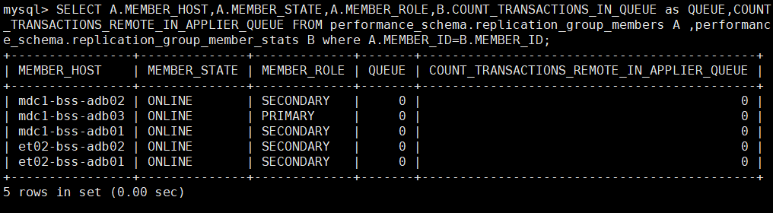
SQL Query to Identify Eligible Secondary Servers:
SELECT A.MEMBER_HOST,A.MEMBER_STATE,A.MEMBER_ROLE,B.COUNT_TRANSACTIONS_IN_QUEUE as QUEUE,COUNT_TRANSACTIONS_REMOTE_IN_APPLIER_QUEUE FROM performance_schema.replication_group_members A ,performance_schema.replication_group_member_stats B where A.MEMBER_ID=B.MEMBER_ID;

Explanation of Fields:
- MEMBER_HOST: Hostname of the MySQL server.
- MEMBER_STATE: Current state of the node (e.g., ONLINE).
- MEMBER_ROLE: Role within the replication group (PRIMARY or SECONDARY).
- QUEUE: Number of local transactions pending on the node.
- COUNT_TRANSACTIONS_REMOTE_IN_APPLIER_QUEUE: Number of remote transactions yet to be applied from the group.
Execute the read query only if a secondary node is ONLINE and both queue values are zero.

If No Suitable Server Is Available:
- Do not proceed with the query.
- Wait until a secondary node becomes available that meets the above conditions.
- Optionally, implement a polling mechanism or monitoring alert to detect when an idle secondary is ready.

Benefits of Following This Approach:
- Prevents unnecessary load on the primary server, maintaining performance for critical transactions.
- Ensures accurate and up-to-date results by avoiding stale reads.
- Supports reliable backend analytics, reporting, and audit processes.

DB Backup & Archiving
To ensure data integrity, disaster recovery readiness, and the ability to recover from accidental configuration changes, a comprehensive backup strategy is implemented for the CM database (WKN_CM) as part of the Cluster 1 MySQL deployment.

MySQL Enterprise Backup (MEB) – Cluster-Level Snapshot
A scheduled MySQL Enterprise Backup (MEB) process is configured to take daily backups of the entire Cluster 1, which includes the CM database. The backup strategy follows a hybrid approach:
- Full Back up: Performed twice a week (typically on fixed days Monday and Thursday).
- Incremental Backup: Performed on the remaining days.
This ensures storage efficiency while maintaining reliable recovery points.
Backup Scheduling & Execution
- The MEB is triggered via a scheduled shell script at 04:00 AM daily on all five database nodes.
- Only one node will execute the actual backup at any given time, based on internal eligibility logic.
- The same node will continue to perform backups until it becomes unavailable, in which case another node takes over.
Cron Schedule:
00 04 * * * sh -x /data/Daily_MEB_Job/run_meb.sh >> /data/Daily_MEB_Job/logs/meb_log.log 2>&1

Note: This script is scheduled under the root user on all Cluster 1 database servers to enable automated MySQL Enterprise Backup (MEB) execution. Only one eligible node will perform the backup at a time, based on internal logic.

Backup Path Locations:
Hostname | Server IP | Path
mdc1-bss-adb01 | 10.4.74.132 | /db-backup/MEB_CLUSTER
mdc1-bss-adb02 | 10.4.74.133 | /db-backup/MEB_CLUSTER
mdc1-bss-adb03 | 10.4.74.134 | /db-backup/MEB_CLUSTER
et02-bss-adb01 | 10.3.174.24 | /db-backup/MEB_CLUSTER
et02-bss-adb01 | 10.3.174.25 | /db-backup/MEB_CLUSTER

Important: Since this MEB script takes a snapshot of the entire cluster, no modifications should be made to the backup script without prior consultation with the Onshore 6D L2 Team.

Daily Configuration Table Dump – Fine-Grained Recovery
As the MEB snapshot covers the entire cluster, restoring a specific table or row from it is not practical for minor data recovery needs. To address this, a daily dump of critical configuration tables is scheduled separately.
This allows L2 support to restore configuration data in case of accidental changes without impacting the broader system.
Cron Schedule:
00 04 * * * sh /home/svc-bss-pam@safaricomet.net/OPS/DailyDBDump/Cluster1/DailyDBDumpCluster1.sh

Note: This script is scheduled under the root user on et02-bss-jump01 (10.3.124.21) to perform the daily dump of configuration tables. This backup supports fine-grained restoration in the event of accidental changes.

Dump Storage Path:
Hostname | Server IP | Path
et02-bss-jump01 | 10.3.124.21 | /MDC1_BSS_App_Data/bss-nfs-doc/DailyDBDump/Cluster_1

This setup ensures that the latest copy of key configuration tables is always available for quick restoration when needed.

CI/CD & Deployment
This section outlines the CI/CD workflow for the CM application deployed on Kubernetes in the MDC1 and DC2 production environments. The deployment approach focuses on GitOps principles, with centralized configuration management, controlled image delivery, and manual syncing through ArgoCD.

Overview

Component | Role
Git Repository | Stores production deployment and application configurations (kustomization.yaml, deployment.yaml, etc.)
Git Extension | Used by engineers to commit and push changes to the Git repository
Harbor Registry | Hosts Docker images for all CM microservices
ArgoCD | Monitors Git repository and syncs changes to target Kubernetes clusters
Environment Scope | GitOps applies to Production only (MDC1 & EDC2)

Deployment Workflow Overview
The CM production deployment process involves collaboration between the L3 Dev and L2 Operations teams. Configuration is managed through Git, and synchronization is performed via ArgoCD. In the event of ArgoCD issues, manual deployment via the jump server is also supported.

Git Extension Setup on Local Machine (L2)
To prepare for configuration editing, L2 engineers must install Git Extension locally and use VS Code for updating files.
Installation & Setup:
- Install Git Extension and clone the production Repository
Refer the attached document for installing portable git extension in your local machine.
- Edit in VS Code
- Open the folder in Visual Studio Code.
- Navigate to the relevant path (e.g., overlays/mdc1/cm-pod-1/)
- Edit and save the changes

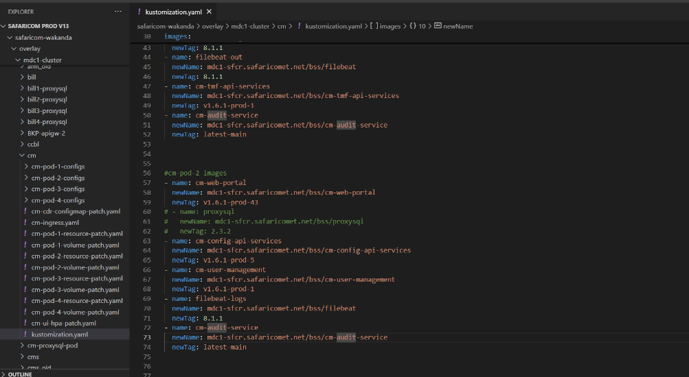

- Commit and Push Changes
Use Git Extension to:
- Pull & Merge all the changes before pushing any new changes to avoid conflicts.

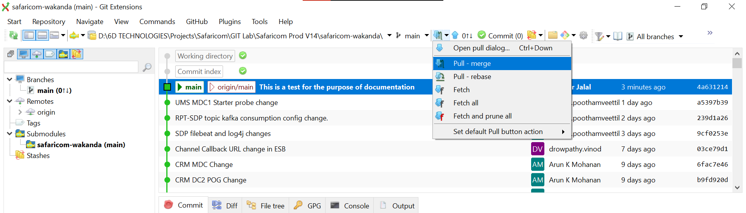

- Stage changes
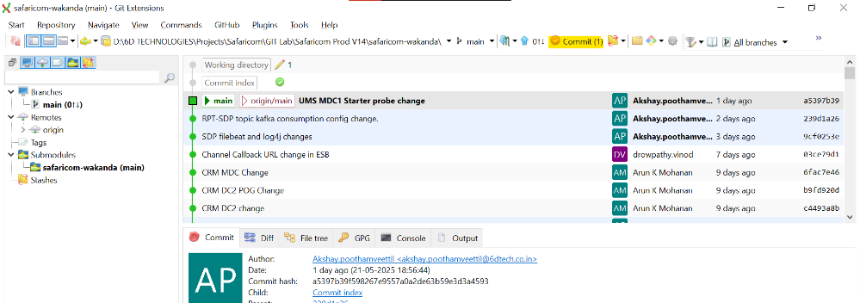
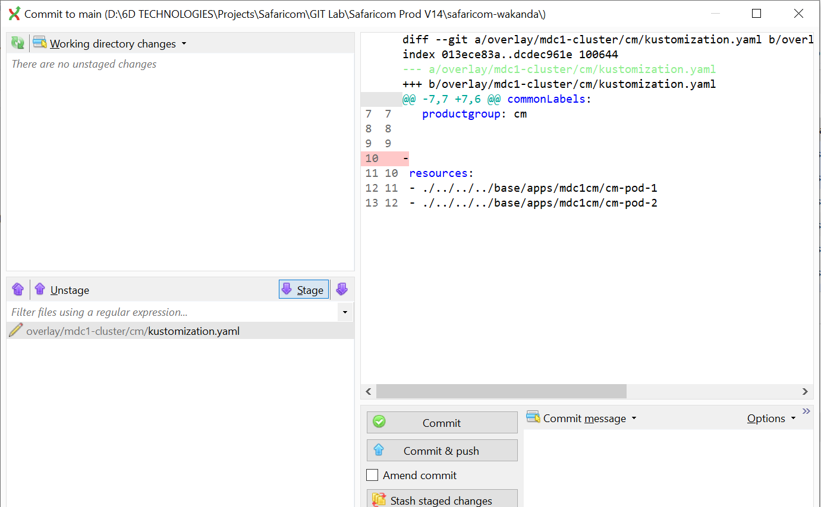
- Commit & push with a clear message
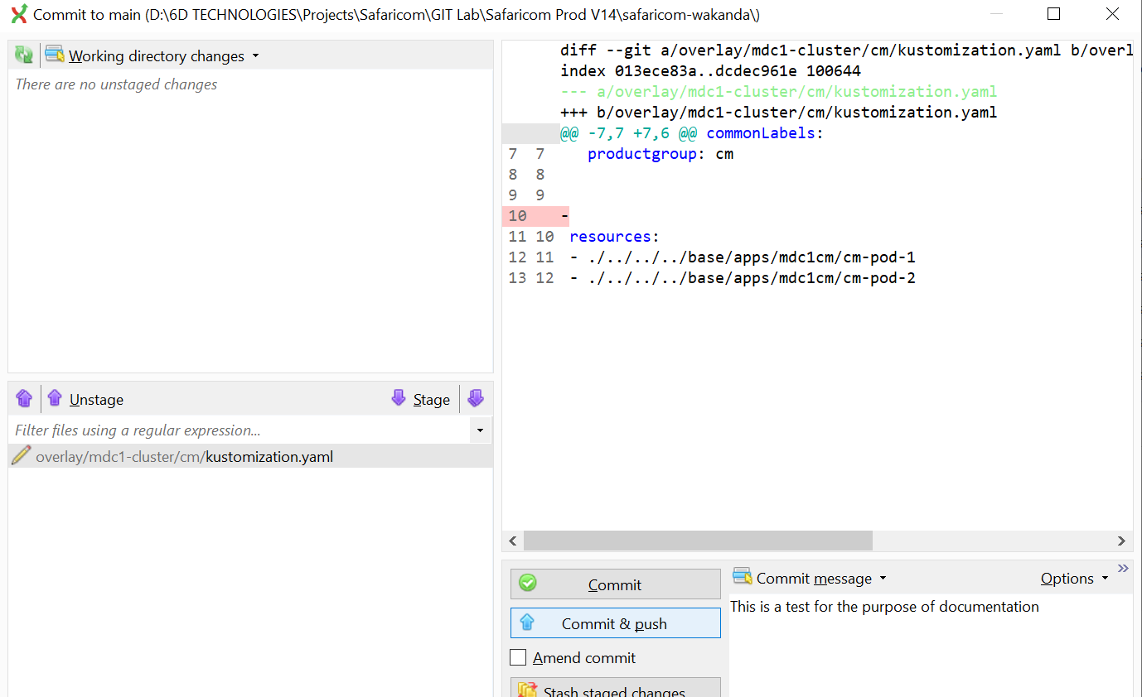
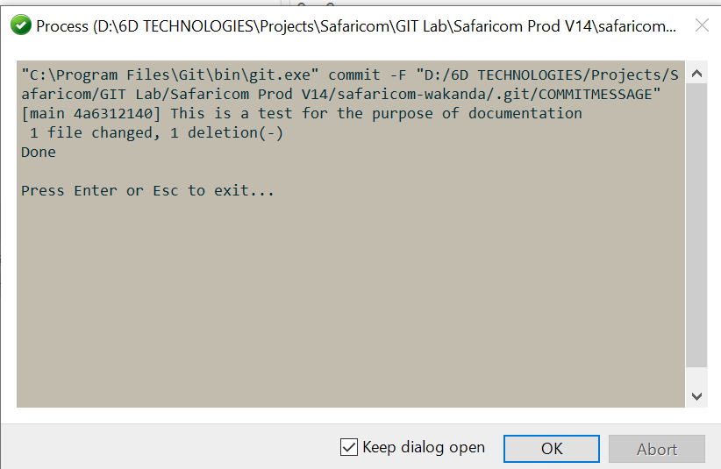
- After commit and push the changes can be viewed as below:
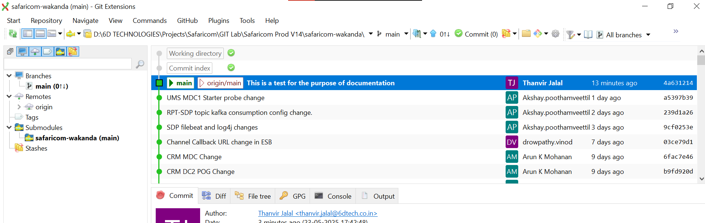

L2 Image Retrieval and Internal Registry Push
- Image Build & Push by L3

- L3 builds Docker images for updated CM microservices.
- These images are tagged and pushed to a common Docker Hub repository.
- L3 shares:
- DockerHub image tag(s)
- Any updated configuration files (e.g., application.yaml, kustomization.yaml)

- Image Pull & Re-Publish by L2

- L2 logs into Docker Hub using pre-shared credentials.
- Pulls the shared image to the BP/Prod Jump servers.
- Tags and pushes the image to the internal Harbor registry in BP/Prod.
# Steps
- docker login -u " safaricoml2deploy " // Login to dockerHub

- docker pull thanvirjalal/upc-web-portal:v1.1.1-dev-498 // Pull image for dockerHub
- docker login -u "thanvir.jalal@blueprint.lab" registry.tools.blueprint.lab // Login to Harbor

- docker tag docker.io/thanvirjalal/upc-web-portal:v1.1.1-dev-498 registry.tools.blueprint.lab/bss/upc-web-portal/upc-web-portal:v1.1.1-dev-498 // Tag the image to Harbor

- docker push registry.tools.blueprint.lab/bss/upc-web-portal/upc-web-portal:v1.1.1-dev-498 // Push the image to Harbor

- Git Configuration Update by L2

- L2 updates the image field in the appropriate kustomization.yaml file in overlay of corresponding sites on VS Code.
- Also applies any configuration files (if shared by L3).
- Commits and pushes changes using the Git extension.

Sync via ArgoCD
Once Git changes are pushed, ArgoCD must be manually synced:
- Log in to ArgoCD
- EDC2 URL: https://argocd.bss2.safaricomet.net/login
- MDC1 URL: https://argocd.bss3.safaricomet.net/login
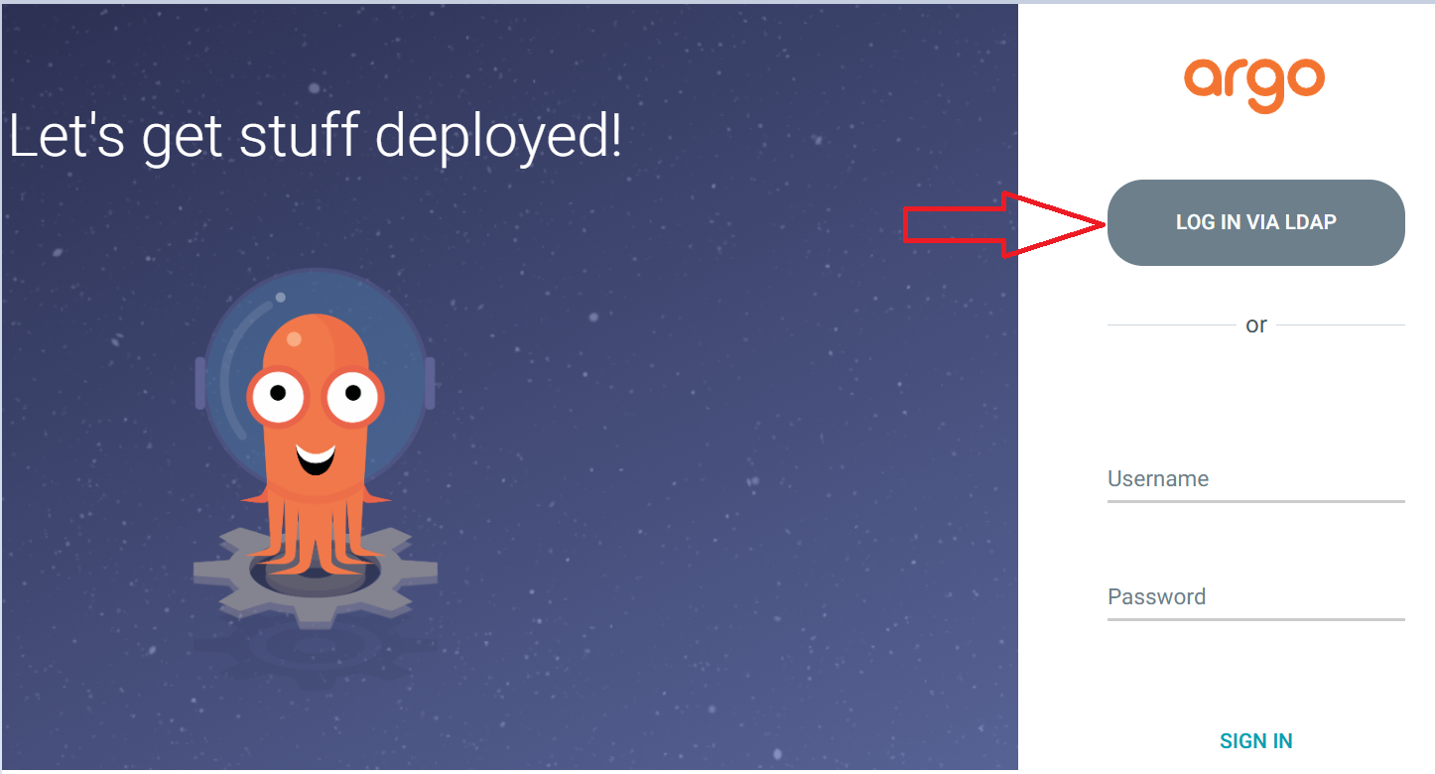
- Locate the Application
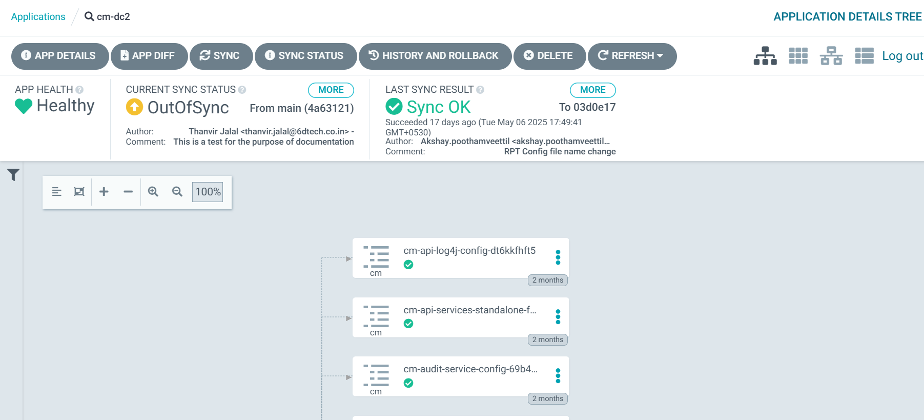

- Perform a Sync
- Click Refresh → Sync → Synchronize
- Enable “Prune” and Prune Last before Synchronize
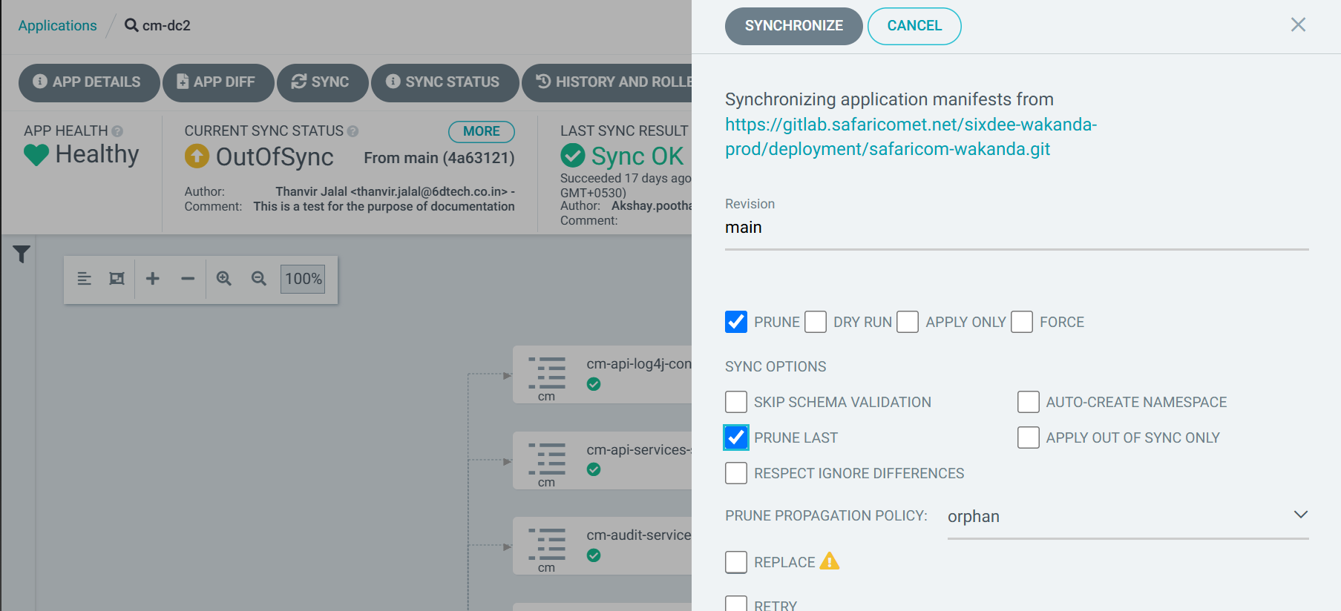

Validation After Deployment
After ArgoCD sync:
- Verify pods are updated:
kubectl get pods -n bss-prod-apps|grep cm

- Check logs or use:
kubectl logs <pod-name> -c <container>

- Confirm application endpoints are responding correctly via Ingress

Manual Git-Based Deployment (Fallback – Jump Server)
If ArgoCD is unavailable or unresponsive, deployment can be performed manually using the Git CLI on the jump server:
- Log in to Jump Server
ssh svc-bss-pam@xx-bss-jump01

- Clone or Update the Repo

cd /home/thanvir.jalal@safaricomet.net/gitsample

# If not cloned

git clone https://gitlab.safaricomet.net/sixdee-wakanda-prod/deployment/safaricom-wakanda.git

cd safaricom-wakanda

# If already cloned

git stash
git pull
sudo chmod 777 /opt/safaricom-wakanda -R

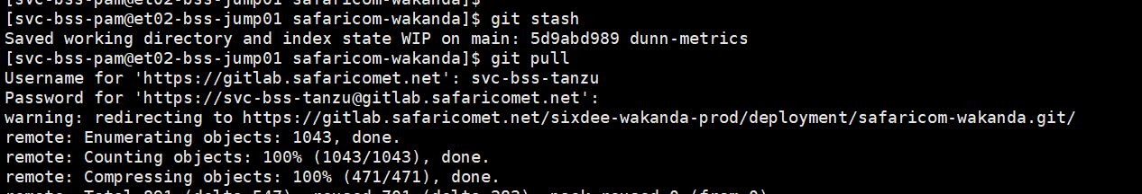

- Apply the Changes Manually
cd safaricom-wakanda/overlay/edge-dc2-cluster/cm

kubectl apply -k .

References and Access Details

Item | Value (MDC1) | Value (EDC2)
Git Repo (Prod) | https://gitlab.safaricomet.net/sixdee-wakanda-prod/deployment/safaricom-wakanda.git | https://gitlab.safaricomet.net/sixdee-wakanda-prod/deployment/safaricom-wakanda.git
Docker Hub | https://hub.docker.com/repositories/safaricoml2deploy | https://hub.docker.com/repositories/safaricoml2deploy
Harbor Registry | mdc1-sfcr.safaricomet.net | et02-harbor.safaricomet.net
ArgoCD URL | https://argocd.bss3.safaricomet.net/login | https://argocd.bss2.safaricomet.net/login
DockerHub Credentials | Will be shared with L2 via email | Will be shared with L2 via email
Harbor Credentials | AD Credentials | AD Credentials
ArgoCD Credentials | AD Credentials | AD Credentials

Logging, Reporting, Monitoring, and CDR Management
Logging, Reporting and monitoring are critical components of the CM application’s operational reliability. All application logs and CDRs are stored on NFS-mounted directories to ensure centralized access, backup, and long-term retention.

Log Storage Overview
Each CM pod (e.g., cm-api-services, cm-user-management, cm-scheduler) writes logs to a specific NFS-mounted directory. These logs are mounted to the Kubernetes containers at runtime using shared volumes.
- Logs are categorized per microservice and are persisted to NFS, allowing:
  - Centralized access from jump servers
  - Consistent backup and archiving
  - Separation of logs by pod and container type

Accessing Logs from Jump Servers
Site | Jump Server Hostname | Mounted Log Path
MDC1 | mdc1-linuxjump01 | NFS mount to /bss-nfs-log/CM/
DC2 | dc2-linuxjump01 | NFS mount to /bss-nfs-log/CM/

Microservices | Mounted Log Path from Jump Server
cm-processor | /BSS_App_Data/bss-nfs-log/CM/cm-processor/logs
cm-config-api-services | /BSS_App_Data/bss-nfs-log/CM/cm-config-api-services/logs
cm-scheduler | /BSS_App_Data/bss-nfs-log/CM/cm-scheduler/logs
cm-notification | /BSS_App_Data/bss-nfs-log/CM/cm-notification/logs
cm-api-services | /BSS_App_Data/bss-nfs-log/CM/cm-api-services/logs
cm-tmf-api-services | /BSS_App_Data/bss-nfs-log/CM/cm-tmf-api-services/logs
cm-audit-service | /BSS_App_Data/bss-nfs-log/CM/cm-audit-service/logs
cm-user-management | /BSS_App_Data/bss-nfs-log/CM/cm-user-management/logs
cm-batch-processor | /BSS_App_Data/bss-nfs-log/CM/cm-batch-processor/logs
cm-web-portal | /BSS_App_Data/bss-nfs-log/CM/cm-notification/logs

Log Backup and Housekeeping Script
A scheduled housekeeping script runs daily to:
- Move logs of previous days to a backup directory
- Archive them into .zip files
- Delete backup archives based on a defined retention period
Cron Schedule:
00 02 * * * /home/svc-bss-pam@safaricomet.net/OPS/Daily-HouseKeeping-Scripts/Daily-HouseKeeping-Scripts.sh

Note: This script is scheduled under the root user on DC2 jump server. It is a common script used for housekeeping of all BSS modules, not just CM. Do not modify the script or configuration file directly without consulting the Onshore 6D L2 Team.
Back Storage Path:
Hostname | Server IP | Path
mdc1-bss-adb01 | 10.4.74.132 | /BSS_App_Data/bss-nfs-log/bkp_dir
et02-bss-jump01 | 10.3.124.21 | /BSS_App_Data/bss-nfs-log/bkp_dir

Current Log Retention Policy
As of now:
- All CM service logs are retained for 3 days
- This is defined in the in_path.txt file used by the housekeeping script
- Retention days can be configured per service

Reason: Due to CM’s consistent stability over the past 2 years, only 3-day logs are retained to optimize storage usage.

CDR Storage
In addition to logs, CM (cm-api-services) also generates CDRs for ticket activity. These are stored and rotated separately.
CDR Type | Path
Application Generated Raw CDRs | /BSS_App_Data/bss-nfs-log/CDR/CM/CM-CDR
Filebeat Out Moved NDJSON CDRs | /bss-nfs-cdr/CM/cm-edr-output
Mediation Picked CDR Files | /BSS_App_Data/bss-nfs-cdr/DWH_BI_Final

CDR Processing and Data Flow
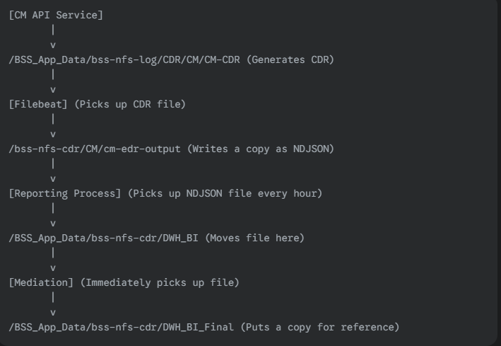
Explanation of the Flow:
- CM API Service: This is the starting point, responsible for generating the Call Detail Records (CDRs).
- /BSS_App_Data/bss-nfs-log/CDR/CM/CM-CDR: This is the directory where the CM API Service initially places the CDR files.
- Filebeat: Monitors the CM-CDR directory. When a new CDR file appears, Filebeat picks it up.
- /bss-nfs-cdr/CM/cm-edr-output: Filebeat then writes a copy of the CDR data to this directory, converting it into NDJSON format.
- Reporting Process: This process is scheduled to run hourly. It monitors the cm-edr-output directory for new NDJSON files.
- /BSS_App_Data/bss-nfs-cdr/DWH_BI: The Reporting Process moves the NDJSON files from cm-edr-output to this directory. This serves as an input for the Meditation process.
- Mediation: As soon as a file lands in DWH_BI, the Meditation process immediately picks it up.
- /BSS_App_Data/bss-nfs-cdr/DWH_BI_Final: Finally, Meditation processes the file and places a copy of it in this directory for reference or further processing.

Monitoring and Alerting
Robust monitoring is essential for ensuring service uptime and proactive fault detection. While the Safaricom CM deployment does not currently utilize a full observability stack (e.g., Prometheus + Grafana), basic health monitoring and auto-recovery mechanisms are in place.

Prometheus Metrics Endpoints
Each CM microservice is instrumented to expose a metrics endpoint, which can be consumed by Prometheus or any compatible monitoring tool. These endpoints return live operational metrics such as request counts, response times, memory usage, and active threads.

Note: Although these endpoints are available, Grafana and Prometheus are not currently integrated into the Safaricom deployment. This can be enabled in future if advanced monitoring dashboards are required

Shell Script-Based Health Monitoring
To ensure high availability of critical services, a custom shell script is scheduled to monitor the health of cm-api-services. The script performs the following:
- Periodically sends a request to the cm-api-services
- Verifies response presence and correctness within a configured timeout
- If no valid response is received:
- Logs memory and pod status
- Automatically triggers a restart of the cm-pod-1 deployment
- Sends email alerts to the L2 and NOC teams
This mechanism helps prevent prolonged service degradation due to transient failures.

Reporting
Reporting is an essential function in the CM application for visibility into ticket operations, user activity, and audit compliance. Reports are generated using stored procedures defined in the underlying databases.
The following table outlines the available reports, their associated procedures, and database details:
Report Name | Procedure Name | DB Name | Cluster Name | DB User
Case Detail Report | getCaseDetailsReport | WKN_CM | Cluster 1 | cmadmin
Case Detail History | getCaseDetailsHistoryReport | WKN_CM | Cluster 1 | cmadmin
Open Tickets Tracker Report | Open Tickets Tracker Report | WKN_CM | Cluster 1 | cmadmin
Case Audit Report | getAssigneeAuditing | WKN_CM | Cluster 1 | cmadmin
Agent Wise Report | getAgentWiseReport | WKN_RPT | Reporting DB (Standalone) | rptuser
Category Wise Report | getCategoryWiseReport | WKN_RPT | Reporting DB (Standalone) | rptuser
Location Wise Report | getLocationWiseReport | WKN_RPT | Reporting DB (Standalone) | rptuser

Note: All reports running on the WKN_CM database are to be managed and maintained by the L2 Team. This includes analysing procedures, troubleshooting data mismatches, and applying updates as needed.

To analyse or validate the logic used in any report procedure
Step 1: Extract the Procedure
SHOW CREATE PROCEDURE <Procedure_Name>;
Example:
SHOW CREATE PROCEDURE getCaseDetailsReport;

Step 2 – Review the Logic
Extract the SELECT query and thoroughly analyse the WHERE clause, joins, and filters for any inconsistencies.

Procedure Update Process
If a modification is required in a report’s logic, follow the steps below:
- Login to Primary Node
- Connect to the master instance of the WKN_CM cluster.
- Use the correct DB user cmadmin
- Backup Existing Procedure
SHOW CREATE PROCEDURE getAssigneeAuditing;

- Update the Procedure
DROP PROCEDURE IF EXISTS getAssigneeAuditing;
DELIMITER $$
CREATE PROCEDURE getAssigneeAuditing()
BEGIN
// updated procedure logic here
END$$
DELIMITER ;

Scheduled Operational Shell Scripts
This section documents the key shell scripts deployed for the CM Module to automate operational tasks. Each script is scheduled via cron, either in MDC1, DC2, or both, depending on its function.
The table below summarizes each script’s scheduling pattern, deployment location, and purpose. Detailed logic for each script is provided in the sections that follow.

Summary of Scheduled Scripts

Script Name | Cron Schedule | Execution User | Script Path | Location | Purpose
HOURLY_CM_TOP_TICKETS_V2.sh | 05 */1 * * * | root | /home/svc-bss-pam@.../HOURLY_CM_TOP_TICKETS/HOURLY_CM_TOP_TICKETS_V2.sh | EDC2 | Hourly extraction of top ticketing metrics
Daily-CM-Ticketing-History-Loading.sh | 30 01 * * * | root | /home/svc-bss-pam@.../Daily-CM-Ticketing-History-Loading/Daily-CM-Ticketing-History-Loading.sh | EDC2 | Load historical ticketing data into CM DB
CM_POD1-Refresh.sh | */2 * * * * | svc-bss-pam@safaricomet.net (EDC2), anpin.abraham (MDC1) | /home/svc-bss-pam@.../CM-Monitoring/CM_POD1-Refresh.sh | MDC1,EDC2 | Health-check and restart monitor for CM-POD-1

Script Logic Summaries

HOURLY_CM_TOP_TICKETS_V2.sh – Hourly Ticket Summary Alert
- Path: /OPS/HOURLY_CM_TOP_TICKETS/
- Purpose: Connects to a healthy secondary DB node, extracts the top 10 case types based on ticket count in the last 3 hours, and compares them with the previous interval.
- Output: Generates an HTML summary with % change and sends to operational teams.
- Failsafe: Prevents concurrent execution and alerts if the script is already running.

Daily-CM-Ticketing-History-Loading.sh – Hard-Closed Ticket Archiver
- Path: /OPS/Daily-CM-Ticketing-History-Loading/
- Purpose: On the 1st day of each month, the script:
  - Validates that the hard close thread has completed.
  - Moves hard-closed tickets (status 30) from the main table to the history table in chunks.
  - Verifies count match, then truncates the p_truncate partition.
- Safety Checks:
  - Prevents concurrent execution via PID tracking.
  - Triggers email alerts if errors occur at any step.
  - Only runs if 90 days ago from the current date is the 1st of a month (ensures 3-month archive cycle).

CM_POD1-Refresh.sh – POD Health Monitor
- Path: /OPS/CM-Monitoring/
- Purpose: Every 2 minutes, checks CM-POD-1’s API responsiveness.
  - If unresponsive, it logs memory usage, restarts the deployment, and sends an alert.
- Mechanism:
  - Uses a lock file to prevent overlap.
  - Captures health data before restart.
  - Sends structured HTML alerts via SMTP to alert operational team.

Troubleshooting Guide
This section provides a structured approach for L2 engineers to diagnose, investigate, and resolve issues in the CM application. It includes standard troubleshooting methodology, common scenarios, log tracking techniques, Kubernetes commands, and special considerations for NFS mount slowness.

General Troubleshooting Approach
SL.NO | Step | Action
1. | Reproduce the issue | Understand the user flow and trigger the problem (if safe).
2. | Identify affected service | Use logs or API context to pinpoint the pod/microservice.
3. | Check pod and logs | Use kubectl logs, NFS log path, or Prometheus metrics if available.
4. | Validate configuration | Review service, image tag, environment variables, and Git history.
5. | Analyze root cause | Identify time of failure, patterns, or errors.
6. | Perform safe action | Restart pods or sync ArgoCD if appropriate.
7. | Escalate to L3 if needed | Use the documented escalation process in Section 12.

Log Access Paths
Site | Jump Server Hostname | Mounted Log Path
MDC1 | mdc1-linuxjump01 | NFS mount to /bss-nfs-log/CM/
DC2 | dc2-linuxjump01 | NFS mount to /bss-nfs-log/CM/

Microservices | Mounted Log Path from Jump Server
cm-processor | /BSS_App_Data/bss-nfs-log/CM/cm-processor/logs
cm-config-api-services | /BSS_App_Data/bss-nfs-log/CM/cm-config-api-services/logs
cm-scheduler | /BSS_App_Data/bss-nfs-log/CM/cm-scheduler/logs
cm-notification | /BSS_App_Data/bss-nfs-log/CM/cm-notification/logs
cm-api-services | /BSS_App_Data/bss-nfs-log/CM/cm-api-services/logs
cm-tmf-api-services | /BSS_App_Data/bss-nfs-log/CM/cm-tmf-api-services/logs
cm-audit-service | /BSS_App_Data/bss-nfs-log/CM/cm-audit-service/logs
cm-user-management | /BSS_App_Data/bss-nfs-log/CM/cm-user-management/logs
cm-batch-processor | /BSS_App_Data/bss-nfs-log/CM/cm-batch-processor/logs
cm-web-portal | /BSS_App_Data/bss-nfs-log/CM/cm-notification/logs

CDR Type | Path
Application Generated Raw CDRs | /BSS_App_Data/bss-nfs-log/CDR/CM/CM-CDR
Filebeat Out Moved NDJSON CDRs | /bss-nfs-cdr/CM/cm-edr-output
Mediation Picked CDR Files | /BSS_App_Data/bss-nfs-cdr/DWH_BI_Final

Log Analysis – Tracking Requests
Understanding how to trace and correlate UI and backend requests is essential for debugging user complaints, analysing failures, and verifying response flows.

Tracking GET Requests from UI to Backend
This section explains how to analyse cm-web-portal and cm-api-services logs to track GET requests from the user interface through the backend layers.
Step 1: Identify the Request in the Browser Dev Tools
- Open the Developer Tools in your browser and navigate to the Network tab.
- Reproduce the user action or screen load.
- Identify the Request URL corresponding to the GET request.
- Locate the Request ID from the URL query string — this will be used to trace the request in logs.

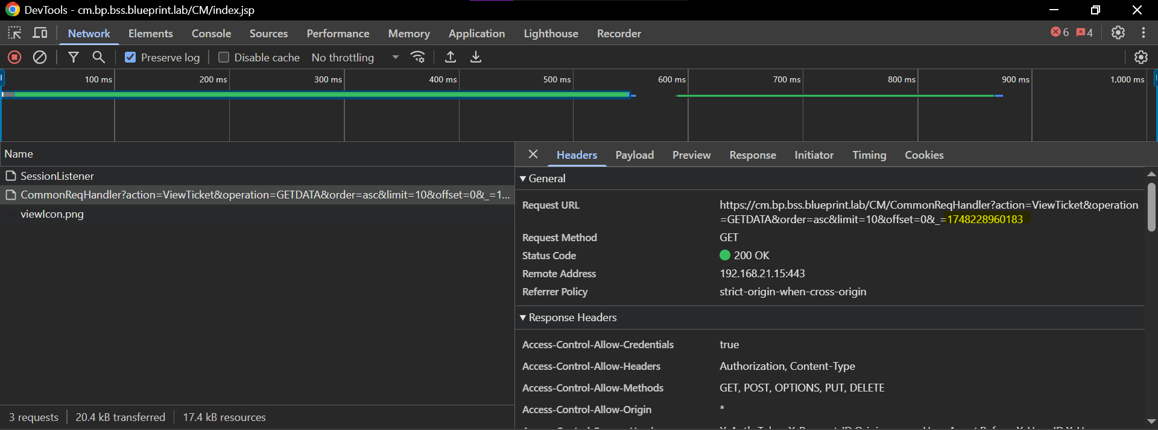

Step 2: Search for the Request ID in cm-web-portal Logs
- Open the log file of cm-web-portal:
- Search for the extracted Request ID (Highlighted in yellow).
- You’ll see a log entry that includes this request ID along with a Thread ID (Highlighted in Green).
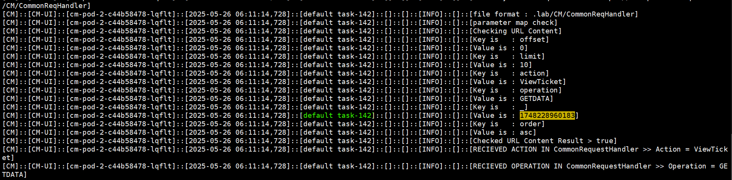
Step 3: Identify the End of Request Processing
- To determine the completion of the request, search for the last occurrence of the Thread ID (same one tied to the Request ID). This log entry usually includes:
- The total time taken for processing
- A marker like [ TIME TAKEN : 1 ms ] or a response indicator
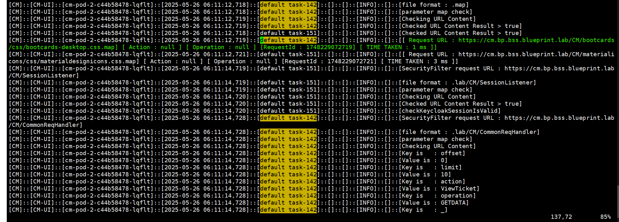
This marks the end of the request lifecycle. The very next line after this in the logs will indicate the start of a new request, which helps bracket the logs for the current request.
Step 4: Trace the Request Flow to Backend (BL)
- From the beginning of the request (as found in logs after the last Total time line of the previous request), continue tracing downward.
- You will see a log indicating a call to the BL (backend) layer.
- The log will print:
- The request to BL
- A "Get Call Request Id:" which is passed from the cm-api-services
- The BL response and status (Success or Failure)
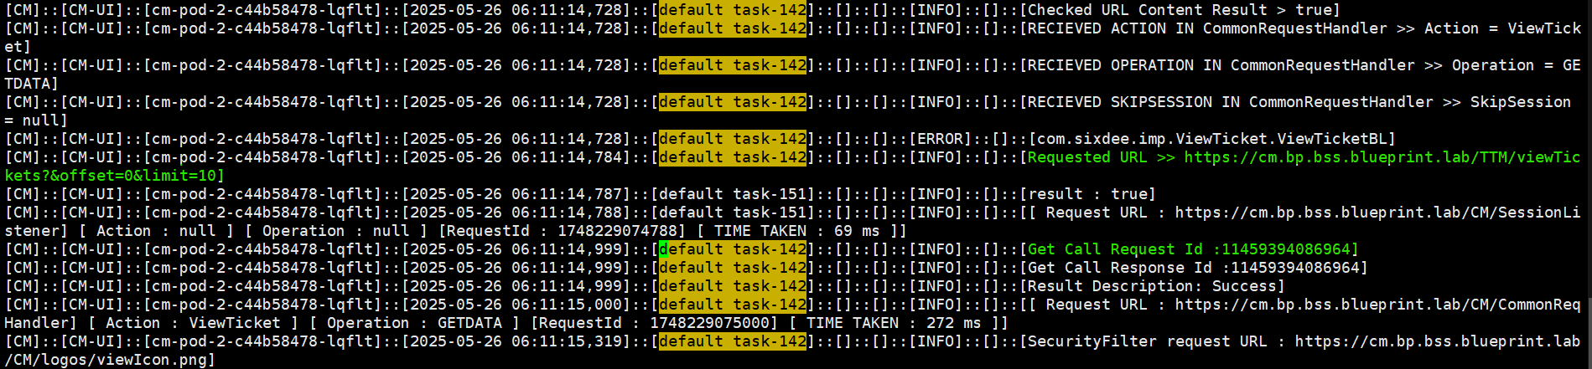
Step 5: Handling Timeout or Missing Response Scenarios
There may be scenarios where the line containing ‘Get Call Request Id’ is not printed. This typically occurs when:
- The backend (cm-api-services) is unresponsive
- A timeout occurred from UI before the request reached BL
In such cases:
- Use the timestamp from the frontend logs
- Switch to cm-api-services logs
- Search for requests received around that timestamp to find the matching call
Step 6: Tracing the Request ID in BL (cm-api-services)
Once you extract the “Get Call Request Id” from the cm-web-portal logs, the same Request ID can be used to track the request flow in the Backend Layer (BL), which resides in cm-api-services.
- Open the log file for the cm-api-services:
- Use the Request ID from Step 4 or Step 5 and search in the BL logs:
- The backend logs typically print:
- The start of request reception
- Internal service-to-service calls
- Validation and DB interaction results
- Final Outcome (Success / Failure)
- Time taken to process the request
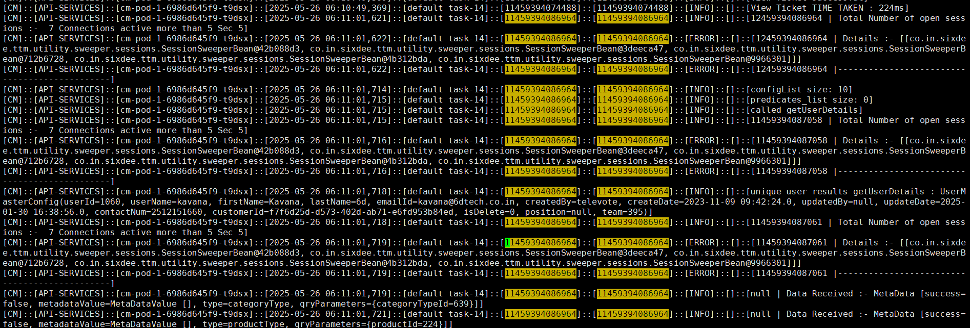
Logs in BL are usually tagged with the same trace ID or transaction ID throughout the request, making it easy to follow full processing steps line-by-line.

Tracking Post or Put Requests from UI to Backend
This section explains how to analyse cm-web-portal and cm-api-services logs to track Post/Put or other requests from the user interface through the backend layers.
Step 1: Identify the Request in the Browser Dev Tools
- Open the Developer Tools in your browser and navigate to the Network tab.
- Reproduce the user action or screen load.
- Identify the request_id corresponding to the post request from the Payload.
- Locate the Request ID from the URL query string — this will be used to trace the request in logs.
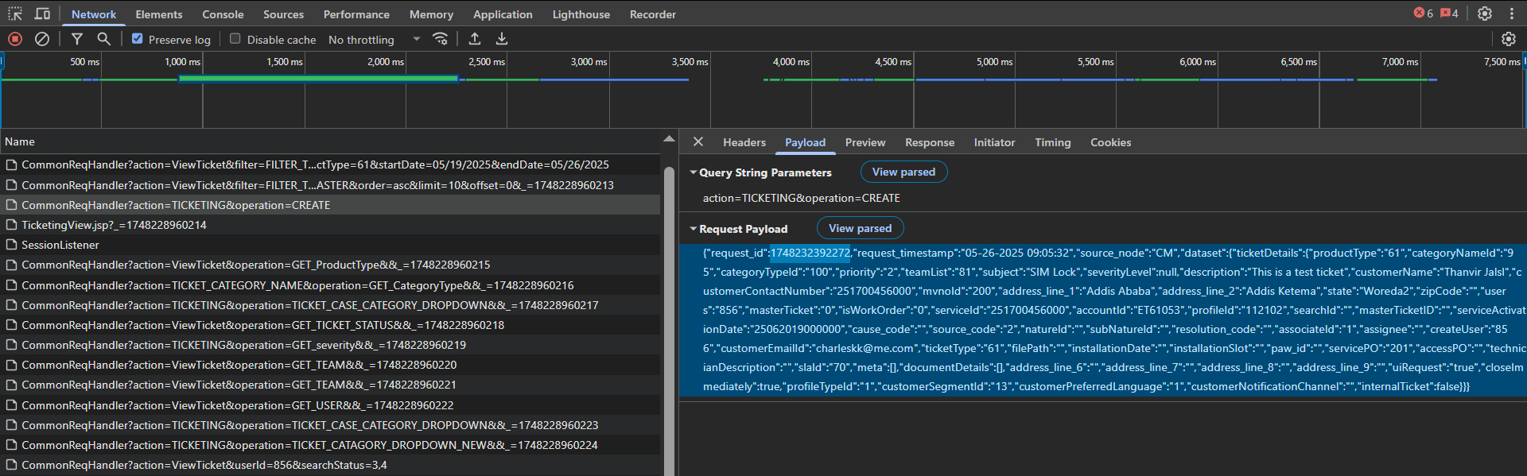
Step 2: Search for the Request ID in cm-web-portal Logs
- Open the log file of cm-web-portal:
- Search for the extracted Request ID (Highlighted in yellow).
- You’ll see a log entry that includes this request ID along with a Thread ID (Highlighted in Green).
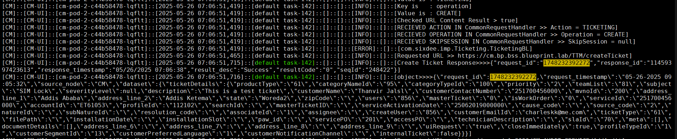
Step 3: Identify the End of Request Processing
- To determine the completion of the request, search for the last occurrence of the Thread ID (same one tied to the Request ID). This log entry usually includes:
- The total time taken for processing
- A marker like [ TIME TAKEN : 1 ms ] or a response indicator
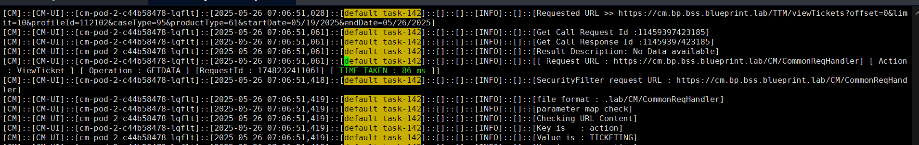
This marks the end of the request lifecycle. The very next line after this in the logs will indicate the start of a new request, which helps bracket the logs for the current request.
Step 4: Trace the Request Flow to Backend (BL)
- From the beginning of the request (as found in logs after the last Total time line of the previous request), continue tracing downward.
- You will see a log indicating a call to the BL (backend) layer.
- The log will print:
- The request to BL
- The BL response and status (Success or Failure) along with request_id
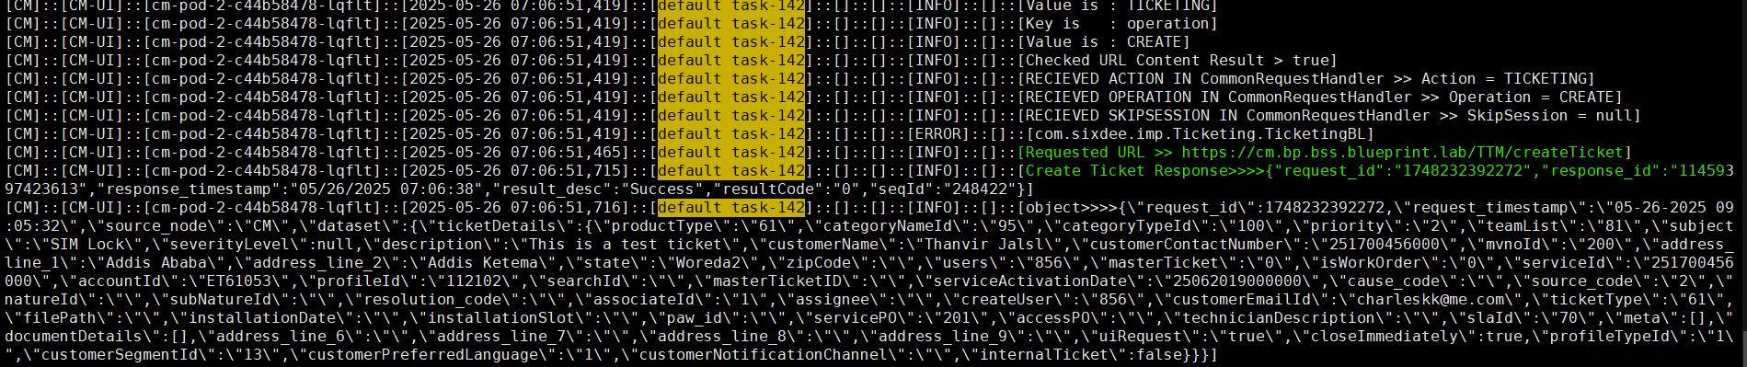
Step 5: Handling Timeout or Missing Response Scenarios
There may be scenarios where the line containing ‘Response’ is not printed. This typically occurs when:
- The backend (cm-api-services) is unresponsive
- A timeout occurred from UI before the request reached BL
In such cases:
- Use the timestamp from the frontend logs
- Switch to cm-api-services logs
- Search for requests received around that timestamp to find the matching call
Step 6: Tracing the Request ID in BL (cm-api-services)
Once you extract the “request_id” from the cm-web-portal network logs, the same Request ID can be used to track the request flow in the Backend Layer (BL), which resides in cm-api-services.
- Open the log file for the cm-api-services:
- Use the Request ID from Step 4 or Step 5 and search in the BL logs:
- The backend logs typically print:
- The start of request reception
- Internal service-to-service calls
- Validation and DB interaction results
- Final Outcome (Success / Failure)
- Time taken to process the request

Logs in BL are usually tagged with the same trace ID or transaction ID throughout the request, making it easy to follow full processing steps line-by-line.

Common Kubernetes Troubleshooting Commands
Action | Command
Get pods | kubectl get pods -n bss-prod-apps
Describe a pod | kubectl describe pod <pod> -n bss-prod-apps
Tail logs | kubectl logs -f <pod> -n bss-prod-apps
Tail logs from a container | kubectl logs -f <pod> -c <container> -n bss-prod-apps
Restart deployment | kubectl rollout restart deployment <deployment> -n bss-prod-apps
Delete a pod | kubectl delete pod <pod> -n bss-prod-apps
Stop Application | Kubectl delete deployment deployment_name -n bss-prod-apps
Exec into container shell | kubectl exec -it <pod> -c <container> -n bss-prod-apps -- /bin/bash

CM Unresponsiveness Due to NFS Mount Slowness
In the past, a frequent and critical issue was observed in the CM platform where the application became unresponsive due to slow or blocked NFS mounts. These mounts are integral for:
- Writing application logs
- Generating and flushing CDRs
This issue has since been mitigated following an NFS mount upgrade by the INFRA team. However, L2 should remain familiar with the symptoms and troubleshooting steps in case the problem resurfaces in the future.
Key Symptoms (If Issue Reappears):
- API returns timeouts
- Pods stuck in Running but non-responsive
- No log output written or log updates are delayed
- CDRs are not generated or flushed
- PODs restart repeatedly, especially those with log/CDR mounts (e.g., cm-api-services, cm-web-portal)
Why It’s Difficult to Detect
- NFS latency may not immediately crash the pod but can cause it to hang silently
- Standard kubectl logs or health check APIs may not show any errors
- Affected pods may show Running status while failing internally to write logs or CDRs
- Other unrelated services may appear fully healthy

Isolation Strategy Based on Affected Modules:
Observed Behavior | Likely Cause | Remarks
All CM-like services are down, but Keycloak, Proxy, CRM-UI work fine | Likely log mount issue | These unaffected services do not depend on NFS log mounts
Only cm-pod-1, COM and SM-related services affected | Likely CDR mount issue | These services actively generate and flush CDRs
Only CM impacted (isolated to one pod or service) | Likely service-specific log/CDR path issue | May be caused by mount lag or stale CDR files
Repeated pod restarts across CM | Pods not terminating properly as the mount path not releasing properly | Stale CDR/Log Mount

Validation Commands for L2
- Log into the Pod and Manually Check the Mounts
kubectl exec -it <pod-name> -c <container-name> -n bss-prod-apps -- /bin/bash

- Check Mount Responsiveness via CLI:
ls -lrth /BSS_App_Data/bss-nfs-log/CM/cm-api-services/logs

ls -lrth /BSS_App_Data/bss-nfs-log/CDR/CM/CM-CDR

- If the command hangs, NFS is likely blocked
- If only CM paths hang, it's a CM-specific NFS issue
- Verify Affected Pods:
kubectl get pods -n bss-prod-apps

- Restart the Pod (if confirmed safe):
kubectl rollout restart deployment deployment_name -n bss-prod-apps

- Check log write behaviour:
tail -f /BSS_App_Data/bss-nfs-log/CM/cm-api-services/logs cm-api-service.log

Escalate to Infra if:
- You observe hangs when accessing NFS from the pod or jump server
- Pod continuously restarts after deletion
- CDRs/logs are not written and multiple apps are impacted
- Timeout persists beyond 10–15 minutes
Attach evidence like ls command output (or hang), list of affected services, pod restart count, and NFS path involved when escalating.

CM UI Loads as a White Screen After Web Portal Restart
Issue Summary:
In certain cases, after restarting the cm-pod-2 (which hosts the cm-web-portal), users may encounter a blank white screen or JSP errors when attempting to access the CM UI via SSO.
This issue typically occurs if the restart happens while users are actively using the UI. The abrupt shutdown of active user sessions can result in incomplete or corrupted session states, which causes the frontend to fail rendering properly post-SSO authentication.
L2 Resolution Steps:
- After restarting cm-pod-2, L2 must immediately verify that the UI is loading correctly by accessing the CM application via the keycloak SSO
- If a white screen or JSP error is observed:
  - Trigger a second restart of cm-pod-2 using:
kubectl rollout restart deployment cm-pod-2 -n bss-prod-apps

  - After restart, the UI typically recovers and loads as expected.

Note: This behaviour has been confirmed by the Solution team and is related to active session persistence during abrupt UI shutdowns.

Steps to take Heap & Thread Dump
Heap and thread dumps are essential for diagnosing memory leaks, GC issues, stuck threads, and performance bottlenecks in CM Java-based services. These dumps can be analyzed using tools such as Eclipse MAT, VisualVM, or Thread Dump Analyzer.
Applicable To:
- Java services running in CM pods (e.g., cm-api-services, cm-web-portal, etc.)
- Typically needed when:
- There’s high memory usage
- Pod restarts frequently due to OOM
- Threads hang or service response is delayed

Heap Dump Collection
- Exec into the container:
kubectl exec -it <pod-name> -c <container-name> -n bss-prod-apps -- /bin/bash

- Find the Java process ID:
ps -ef | grep java
- Go to the log path
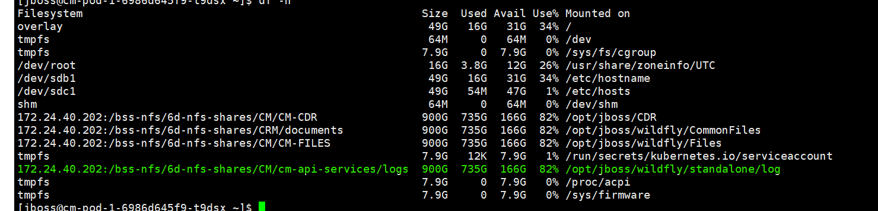
- Take a heap dump using jmap:
jcmd pid GC.heap_dump log_path/cm-api-heapdump.hprof

- The dump will be saved to the same NFS-mounted log directory (e.g., /mnt/cm-api-services/logs/) and is immediately accessible via the jump server without the need to use kubectl cp.

Thread Dump Collection
- Exec into the container:
kubectl exec -it <pod-name> -c <container-name> -n bss-prod-apps -- /bin/bash

- Find the Java process ID:
ps -ef | grep java

- Navigate to the log directory of the application
- Generate a thread dump:
Using jstack:
jstack <java-pid> > cm-thread-dump.txt

Using jcmd:
jcmd <java-pid> Thread.print > cm-thread-dump.txt

- Access the thread dump from the jump server
Best Practices:
- Take multiple thread dumps at 10-second intervals to analyze blocked threads and deadlocks.
- Label the dump files with pod name and timestamp.
- Avoid taking dumps during high-traffic periods unless absolutely necessary.

Operational Tasks
The Case Management (CM) platform is relatively stable and requires minimal day-to-day operational intervention. However, the following tasks are crucial for maintaining SLA compliance, historical ticket data integrity, and ensuring seamless scheduling operations across data centres.

Monthly Ticket Movement to History Table
Purpose:
To move hard-closed tickets from the main table (TTM_TICKET_DETAILS) to the history table (TTM_TICKET_DETAILS_HISTORY) via a scheduled shell script.
Frequency:
Typically executed on the 1st day of every month by a cron job.
L2 Responsibilities:
- Daily in the first week of each month, verify the script executed successfully.
- If the script fails, an email alert will be triggered.
- Upon receiving the alert:

- Check the script logs located in:
/home/svc-bss-pam@safaricomet.net/OPS/Daily-CM-Ticketing-History-Loading/

- Identify the root cause (e.g., DB connection, disk space, NFS delay).
- Manually re-execute the script to complete the ticket migration.

Note: Always ensure the migrated record count in TTM_TICKET_DETAILS_HISTORY matches the count from the p_truncate partition before deletion.

Scheduler Site Failover Handling
Current Configuration:
- MDC1 Scheduler: Handles SLA Breach processing
- DC2 Scheduler: Handles Hard Closing of Tickets
L2 Responsibility in Site Failure:
If either MDC1 or DC2 goes out of service for more than 2 days:
- L2 must activate the scheduler functionality on the remaining available site.
- This can be done by:
- Updating scheduler configuration files
- Verifying with kubectl logs that the newly activated scheduler starts processing jobs
Important:
- L2 must ensure that schedulers in MDC1 and DC2 never perform the same function simultaneously.
- Only one site should process SLA Breaches, and only one should handle Hard Close logic at any given time.
- Additionally, cm-pod-4 must always run with replica: 1 to prevent:
- Multiple schedulers running in parallel
- Duplicate processing on the same tickets
- Database locking and data consistency issues

Note: Always verify scheduler behaviour and replica settings before enabling any function during failover or post-recovery.

BS CATEGORY MASTER Manual Data Addition
The BS_CATEGORY_MASTER table defines customer or business segment categories within the BSS ecosystem. Whenever a new category is introduced in the UPC system, it must be added to this table with its corresponding category ID. This mapping ensures alignment across systems and supports accurate classification and reporting.
Table name: BS_CATEGORY_MASTER
INSERT INTO `BS_CATEGORY_MASTER` (`CATEGORY_ID`, `CATEGORY_NAME`, `CREATE_DATE`) VALUES ('11', 'Large Enterprise LE', '2023-07-13 23:29:55');

SSL/TLS Certificate Update Procedure
To ensure secure HTTPS communication, the SSL certificate for CM must be updated whenever a renewal is due. This is typically initiated when a new certificate is issued by the Safaricom Certificate Authority (CA).
Steps for SSL Certificate Update
- Obtain the New Certificate:
- The 6D Ops/DevOps team will share a new Kubernetes secret name (secretName) containing the updated TLS certificate, generated using the renewed certificate from Safaricom CA.
- Update the Ingress Configuration:
- Open the cm-ingress.yaml file in VS Code or any text editor.
- Locate the existing tls section and replace the old secretName with the new one provided by DevOps.
- This update must be performed for both MDC1 and DC2 environments.
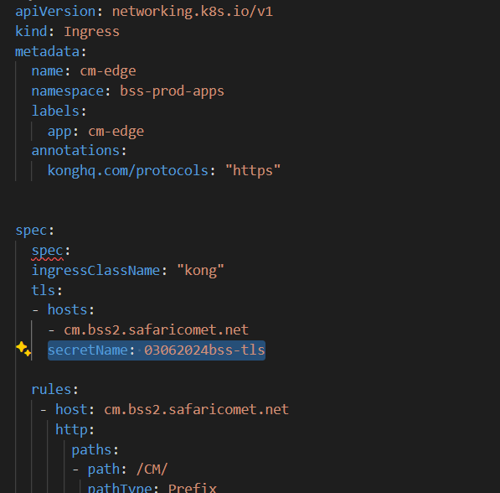
- Commit and Push Changes to Git:
- Save the changes and commit the updated cm-ingress.yaml to the respective Git repository.
- Sync Configuration via ArgoCD:
- Access ArgoCD UI and manually sync the CM application to apply the updated ingress configuration.
- Verification:
- Open the CM UI in a browser (e.g., https://cm.bss2.safaricomet.net/CM/).
- Click the lock icon in the address bar to verify that the new SSL certificate is in effect and reflects the updated expiry date and issuer.

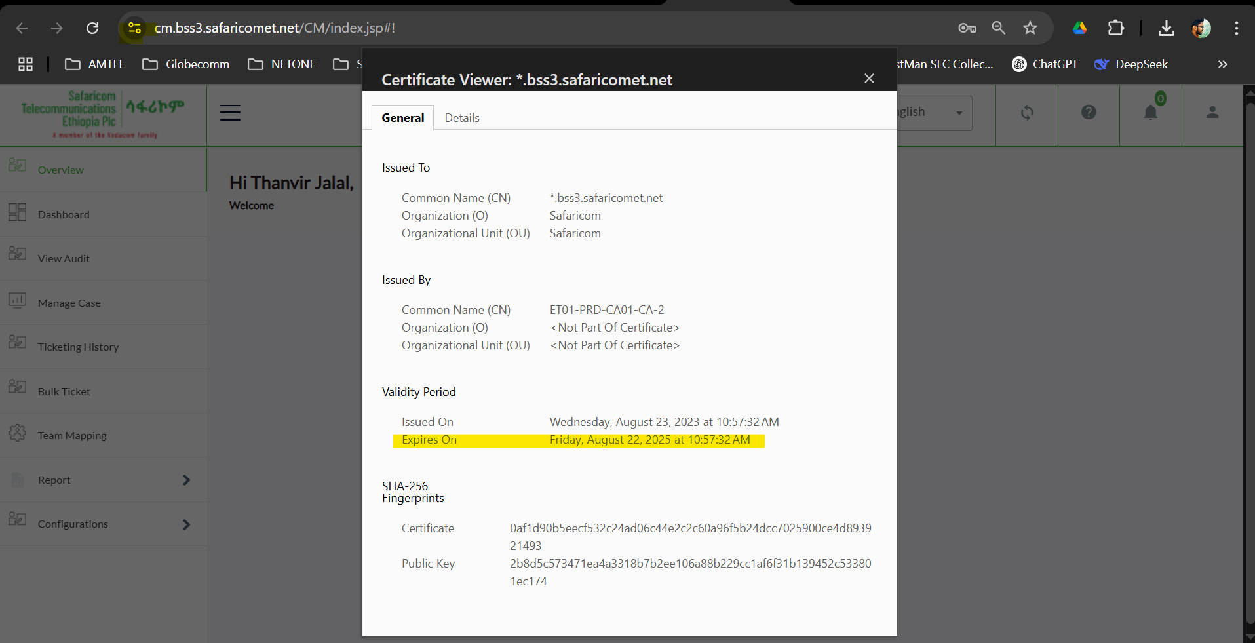

L2-to-L3 Escalation Procedure and SLA Guidelines

Purpose
To formalize the communication and escalation workflow from L2 to L3, ensuring clarity, completeness, and traceability of escalated issues.

Escalation Workflow

L2 Diagnosis
The L2 team performs preliminary investigation and fills the Safaricom L3 Escalation Template (attached below) with all required details:
- Issue summary and logs
- Reproduction steps
- Screenshots, DB entries, dumps (if applicable)
- Initial corrective actions
Safaricom L3 Escalation Template
Safaricom L3 Escalation Template Filled – Sample

Submit Escalation to 6d Support
Send the completed escalation template via email to:
Support Sixdee: [support@6dtech.co.in]
- Subject Format: [BSS Wakanda][CM][L3 Escalation][P1-P4] <Short Description>
- Attach: Filled escalation template, logs, screenshots, etc.

L3 Assignment
The 6d Support team will:
- Acknowledge the mail
- Assign a designated L3 engineer
- Share a tracking reference or ticket ID

Template Verification
The assigned L3 engineer will:
- Review the submitted escalation template and attachments
- Either Accept or Reject the issue

Note: SLA countdown starts only after L3 formally accepts the escalation and confirms the details provided are complete and sufficient.

- If accepted, L3 will request any further data within the same email thread.
- If rejected, L3 will specify the missing or incomplete information. The L2 team must address the gaps and resubmit.

Prerequisites Before Escalation
L2 should ensure the following checks are complete:
- Logs analysed (application, terminal, DB, network)
- System health validated via monitoring tools
- Pod/service restart attempted (if safe)
- DB connection and config verified
- Thread/heap dump collected (for high memory/CPU issues)
- Steps to reproduce clearly documented
- Screenshots, logs, and traces attached

Incident Severity Classification (P1-P4)

Priority | Definition | Customer Impact | Response
P1 (Critical) | Complete outage or major service disruption. No workaround available. Immediate attention needed. | All customers affected | Immediate action
P2 (High) | Severe service degradation or partial outage. Temporary workaround available. | Large group (~30-50%) affected | Fast-track within business hours; workaround until permanent fix.
P3 (Medium) | Minor issue with limited impact. System/service still functions with minor inconvenience. | Small subset (~<10%) affected | Standard resolution timeline (next release or hotfix if needed)
P4 (Low) | Cosmetic/minor performance issues | No real customer impact | Track for future patch/release; no immediate fix required

Ticket Hold & Auto-Closure Policy
- If L2 fails to respond to an L3 query or fix verification within 3 calendar days, the ticket will be moved to On-Hold status.
- If there is still no reply even after 7 days (four days after holding the ticket), the L3 team will close the ticket.
- If needed, L2 can open a new escalation with updated details referencing the original ticket.

Post-Escalation Handling
Once an escalation is formally accepted by the L3 team, the following steps must be followed by the L2 team to ensure proper resolution tracking, implementation, and knowledge capture:
Actions Taken by L3 Team:
- Provide Root Cause Analysis (RCA), any available interim workaround, and a tentative timeline for resolution.
- Request any additional logs, queries, or data samples in the same escalation email chain for deeper investigation.
L2 Team Responsibilities:
- Coordinate fix validation:
- Deploy and validate the fix in UAT (if applicable) and Production environments.
- Confirm the expected behaviour is achieved after the fix is applied.
- Perform regression checks to ensure all existing functionalities remain unaffected and continue working as expected.
- Execute data correction (if needed):
- If L3 identifies corrupted or inconsistent data requiring direct DB update:
- L3 will provide a sample correction query.
- L2 must use this sample logic to formulate and apply the update across all affected records.
- Perform necessary backup or export before applying DB changes.
- Document learnings:
- Update the internal knowledge base or runbook with:
- RCA summary
- Symptoms and identification methods
- Final fix or workaround
- SQLs/scripts used
- Preventive measures (if any)

Appendices

API Request Reference
This section provides reference details for API integrations with the Case Management (CM) system. It includes the request and response structures, key field descriptions, and example payloads for commonly used GET and POST endpoints.

Note: All APIs documented in this section are exposed through the API Gateway (apigw.bss2.safaricomet.net/ apigw.bss3.safaricomet.net) to ensure security, rate limiting, centralized logging, and proper monitoring. While internal teams may use the cm internal ingress endpoint (cm.bss2.safaricomet.net/cm.bss3.safaricomet.net) during internal testing, it is strictly mandated that only the API Gateway endpoints be shared with third-party consumers. Under no circumstances should direct CM endpoints be shared to external parties. API usage tracking, throttling, and access enforcement are only possible when traffic is routed via the API Gateway.

View Tickets
Method: GET
Endpoint:
https://{{url}}/TTM/viewTickets

Query Parameters:
- accountId: Customer account ID (e.g., ET73001)
- limit: Number of results to return
- offset: Result pagination offset
- serviceId: Unique identifier for the service
- customerName: Name of the customer
- customerContactNumber: Customer's contact number
- ticketId: (Optional) Specific ticket ID to filter by
Headers:
- X-Authorization: Bearer token for authentication
- request-id: Unique identifier for the request

View Remarks on a Ticket
Method: GET
Endpoint:
https://{{url}}/TTM/viewRemarks

Query Parameters:
- ticketId: ID of the ticket to retrieve remarks for
Headers:
- X-Authorization: Bearer token
- request_id: Request identifier

Fetch Category by Product ID
Method: GET
Endpoint:
https://{{url}}/CM-CONFIG-API/categoryNames/search/byProductId

Query Parameters:
- keyword: Product ID (e.g., 294)
- sort: Sort field and order (e.g., sequenceId,desc)
- page: Page number (e.g., 0)
- size: Results per page (e.g., 50)
Headers:
- X-Authorization: Bearer token
- Request-ID: Unique request identifier

Fetch Categories by Case Category ID
Method: GET
Endpoint:
https://{{url}}/CM-CONFIG-API/categoryNames/search/byCategoryTypeId

Query Parameters:
- keyword: Case Category to search (e.g., 1172)
- sort: Sorting criteria, typically sequenceId,desc
- size: Maximum number of results per page (e.g., 50)
- page: Page index (starts at 0)
Headers:
- X-Authorization: Bearer token for authentication
- Request-ID: Unique identifier for tracing requests

Update Ticket Status (Multiple Tickets)
Method: POST
Endpoint:
https://{{url}}/TTM/updateMultiTicketStatus

Headers:
- X-Authorization: Bearer token
- request_id: Unique ID for traceability
- Content-Type: application/json
Request Body:
{
"request_id": "Tes-20450167",
"ticketIds": "6764244,123333",
"createUser": "856",
"dataset": {
"ticketStatusDetails": {
"status": "1"
}
}
}

Field | Type | Description
request_id | String | Unique request identifier for tracing.
ticketIds | String | Comma-separated ticket IDs to be updated.
createUser | String | ID of the user initiating the status update.
dataset.ticketStatusDetails.status | String | New status code to be applied to the listed tickets.

Add Remarks to a Ticket
Method: POST
Endpoint:
https://{{url}}/TTM/addRemarks
Headers:
- X-Authorization: Bearer token
- request_id: Unique request identifier
- Content-Type: application/json
Request Body:
{
"dataset": {
"ticketRemarks": {
"comment": "This is test remark by mpesa",
"rating": "4",
"request_timestamp": "05/09/2024 20:41:03",
"ticketId": "71",
"transactionId": "Tes-41334265",
"type": "string",
"userId": "4182"
}
},
"request_id": "Tes-85728885",
"request_timestamp": "05/09/2024 20:41:03",
"source_node": "MPESA"
}
Field | Type | Description
dataset.ticketRemarks.comment | String | The actual remark or comment to be added to the ticket.
dataset.ticketRemarks.rating | String | Default the value to 4
dataset.ticketRemarks.request_timestamp | String | Timestamp when the request was made (format: dd/MM/yyyy HH:mm:ss).
dataset.ticketRemarks.ticketId | String | ID of the ticket to which the remark is being added.
dataset.ticketRemarks.transactionId | String | Unique transaction ID for traceability.
dataset.ticketRemarks.type | String | Type of the remark (e.g., "string" or internal categorization).
dataset.ticketRemarks.userId | String | ID of the user adding the remark.
request_id | String | Unique identifier for the request.
request_timestamp | String | Timestamp when the request was made (format: dd/MM/yyyy HH:mm:ss).
source_node | String | Source system name (e.g., MPESA, CRM) that initiates the request.

Update Ticket Status (Single Ticket)
Method: POST
Endpoint:
https://{{url}}/TTM/updateTicketStatus/{ticketId}

Path Parameter:
- ticketId. Eg. 71
Headers:
- X-Authorization: Bearer token
- request_id: Unique identifier
- Content-Type: application/json
Request Body:
{
"createUser": "4182",
"dataset": {
"ticketStatusDetails": {
"status": "1"
}
},
"request_id": "Tes-60261022",
"request_timestamp": "string",
"source_node": "MPESA",
"ticketIds": "71"
}
Field | Type | Description
createUser | String | ID of the user initiating the update.
dataset.ticketStatusDetails.status | String | New status value to be assigned to the ticket.
request_id | String | Unique request identifier.
request_timestamp | String | Timestamp of the request
source_node | String | Name of the system originating the request.
ticketIds | String | ID of the ticket to be updated (even if passed in path).

Create Trouble Ticket (TMF Compliant)
Method: POST
Endpoint:
https://{{url}}/TMF/troubleTicket

Headers:
- X-Authorization: Bearer token
- Content-Type: application/json
Request Body:
{
"@type": "TroubleTicket",
"relatedEntity": [
{"id": "294", "@referredType": "ProductType"},
{"id": "917", "@referredType": "CategoryTypeId"}
],
"channel": {
"@type": "Channel",
"name": "SCM",
"id": "1"
},
"description": "Test ticket by 6d",
"ticketType": "2493",
"priority": "2",
"relatedParty": [
{
"@referredType": "Customer",
"name": "Thanvir",
"contactNumber": "251799100313",
"mailId": ""
},
{
"id": "",
"@referredType": "Owner"
}
],
"requestId": "Tes-MC49050026385723KT26XU47364",
"name": "This is Test ticket"
}

Field | Type | Description
@type | String | Type of the object being submitted (always "TroubleTicket").
relatedEntity[].id | String | ID of the related entity (Product Type, Category Category, etc.).
relatedEntity[].@referredType | String | The type of the related entity (e.g., "ProductType" or "CategoryCategoryId").
channel.name | String | Channel name through which the ticket is created (e.g., "SCM").
description | String | Detailed description of the issue.
ticketType | String | Case Type ID.
priority | String | Priority level (e.g. High, Medium).
relatedParty[].name | String | Customer’s name.
relatedParty[].contactNumber | String | Customer’s contact number.
relatedParty[].mailId | String | Email address of the customer (can be blank).
relatedParty[].@referredType | String | Type of the party Customer Details of the user for whom the ticket is created.  Owner The agent who is creating the ticket
requestId | String | External unique request identifier.
name | String | Name/title of the ticket (e.g., subject line).

Response
- Success Response
- HTTP Status Code: 201 Created
- Response Body:

{
"id": "248427",
"href": "http://cm-pod-1:4444/TTM/viewTickets?ticketId=248427",
"description": "Test ticket by 6d",
"name": "This is Test ticket",
"priority": "2",
"requestId": "Tes-PS433701004065668300632050028",
"ticketType": 861,
"channel": {
"id": "1",
"name": "M-PESA",
"@type": "Channel"
},
"relatedEntity": [
{
"id": "159",
"@referredType": "ProductType"
},
{
"id": "613",
"@referredType": "CategoryTypeId"
}
],
"relatedParty": [
{
"name": "Thanvir",
"contactNumber": "700456313",
"@referredType": "Customer"
},
{
"id": "1134",
"@referredType": "Owner"
}
],
"@type": "TroubleTicket"
}

- Response Field Descriptions
Field | Type | Description
id | String | TicketID of the created ticket.
description | String | Detailed description provided during ticket creation.
name | String | Ticket title or short summary provided during ticket creation.
priority | String | Priority value provided during ticket creation.
requestId | String | Unique external request ID sent by the client provided during ticket creation.
ticketType | Integer | Case Type ID provided during ticket creation.
channel.name | String | Name of the channel provided during ticket creation.
relatedEntity[].id | String | ID of the associated product or category.
relatedEntity[].@referredType | String | ProductType and CategoryTypeId provided during ticket creation.
relatedParty[].name | String | Name of the customer provided during ticket creation.
relatedParty[].contactNumber | String | Customer contact number provided during ticket creation.
relatedParty[].@referredType | String | Customer or Owner provided during ticket creation.

- Failure Response
- HTTP Status Code: 400, 500
{
"status": "Failure, No Team Mapped with productType and Case Category"
}

- Common Failure Scenarios:

- Product or case category lacks mapped team
- Invalid input data or missing required fields
- Backend exception or internal system error

Create Ticket (TTM)
This API is used to create a new ticket in the Case Management system. It is typically invoked by the CM UI and COM modules to log customer complaints or product installation requests (tickets) into the system with all required details. This API is not exposed via APIGW and is intended solely for use within internal BSS modules.
Method: POST
Endpoint:
https://{{url}}/TTM/createTicket

Headers:
- request-id: <Unique request identifier>
- create-user: <Keycloak ID of user creating the ticket>

Request Body:
{
"source_node": "COM",
"dataset": {
"ticketDetails": {
"users": "5a943078-e809-40b5-83c8-80db37f26c77",
"meta": [
{
"meta_id": "correlationId",
"value": "CMCallback:1378995092023623680"
},
{
"meta_id": "orderId",
"value": "1378995090748555264"
}
],
"profileId": "1433205",
"customerContactNumber": "0911504832",
"customerName": "SACHEM IMPORT AND EXPORT PLC",
"address_line_2": "6",
"address_line_1": "1",
"state": "93",
"zipCode": "05",
"accountId": "ET7364262",
"serviceId": "251700391277",
"customerPreferredLanguage": "1",
"categoryNameId": "3905",
"categoryTypeId": "1173",
"closeImmediately": "false",
"masterTicket": "0",
"isWorkOrder": "0",
"productType": "332",
"priority": "3",
"slaId": "454",
"subject": "Fixed Data Termination",
"description": "Fixed Data Termination",
"teamList": "442",
"source_code": "54"
}
},
"request_id": "CRM49x9zhf_1748848449345",
"requestTimestamp": "02-06-2025 10:20:24"
}

Parameter | Type | Description
source_node | String | Source of the request (e.g., COM, CRM, CM)
dataset.ticketDetails | Object | Object containing all ticket-specific details
ticketDetails.users | String (UUID) | Keycloak ID of User creating the ticket
ticketDetails.meta | Array | Additional meta information, e.g., correlationId, orderId
ticketDetails.profileId | String/Number | Customer profile ID
ticketDetails.customerContactNumber | String | Customer’s contact number
ticketDetails.customerName | String | Customer’s name
ticketDetails.address_line_1 | String | Customer’s address line 1
ticketDetails.address_line_2 | String | Customer’s address line 2
ticketDetails.state | String/Number | State/Region identifier
ticketDetails.zipCode | String | Postal code
ticketDetails.accountId | String | Account ID
ticketDetails.serviceId | String | Service ID
ticketDetails.customerPreferredLanguage | String | Preferred language code
ticketDetails.categoryNameId | String/Number | Case Type ID
ticketDetails.categoryTypeId | String/Number | Case Category ID
ticketDetails.closeImmediately | String ("true"/"false") | If the ticket should be closed immediately
ticketDetails.masterTicket | String ("0"/"1") | If this is a master ticket
ticketDetails.isWorkOrder | String ("0"/"1") | In SFC the value should be always 0
ticketDetails.productType | String/Number | Product type ID
ticketDetails.priority | String/Number | Ticket priority
ticketDetails.slaId | String/Number | SLA ID
ticketDetails.subject | String | Short subject or title of the ticket
ticketDetails.description | String | Detailed ticket description
ticketDetails.teamList | String/Number | Team ID of the User
ticketDetails.source_code | String/Number | Source code ID
request_id | String | Unique request identifier
requestTimestamp | String (dd-MM-yyyy HH:mm:ss) | Request timestamp (system time at request initiation)

Response
- Success Response
- HTTP Status Code: 200 Created
- Response Body:
{"request_id":"11460009319648","response_id":"11460009319648","response_timestamp":"06/02/2025 09:04:54","result_desc":"Success","resultCode":"0"}

- Response Field Descriptions
Field | Description
request_id | Request identifier (echoed from input)
response_id | Unique response identifier
response_timestamp | Time at which the response was generated
result_desc | Description of the operation result
resultCode | Status code (0 for success, others for error)
seqId | Ticket ID for the created ticket

API Response Reference
All POST APIs (except Create Trouble Ticket API ) in the Case Management application follow a standard JSON response format that communicates the success or failure of the request.

Response Format

Success Response

{
"request_id": "11426518991687",
"response_id": "11426518991687",
"response_timestamp": "05/10/2024 18:12:46",
"result_desc": "Success",
"resultCode": "0"
}

Failure Response

{
"request_id": "11426518901213",
"response_id": "11426518901213",
"response_timestamp": "05/10/2024 18:11:15",
"result_desc": "Failure",
"resultCode": "2"
}

Response Fields Explained

Field | Type | Description
request_id | String | Unique ID passed by client in the request. Echoed back for traceability.
response_id | String | Unique ID for client-server correlation.
response_timestamp | String | Timestamp when the response was generated by the system.
result_desc | String | Descriptive message indicating success or failure.
resultCode | String | Numeric code representing the response outcome.

Response Codes and Descriptions

Code | Meaning
0 | Success – The operation was completed successfully.
2 | Failure – The operation failed due to a system or validation error.
3 | No Data Available – No matching records were found.
4 | Missing Mandatory Parameter(s) – Required fields were not provided.
5 | Request ID Already Exists – Duplicate request ID was submitted.
8 | Pending Tasks Exist – Ticket cannot be closed due to pending items.
9 | User/Team Mapping Missing – No team or user is mapped for handling.
10 | Customer Acceptance Form not uploaded

Postman collection of the APIs
All the API endpoints defined in this section including ticket management, configuration, status updates, remarks handling, and TMF ticket creation are included in the official Postman collection below.

Sample Logs for COM Callbacks
Please find the sample failure and success callbacks from CM (cm-api-services) towards COM for your reference.

